Episode 4: The Case of Drop-Dead Esmin

Pictures:
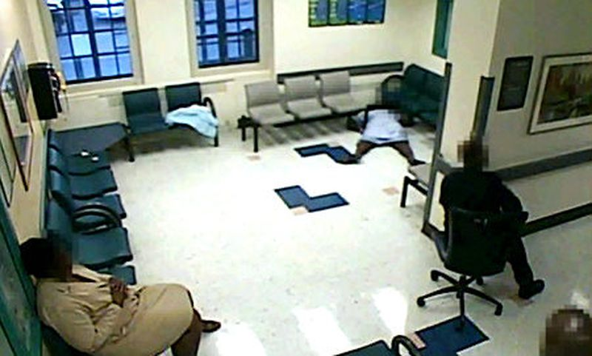
Esmin Green in Waiting Room (2008)

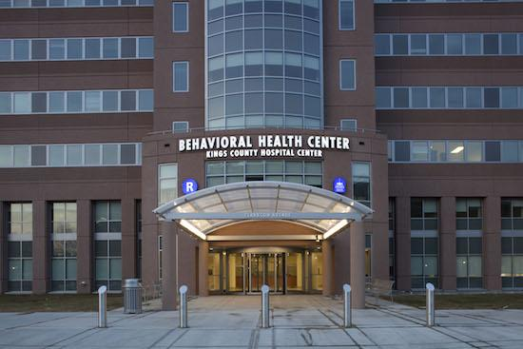
Kings County Hospital, Brooklyn, New York (2017)

Episode References:
https://www.nytimes.com/2009/05/28/nyregion/28settle.html?searchResultPosition=2

https://www.nytimes.com/2011/05/17/nyregion/ex-hospital-worker-accused-of-cover-up-in-patients-death.html?searchResultPosition=1

https://www.google.com/amp/s/www.nydailynews.com/new-york/brooklyn/esmin-green-died-brooklyn-hospital-floor-perished-sitting-article-1.347467%3foutputType=amp

http://www.cnn.com/2008/US/07/03/hospital.woman.death/

https://www1.nyc.gov/assets/doi/reports/pdf/2009/2009-06-19-Pr_esmingreen_finalrpt.pdf

https://tcf.org/content/report/racism-inequality-health-care-african-americans/?agreed=1

Video Footage:
https://www.youtube.com/watch?v=LaU49D-b5MU

https://www.youtube.com/watch?v=-8aSdqOa0LM

Disease of the Week:
https://www.mayoclinic.org/diseases-conditions/bipolar-disorder/symptoms-causes/syc-20355955

https://www.nimh.nih.gov/health/topics/bipolar-disorder/

https://www.nami.org/About-Mental-Illness/Mental-Health-Conditions/Bipolar-Disorder

