Episode 13: Baby Fever in the NICU

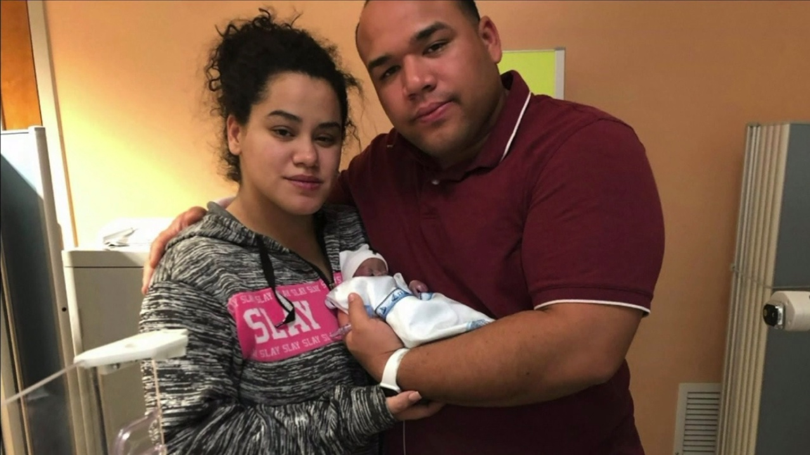
Zuleyka Rodriguez and Luis David Cepeda, holding their son, Abel David Cepeda who died at the age of only 6 days old because of the infection.

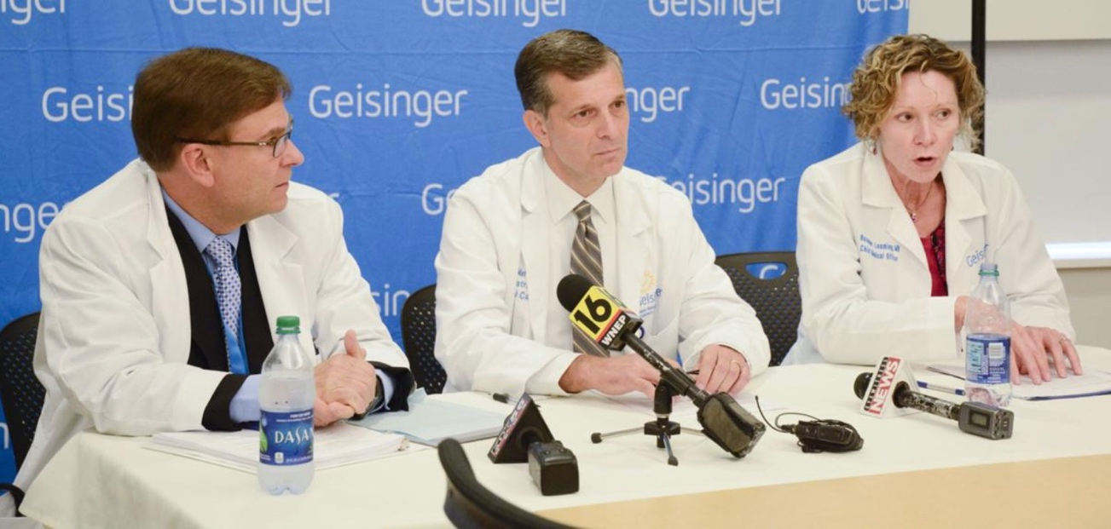

Geisinger officials, Dr. Mark Shelley (Left), Dr. Frank Maffei (Middle), and Dr. Rosemary Leeming (Right) in October press conference discussing the spread of P. aeruginosa.

Videos:
Geisinger Officials in Press Conference held in October 2019:
https://www.dailyitem.com/multimedia/geisinger-doctors-discuss-infection-at-hospital/video_4219f967-0e74-5cb3-b02a-f59caccdec44.html

References:
https://www.nytimes.com/2019/10/07/us/babies-bacterial-infection-pennsylvania.html

https://www.dailyitem.com/the_danville_news/update-family-attorney-geisinger-knew-there-was-a-problem-and-still-accepted-patients/article_ec11aaf4-ec58-11e9-9bc5-174a3c7355e5.html

https://www.wnep.com/article/news/local/montour-county/family-of-child-who-died-in-geisinger-nicu-plans-lawsuit/523-9a9c817f-34fd-4171-89f6-2027ecda516d

https://www.dailyitem.com/the_danville_news/news/attorney-gmc-withheld-info-of-infant-deaths-outbreak/article_6c4f4640-3ea1-521b-8700-3741cc1bac10.html

https://www.abc27.com/news/pennsylvania/hospital-settles-suit-over-infection-that-killed-preemies/

https://www.ncbi.nlm.nih.gov/pmc/articles/PMC2692859/#B1

https://www.hopkinsallchildrens.org/Patients-Families/Health-Library/HealthDocNew/Neonatal-Infections

https://www.nbcnews.com/news/us-news/bacteria-killed-3-infants-traced-pennsylvania-hospital-equipment-n1078911

https://www.infectioncontroltoday.com/view/poor-infection-control-leads-deaths-3-premature-infants

Disease of the Week:

Centers for Disease Control and Prevention
https://www.cdc.gov/tetanus/index.html

Mayo Clinic
https://www.mayoclinic.org/diseases-conditions/tetanus/symptoms-causes/syc-20351625

WebMD
https://www.webmd.com/children/vaccines/understanding-tetanus-basics

