EP 27: The Faith Case Fiasco

Description

This week we discuss the unfortunate case of Faith DeGrand. At 10-years-old, Faith underwent surgery to repair her worsening scoliosis but left the botched surgery with nothing but paralysis and incontinence. Seven years later, her case is finally settled for $135 million, but the road to get there was nothing short of a fiasco with Detroit Medical Center.

Pictures

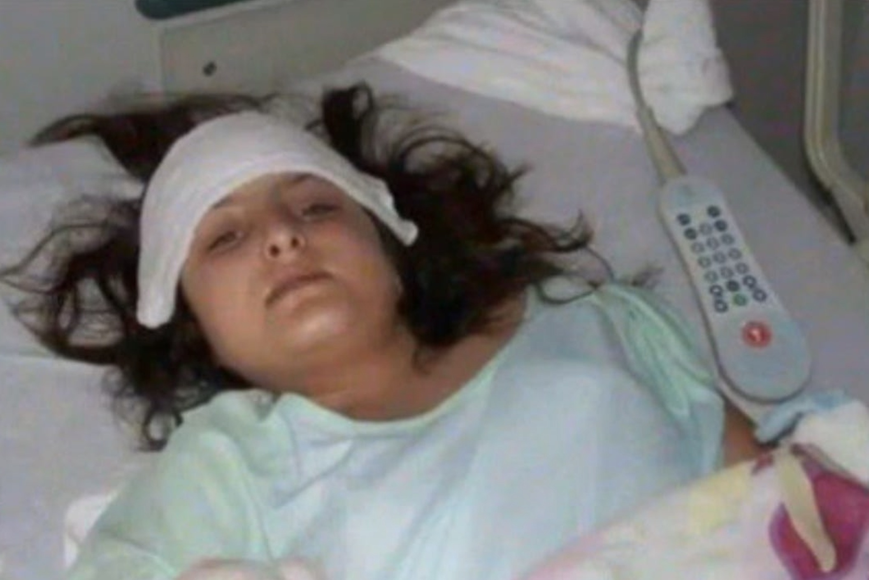
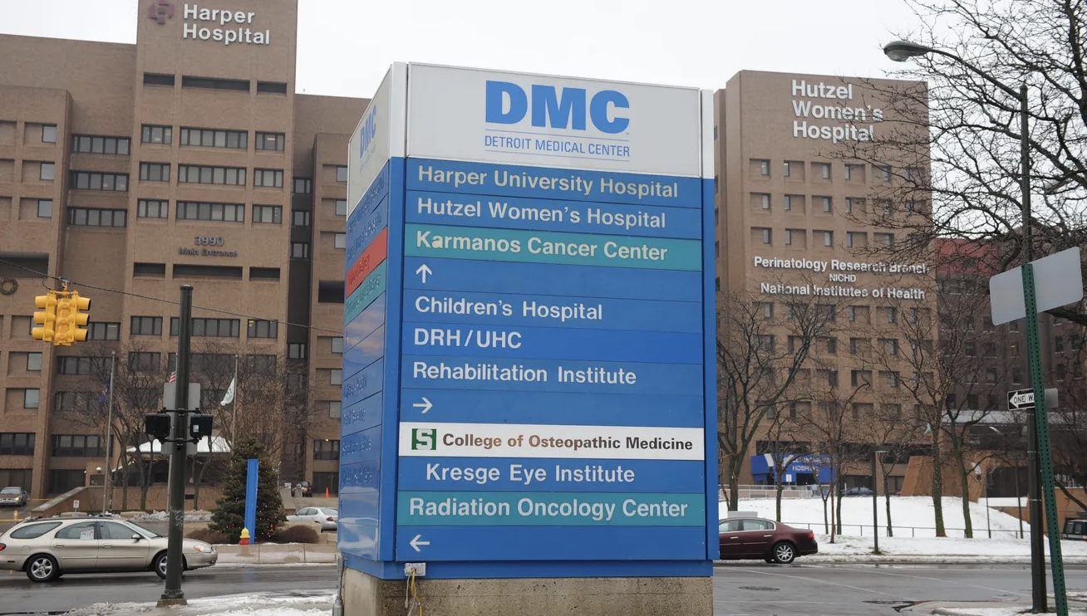

Detroit Medical Center, the hospital that faith had her scoliosis surgery.

Faith Degrand after scoliosis surgery in 2010.

References

The Detroit News
https://www.detroitnews.com/story/news/local/detroit-city/2018/07/02/17-year-old-girl-wins-135-million-lawsuit-malpractice-case/753275002/

Kreisman Law Offices: Medical Malpractice Lawyers
https://www.robertkreisman.com/medical-malpractice-lawyer/135-million-jury-verdict-for-failure-to-diagnose-treat-postoperative-problem-permanent-quadriplegia/

Only One Fieger Law
https://www.fiegerlaw.com/fieger-law-news/wayne-county-jury-awards-135-million-malpractice-verdict-against-dmc/

Vaaju
https://vaaju.com/dmc-ordered-to-pay-135m-to-girl-left-partially-paralyzed-after-surgery-story/

ShareCare
https://www.sharecare.com/doctor/dr-eric-t-jones

MedMalFirm.com
https://www.medmalfirm.com/news-and-updates/135-million-medical-malpractice-lawsuit/

West Virginia Record
https://wvrecord.com/stories/510590872-suit-says-doctor-performed-unnecessary-operation

Disease of the Week

Mayo Clinic
https://www.mayoclinic.org/diseases-conditions/scoliosis/symptoms-causes/syc-20350716

WebMD
https://www.webmd.com/back-pain/causes-scoliosis

