EP 32: Christmas Conundrums

Description

In the spirit of the holiday season, we discuss two unfortunate malpractices cases that occurred on Christmas Eve and Christmas Day. The story of Tom Buckley's misdiagnosed stroke in 2001 and Emma Mejias's wrongful death in 2004 will have us all wondering how such well-trained medical professionals continuously miss the mark, resulting in such severe damages that are anything but jolly.

Pictures

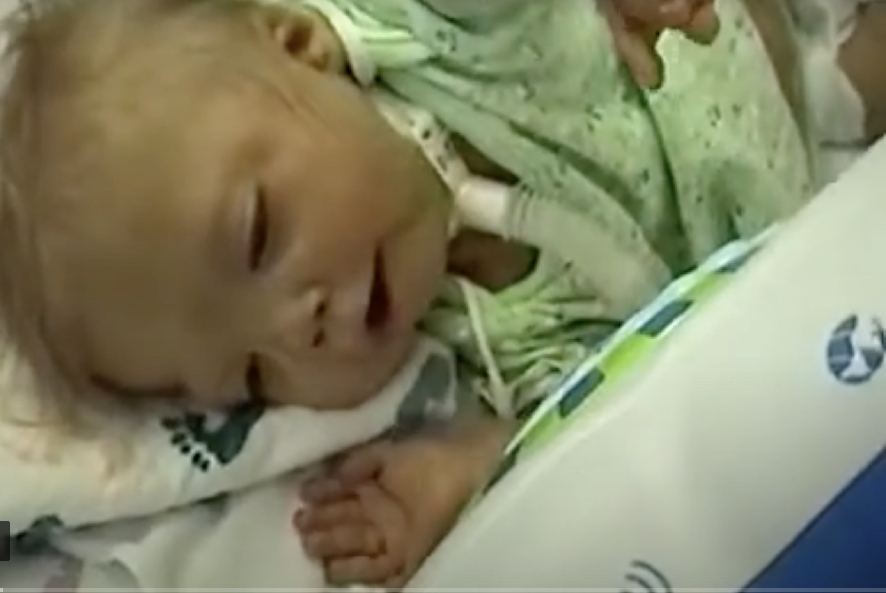

Emma Mejias before her death in 2004.
Lisa and Jim Koehne holding picture of their late son, Alex Koehne.

References

Buckley Case:

New York Injury Case Blog
https://www.newyorkinjurycasesblog.com/2014/01/articles/brain-injuries/appeals-court-slashes-awards-in-medical-malpractice-case/

https://www.newyorkinjurycasesblog.com/files/2014/01/2d-Dept.-2013.pdf

Justia US Law
https://law.justia.com/cases/new-york/appellate-division-second-department/2013/2012-00640.html

Meijas Case:

Nelson & Hamons Attorneys at Law
https://www.nelsonhammons.com/emma-mejias-story/

Video Interview and Article: Insider Exclusive
https://insiderexclusive.com/the-truth-about-medical-malpractice-suits-the-emma-mejias-story/

Disease of the Week

Mayo Clinic
https://www.mayoclinic.org/diseases-conditions/glaucoma/symptoms-causes/syc-20372839

Healthline
https://www.healthline.com/health/glaucoma

WebMD
https://www.webmd.com/eye-health/glaucoma-eyes

Glaucoma Research Foundation
https://www.glaucoma.org

