EP 51: The Viral Anesthesiologist

Description

This week we cover the Brazilian anesthesiologist, Giovanni Quintella Bezerra, who went viral in July 2022 for sexually assaulting women while undergoing c-sections. In our discussion of his disturbing actions, we also learn that Bezerra's record of malpractice goes back further than just these assault cases.

Pictures

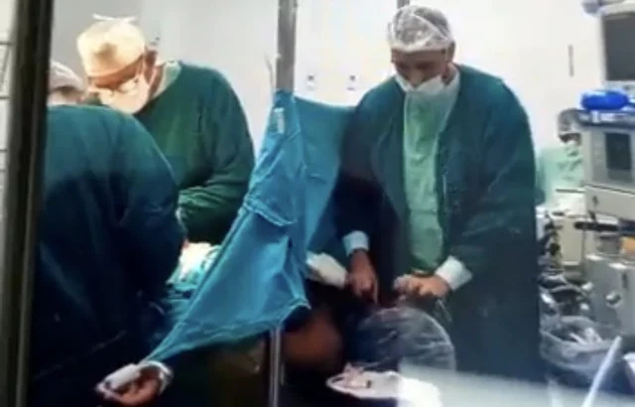
Screenshot of the footage of Bezerra amidst the assault.

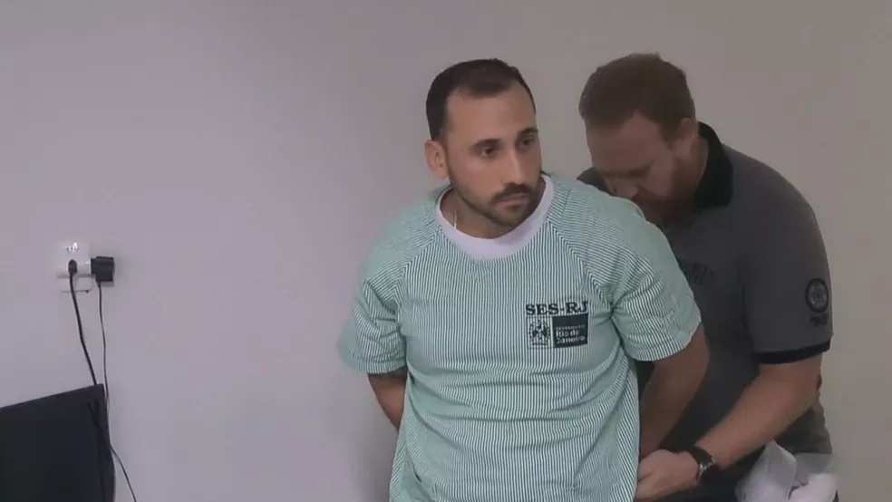
Bezerra getting arrested on July 10, 2022. Photo credit: GloboG1

References

*Explicit Content* Twitter Video of Assualt: https://twitter.com/mc_ibtimessg/status/1546782571240906753

Daily Mail
https://www.dailymail.co.uk/news/article-11008785/Brazilian-anaesthetist-investigated-raping-six-sedated-women-C-sections.html

Emily Cotton Top Blog
https://emilycottontop.com/32-y-old-dr-giovanni-quintella-bezerra-was-caught-on-camera-raping-a-pregnant-woman-during-a-c-section/

PubMed Journal Article - Labor Practices in Brazil
https://www.scielo.br/j/csc/a/c8q3b3jhmnqHQftKxfJQBrm/?format=pdf&lang=en

Globo G1 News Outlet - Rio De Janeiro
https://g1.globo.com/rj/rio-de-janeiro/noticia/2022/11/01/justica-nega-pedido-de-liberdade-para-anestesista-acusado-de-estuprar-mulher-durante-o-parto.ghtml

Episode 51 Transcript

Lillee Izadi 0:18
Hello, everyone, and welcome back to another episode of your favorite medical malpractice crime podcast, Ethical Side Effects. If you didn't already know or if you're new here, my name is Lillee, and I'm your host, joined by my favorite co-host, Mr. TJ here.

TJ McKay 0:36
Speaking of favorites, I should be your only co-host!

Lillee Izadi 0:40
Yeah, that's true...and that's what I meant! But to be fair, you don't know how I spend my free time, I could definitely be recording a many a different podcast with multiple co hosts, okay. It's like ethical side effects...but like, the after dark version or something...

TJ McKay 0:55
Coming from the person who can barely stay up past 10 o'clock, let alone talking about these episodes after dark. But that's another story for another time. So, what do you have in store for us today?

Lillee Izadi 1:08
You know what TJ, I have to agree with you. I'm also very excited to tell you about this case today. And this case, specifically is quite the crazy one. And I know I say that most episodes, but you know, this one, we had to mark as explicit because there's some crazy content in there. And it was actually sent to me a month ago or so by one of my best friends and loyal listeners, Mya, so shout out to her. Now, just another warning, some of the content on here is going to be explicit, which is why we marked our episode is that, but for those of you who are gonna stay tuned with us on this episode, this case was also viral on the internet. So you might have even heard of this before this case, and you know, know that we're gonna get into some graphic content.

TJ McKay 1:50
Yeah, I think I have a pretty good idea of what case you and Mya are referring to, I'm ready to explain all the reasons why this individual who performed this heinous act should never be allowed to practice medicine ever again and serve a lengthy prison sentence.

Lillee Izadi 2:06
Oh, yeah. But before we get started, I just wanted to remind all of our amazing listeners to check out our website, subscribe to our podcast and radio show whenever you can. It means a lot to have the support of all of you and we wouldn't be able to make episodes like these happen without you all. So thank you so much for joining us today. And I'm excited to get into this case.

TJ McKay 2:27
Yes, and also make sure to check out our online store if you guys want to shop for some awesome Ethical Side Effects merch.

Lillee Izadi 2:34
Thank you, TJ. And now that we're done with our shameless self promotion, let's get into this case, shall we, guys?

Okay, so this case might or might not be short, depending on the conversation that comes up. But it is quite a doozy nonetheless. And it's still actively ongoing, because it actually just hit the news this summer. And as we know, court systems take quite a while unfortunately. So we might not have all the latest updates in next coming months. But we'll definitely do a bonus episode as things unroll. But to give the details that are currently out right now, this disturbing case takes place in Rio de Janeiro, Brazil, at the Hospital de Mulher literally in July of the Lord's year 2022. And for all of our Brazilian listeners, I apologize if I'm not pronouncing that correctly. I feel like I said that more French than anything else. But we'll...we'll excuse that for right now. But how this case goes down according to the plethora of news articles I read TJ is that on July 10, a 32 year old anesthesiologist, Giovanni Quintella Bezerra, is arrested on accusations of raping a pregnant woman.

TJ McKay 3:50
Well, I'm gonna say that it's quite the introduction. Oh, my goodness, I know. But unfortunately, I'm simply speaking facts. These are exactly what the articles were saying. So please go explain how exactly this entire case went down a little more. Was this an isolated incident? Or was there multiple occurrences of this?

Lillee Izadi 4:11
Those are great questions, TJ. So it looks like there might be more than one rape accusation against him. But I'm only going to go into details about the one that was recorded. Now what he did do to this woman that was recorded could very well happen to the other victims that he was accused of doing this to in the same manner, but nobody can confirm that right now because the police are still investigating the other allegations, which we'll get into in just a second. And like I said, the other cases weren't recorded. But how the one that was recorded went down is that Bezerra apparently put his you know, male genitalia, into the mouth of a woman while she was under anesthesia for a C section. So this man literally raped this woman while she was giving birth. And the video of this happening goes on for like 10 minutes.

TJ McKay 5:02
That is literally sick. And honestly, I am left with even more questions than I started with. So sorry if I'm ahead of myself. But why was he being recorded in the first place? And did nobody noticed until the video was put out there for the public to see.

Lillee Izadi 5:17
So the news articles say that nurses actually sent their phone up on one of the cabinets in the operating room to catch him in the act because they had their suspicions that something weird was going on. Now, I guess you could say, luckily, it wasn't Bezerra himself, recording himself like a weirdo. But the unfortunate part of this is that the nurses did this because he suspected other people were being subjected to this assault or in general, something weird. And the news articles I read, don't pinpoint the exact reason for setting this up. But some concerns that were expressed by the nurses that set this video up and that led to them thinking that something was going on, is that one visitor would not allow the victim's male partner into the room during the C section, which at least in the US is generally allowed. I know in Brazil, C sections are performed at a much higher rate than natural births and companions in the delivery room have increased since there were some policy changes made around 2010 In Brazil, but I don't know how common it is for an anesthesiologist to not allow a companion in the room there. But it was cited as a concern. So I guess it was abnormal to the nurses given the circumstances of these cases. Additionally, they noticed that the women he gave anesthesia to appear to be way too medicated than normal when trying to be awaken. And apparently, when they tried to wake the woman up after the C section, they were either barely conscious or unable to even hold their babies right? Again, once the C section was over, which they said was unusual when working with other anesthesiologist and other cases. Overall, though, I'm right there with you, TJ because I'm really surprised that nobody doing the operation. Notice that this was going on in the moment it was happening. I know that they usually put a curtain between the operating site and the person's face. So they don't wake up and become alarmed or traumatized by what they see. But I just find it a little unbelievable that this guy was able to be so discreet. You know about doing this to these pregnant women.

TJ McKay 7:40
I completely agree Lillee, the nurses must have had really strong suspicions to put their job in jeopardy, because I'm not quite sure what the confidentiality laws are in Brazil when it comes to medical professionals. But setting up a camera in operation room without the patient consent can result in some major consequences for you know, healthcare workers. So, you know, they must have thought that catching Bezerra doing this heinous act would have outweighed the potential consequences that they could endure.

Lillee Izadi 8:15
Yeah, exactly TJ and I'm glad you brought that up, because I don't think I've really connected the dots like that, like, you know, with confidentiality and stuff. I'm not too well versed in what would happen in America if you set up a video camera of an unidentified patient or something like that in the operating room, but I'm sure that that's probably not 100% with protocol in the operating room. So I think that what you said is really important for people to understand that people might have put their jobs on the line just to touch somebody and that in and of itself is important. And going a little bit deeper on that point, TJ. I found out in addition to these rape allegations against him that doctor Becerra also has a medical malpractice case at another hospital. In his record from before he even became certified to do anesthesiology. And this took place in 2018 when Bezerra and another doctor were accused of severely misdiagnosing a woman with swine flu is merely having a urinary tract infection, causing the woman in question to fall into a 23 day coma. And during the coma, the patient lost her big toe sustained severe injuries to her Achilles tendon and lost a large amount of her hair.

TJ McKay 9:31
By no means am I a healthcare professional, any sense of the word okay. But I am very sure having a UTI and swine flu is very different. I don't even know how much of those symptoms will overlap with one another.

Lillee Izadi 9:46
Oh my goodness, TJ, that is exactly the same thing. I was thinking when I read this case. And when I did read this case, I thought for sure that there would be a better explanation for this mistake, you know, but when I looked into that case, again, I was just left with more questions and answers. So apparently the patient question had arrived at the hospital Bezerra was working at at the time with delusions, chills, difficulty breathing, shortness of breath, coughing and dizziness. She was then told by the first physician she saw, which was not Bezerra by the way, that she was suffering from a UTI. So she first went to this one physician who diagnosed her with that UTI infection initially, and they gave her antibiotics for that UTI, which, I mean, okay, if the UTI I guess, you know, like travels to places like the ureters, or the kidneys, I'm sure you would have been in some serious pain having some serious fever and issues. But I don't know about the coughing part. Like I don't think that sounds right. And on cue with a UTI, like I think even if she did have a UTI, I would be prompted to see if anything else was going on simultaneously.

TJ McKay 11:02
Oh yeah, I completely agree with you, Lillee. And I feel as if the ball was dropped in the process of diagnosing the patient. But what does the Bezerra exactly come into this specific case, though?

Lillee Izadi 11:12
Great segue, TJ. Because, first again, this physician misdiagnosis this woman, and this poor woman symptoms worsen, because of course, that wasn't what was wrong with her entirely. And she comes back in for help. Bezerra then sees her as her second physician and just confirms the previous diagnosis. And I don't even know if he did any additional test. I believe he didn't, because it wasn't really outlined in any other medical articles about this. And as a result, he chalks her condition up to just being melodramatic or overreactive...and that's why her symptoms were becoming worse. It wasn't because she was actually really that sick, apparently. And keep in mind when I was reading about it, this woman was literally suffering from what was severe headaches, back pain, was coughing up blood, and had intense shortness of breath and lung pain when she was seen by Bezerra, at that point.

TJ McKay 12:09
Honestly, in my opinion, this would just be summed up as a lack of compassion for his patient. I don't know exactly how you see this Lillee, but I feel as if Dr. Preserve probably knew he could have done more for his patient, but just didn't go the extra mile for her.

Lillee Izadi 12:28
Oh, yeah, I completely agree with you. It is completely not compassionate. I couldn't imagine going to a doctor and then chalking all of my symptoms up to just being over reactive. Like, I'm sitting here coughing up blood, and you're looking at me, like I'm just faking it, like how does that make absolutely any sense? And to get into more details about her case, and how it unfolds, she literally got passed around to not only a third doctor, but a fourth doctor as well. And at the fourth doctor, finally, they discovered that she had pneumonia caused by the swine flu....pneumonia guys...and literally 25% lung function at that point. And like I said before, by the time they did find this out, she also had severe blood clotting that they had to put her in a coma for in order to remove. So they put her in a medically induced coma gas. And I really can't make this up guys, like for real, it's just a complete shame.

TJ McKay 13:24
What happened to her is a complete shame that she had to go through so much to be taken seriously by her physicians.

Lillee Izadi 13:32
I know. And the treatment of women by certain health care providers is a whole other crazy and disappointing topic for unfortunately another day, but it is definitely a shame like you and I said and TJ. And by the way, it looks like this medical malpractice case is also still in its early phases as well, because again, this case didn't happen too far before he was actually certified in anesthesiology. So all of this kind of came at once is when I'm guessing which huge red flags to me. So, overall, Bezerra has a lot ahead of him legally. And rightfully so, in my opinion, because as a physician who is normally certified, this many patients having issues with you, again is a huge problem.

TJ McKay 14:16
For sure. So I must ask, what is the status now for the man of the hour?

Lillee Izadi 14:23
So as of right now, Bezerra is actually being held in a maximum security jail indefinitely while these investigations are taking place. And of course, if we get any updates on him or his cases, we will definitely have another bonus episode to keep you guys fresh on the beat. And honestly, I myself am very intrigued to see how this case unfolds. I have heard from just general, you know, popular news outlets over there that everybody's like booing him, nobody really likes him and even the people in jail are kind of targeting him. I also heard in like certain interviews that he was like, oh, "You guys haven't seen the last of me", like all this other weird narcissistic stuff. So honestly, I don't feel bad for him whatsoever. And I don't think this is a case where he has been wrongly accused because he has shown no remorse for the people that he has harmed.

TJ McKay 15:14
So, yes, so in the future, I will be looking forward to see more updates and details coming out about this specific case and maybe hear some from the victims that actually were being treated by Dr. Bezerra, because honestly, before hearing this case, I have never heard of, I mean, I know it existed, but I just never heard of a case where a physician was basically sexually assaulting his own patients in the operation rooms, which is just truly hard to fathom.

Lillee Izadi 15:47
I'm right there with you, TJ. I think it would be very interesting to hear from these victims, and I'm excited to keep you guys posted. Hopefully these updates won't be coming out too late. But anyway, that is all I have for you guys this week. Please if you have any ideas for a case go on our site and fill out the "Suggest A Case" form and we will be here for you guys in the next couple of weeks to give you a brand new episode. Have a great day guys, bye!

