Episode 15: The Growth Study Stash - Case File

Pictures:

George Reardon listening to the complaint brought forth by the Medical Association in 1993.
(Picture by Michael McAndrews)

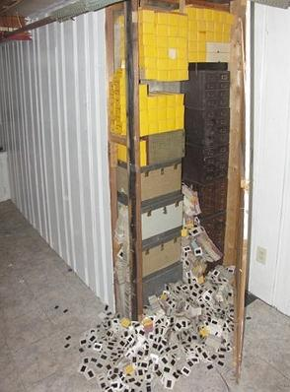
Picture of child pornography slides and videos found in the basement of Dr. Reardon's previous home in 2007.

Episode References:

https://newyork.cbslocal.com/2011/05/09/connecticuts-st-francis-hospital-settles-abuse-lawsuits-involving-dr-george-reardon/

https://www.tremontsheldon.com/news-and-results/timeline-dr-george-reardon-case/

https://www.cbsnews.com/news/hospital-sued-over-sex-abuse-claims/

https://www.ctemploymentlawblog.com/2007/12/articles/st-francis-hospitalgeorge-reardon-employers-at-risk-based-on-actions-of-former-employees-even-from-decades-past/

https://www.seattletimes.com/nation-world/trials-to-start-over-prolific-child-abuser-pediatrician/

https://www.nbcconnecticut.com/news/local/victim-shares-details-of-abuse-by-reardon/1873277/

https://www.tremontsheldon.com/news-and-results/statute-of-limitations-on-lawsuits-could-change-for-reardon-victims/

https://www.bishop-accountability.org/news2007/11_12/2007_11_29_Jones_ACache.htm

Disease of the Week Info: Psoriasis

https://www.mayoclinic.org/diseases-conditions/psoriasis/symptoms-causes/syc-20355840#:~:text=Psoriasis%20is%20a%20skin%20disease,while%20or%20going%20into%20remission.

https://www.psoriasis.org/about-psoriasis/

https://www.webmd.com/skin-problems-and-treatments/psoriasis/understanding-psoriasis-basics

https://www.healthline.com/health/psoriasis/get-involved-national-psoriasis-awareness-month#takeaway

