EP 28: Major Misdiagnosis

Description

Allan Navarro walks into the University Community Hospital Carrollwood emergency room while having a stroke but left 5 and a half hours later with nothing but a sinusitis diagnosis, antibiotics, and Vicodin. When Allan is left permanently disabled from stroke-induced brain swelling the next day, everyone is left wondering how a stroke is so terribly misdiagnosed. However, we learn in this episode that the answer to this may just leave room for more questions...

Pictures

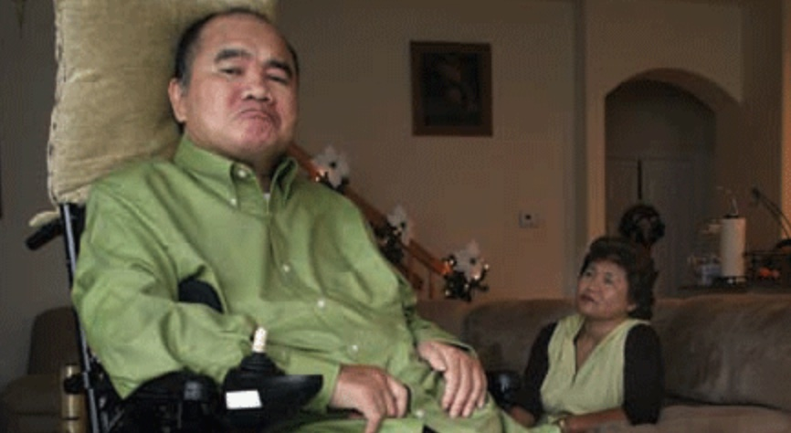

Allan Navarro's attorney, Steve Yerrid *Picture Credit by Hugh Williams*

Allan Navarro after the malpractice incident, with his Marilyn. *Picture Credit by Hugh Williams*
his Marilyn. *Picture Credit by Hugh Williams*after the malpractice incident, with his Marilyn. *Picture Credit by Hugh William

References

LAWDRAGRON
https://www.lawdragon.com/news-features/2007-02-15-the-verdict

The Yerrid Law Firm, P.A.
http://yerridlaw.com/medical-malpractice/friday-a-jury-awarded-allan-navarro-and-his-family-116-7-million/

Thomson Reuters WestLaw
https://content.next.westlaw.com/Document/I264c3cc174fd11db9fe4ff3704b32c13/View/FullText.html?contextData=(sc.Default)&transitionType=Default&firstPage=true

The Wall Street Journal
https://www.wsj.com/articles/BL-LB-2501

MoreLaw
https://www.morelaw.com/verdicts/case.asp?n=Unknown10/4/2006&s=FL&d=32025

Tampa Bay Times
https://www.tampabay.com/archive/2006/10/04/friday-a-jury-awarded-allan-navarro-and-his-family-116-7-million-for-the-pain-and-loss-of-his-crippling-misdiagnosed-stroke-tuesday-came-the-verdict-to-punish-the-doctors-100100000/

Mayo Clinic
https://www.mayoclinic.org/diseases-conditions/stroke/symptoms-causes/syc-20350113

Centers for Disease Control and Prevention
https://www.cdc.gov/antibiotic-use/sinus-infection.html

CHRON by Legacy
https://www.legacy.com/us/obituaries/houstonchronicle/name/mark-herranz-obituary?pid=17517266

Disease of the Week

Johns Hopkins Medicine
https://www.hopkinsmedicine.org/health/conditions-and-diseases/chronic-bronchitis

WebMD
https://www.webmd.com/lung/copd/copd-chronic-bronchitis

Centers for Disease Control and Prevention
https://www.cdc.gov/copd/index.html

