Episode 1: Spontaneous Combustion

Catherine Reuter Before Surgical Fire

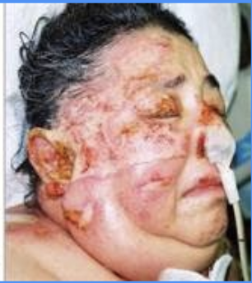
Catherine Reuter After Surgical Fire (December 2002)

Episode Resources Links:

https://pharmpsych.com/2014/10/08/surgical-burn-death-of-elderly-woman-spawns-daughters-safety-website-medical-reforms/

https://www.nbcnews.com/health/health-news/fire-or-hundreds-are-hurt-every-year-flna1C9458911

https://vwpwlaw.com/insights/surgical-fires-operating-room#:~:text=Yet%2C%20it%20has%20been%20estimated,reporting%20requirement%20for%20surgical%20fires.

https://www.patrickmalonelaw.com/malpractice-a-z/burns-operating-room/

https://www.facebook.com/SurgicalFireorg-255712727824771/

HIB disease:

https://www.ecdc.europa.eu/en/invasive-haemophilus-influenzae-disease/facts

https://www.cdc.gov/hi-disease/about/index.html

https://www.who.int/immunization/diseases/hib/en/

