EP 36: The Tuskegee Syphilis Experiment

Description

In observance of Black History Month, we want to share the infamous case of the Tuskegee Syphilis Experiment. In this episode, we discuss why it happened, what happened in the trials, how it managed to go on for so long, and what the lasting impact was for many minority groups in the U.S. in terms of physician trust and seeking medical services.

Pictures
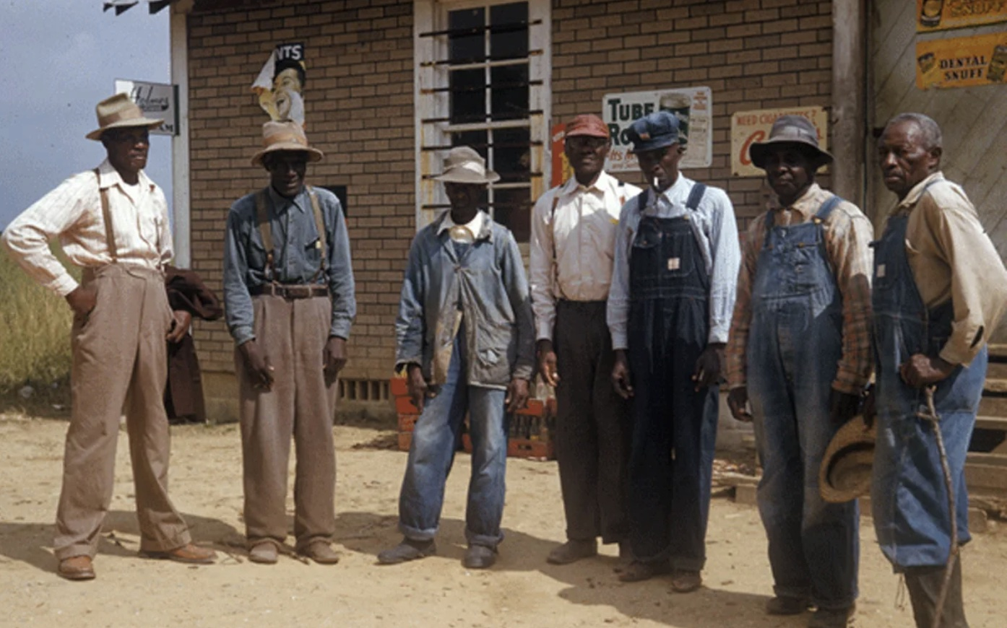
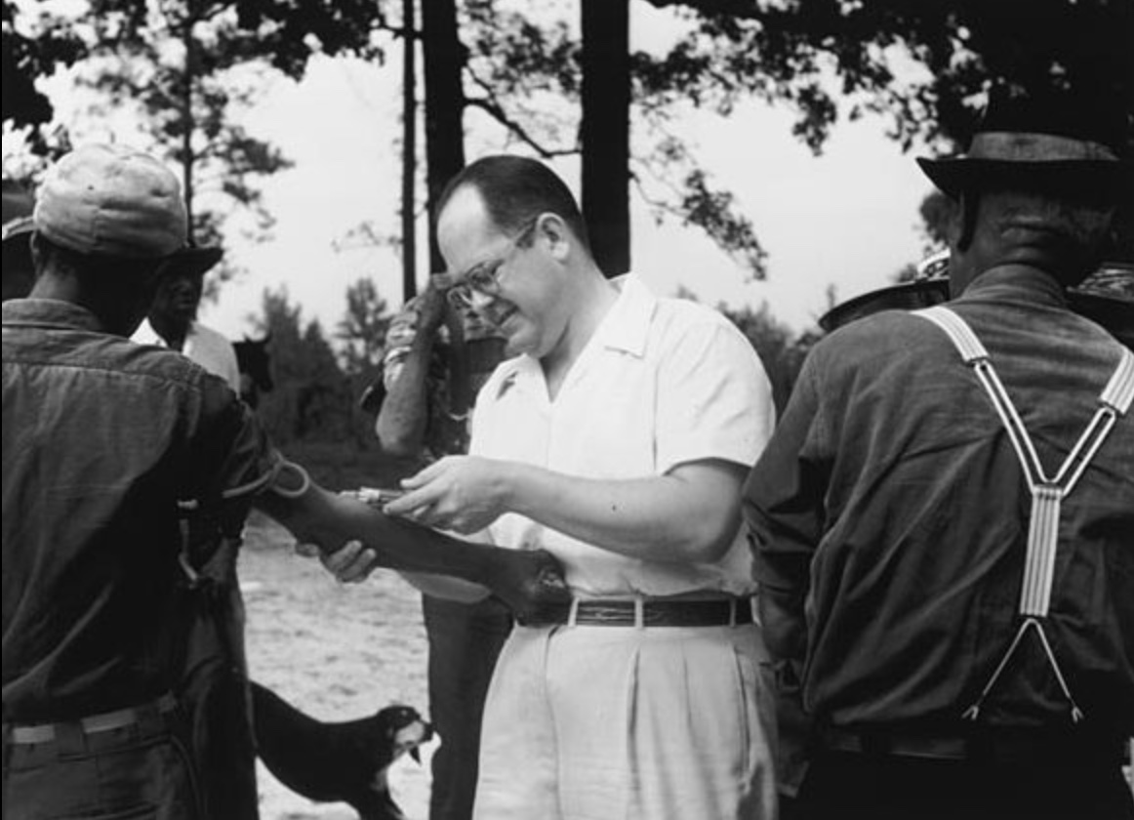

National Archives Photo of a Few of the Tuskegee Syphilis Experiment Participants.
Investigator in the Tuskegee Syphilis Experiment Drawing Blood from Participants in 1953.

References

National lack Leadership Commission of Health, Inc
https://nblch.org/

Tuskegee University
https://www.tuskegee.edu/about-us/centers-of-excellence/bioethics-center/about-the-usphs-syphilis-study

History.com
https://www.history.com/news/the-infamous-40-year-tuskegee-study

Wikipedia
https://en.wikipedia.org/wiki/United_States_Public_Health_Service

McGill
https://www.mcgill.ca/oss/article/history/40-years-human-experimentation-america-tuskegee-study

Disease of the Week

Mayo Clinic
https://www.mayoclinic.org/diseases-conditions/syphilis/symptoms-causes/syc-20351756

WebMD
https://www.webmd.com/sexual-conditions/syphilis#1

MedlinePlus
https://medlineplus.gov/syphilis.html

Center for Disease Control and Prevention
https://www.cdc.gov/std/syphilis/stdfact-syphilis.htm

Episode Transcript:

Lillee Izadi 0:06
Do you have a great podcast idea and don't know where to start? Well, TJ and I were in the exact same boat when we first started. And honestly, it can be very overwhelming. But that's exactly where Buzzsprout comes in. The truth is, podcasting isn't hard when you have the right partners, and the team at Buzzsprout is extremely passionate about helping new podcasters succeed. Not only is their hosting platform extremely easy to use, but they also have free how to video guides for podcasters to get started, equipment recommendations, fantastic listener analytics, and they help you get your show listed on every major platform. Personally, we were shocked with just how easy bus sprout made podcasting, and we highly recommend it to anyone wanting to start their very own show. So if you want to start a podcast, what are you waiting for? Check out the link in our episode show notes below. So Buzzsprout knows that we sent you and join the over 100,000 podcasters already using Buzzsprout to get their message out to the world. Better yet. If you sign up for a paid plan using our link. You can even get a $20 amazon gift card plus route, the easiest way to start a podcast?

Hey guys, and welcome back to ethical side effects. I'm your host Lillee joined by my wonderful co host, Mr. TJ here.

TJ Mckay 1:58
Hello everyone.

Lillee Izadi 2:01
Now, before we get started, how are you doing today? TJ?

TJ Mckay 2:05
I am doing pretty fantastic. How about you Lillee?

Lillee Izadi 2:09
I am doing exceptionally well, thank you for asking. And personally, I'm extremely excited to get into our case for today, especially because it is a little more of a well known case in American history. And it matches up really well with our monthly observance of Black History Month. And speaking of which, in honor of Black History Month, all donations from now until March 1 from our wonderful listeners to this podcast will be going to a healthcare based nonprofit organization called Black Health whose focus is on decreasing the racial based health disparities that are unfortunately present in various diseases, including but definitely not limited to HIV AIDS, hepatitis C, diabetes, mental illness, and even the very own COVID-19. If you want to learn more about the Black Health Organization initiative, as well as check out some other black focused nonprofits. Or if you want to learn more about Black History Month in general, all you have to do is go to our Black History Month page on our website under the support the cost section. And to donate, all you have to do is go to the bottom of our episode description, and click on the Support show link. And we will also have the option to donate on the very front page of our website as well. And lastly, if you haven't already done so, make sure you get involved with ethical side effects by subscribing to our podcast wherever you're listening, so you never have to miss an episode. We also have our monthly newsletter, red bubble merchandise case file extras on our website, and who could forget our very own suggest a case form for those who are eager for us to cover a malpractice story that we have yet to stumble upon quite yet. With all that said, TJ, are you as pumped as I am to get started on a new case today?

TJ Mckay 4:01
Yes, I'm definitely excited because it's black history month. So I know you guys something fabulous in store for us today.

Lillee Izadi 4:10
Yes, I do. So let's get into it. So this week, we are covering the infamous Tuskegee syphilis experiment, formerly known as the quote to ski study of untreated syphilis in the negro male. And I'm sure many of our listeners today know at least a little bit about the unethical human experimentation that took place in this study over a period of four whole decades. But for those who aren't quite familiar with this study, or who want to know more details about the case, this will be a great episode for you. So the Tuskegee syphilis trials start in 1932 in Macon County, Alabama, otherwise known as The Black Belt region at this point in time, because the number of black individuals involved in sharecropping was fairly high. And sharecropping was basically where people would live as tenants on farmland and give up a portion of their grown crops to kind of like a landlord as a form of rent. Now, the reason for it being called the Tuskegee study, though, was because the research itself took place at the Tuskegee Institute, now known as Tuskegee University, by individuals from the US Public Health Service. And the purpose of this study was to overall record the natural progression of syphilis as a disease, specifically in black individuals. Now, you guys may be asking yourself, why did these researchers use black individuals? And why syphilis? Right? And to understand the answer to both these questions, I think it's significant understand a brief recent history of America up until 1932, both racially and medically. So are you ready to have your notebook out? TJ, take some notes.

TJ Mckay 6:07
Oh, I'm way ahead of you.

Lillee Izadi 6:10
So as we are all likely aware of the formal end of indentured servitude came in the late 1800s. With the passing of the infamous 13th amendment. Of course, we still have very real versions of modern slavery still going on to this day. But anyway, that's a huge rant by me for another day. Now, unfortunately, even after Black individuals were, quote, freed from the servitude, they weren't really right. Because there were so many racist ideas being thrown around everywhere, especially in Alabama at this time, and you cannot make racist beliefs illegal, right? You can make discrimination illegal, which at this point, it kind of wasn't. But this is America. And if somebody doesn't like me, because of something, they are rightfully entitled to that belief. And so there were many negative beliefs associated with black people at this time. And very biased science and medicine was definitely not helping the social Darwinism being applied to the black race. And what I mean by this is that black individuals were still thought to be, quote, inferior to white individuals, both intellectually and in other aspects of health, unfortunately, and you guys might think I'm being a little bit overdramatic. But if you read, sort of like the pseudoscience of the time, you will see that many scientists who are deemed to be credible, publicly wrote and spoke about how black individuals were less intelligent biologically, and that their nervous systems were more evolutionarily primitive to that of white people. Which is, by the way, exactly where this false notion of black people not feeling pain at the same level of white people comes from many people in science and medicine, also held the false belief that black people were actually only fit for slave labor, due to their physical strength and this quote, unquote, low intelligence. And not only this, but scientists also spread the fake belief that black genitalia was actually overdeveloped, and that their sexual desires were also more than that of white people. And this, unfortunately, is exactly why scientists in the realm of venereal diseases, were all too quick to make black individuals the ideal candidates for the syphilis study. Why? Because one they were deemed to be, shall I say, too simple minded to know about the details of their study, to black people at that time, due to this fake science, we're deemed to be more likely to get syphilis and other STDs due to this overdeveloped sexual desire. And three, oh, yeah, black people don't really experience pain like us white people. So even if syphilis progression hurts, they won't feel in any way. Right?

TJ Mckay 9:14
So amazing. So according to the scientists back in around the early 1900s, I could contract syphilis. And I would have been completely fine because I wouldn't be able to feel pain.

Lillee Izadi 9:27
Basically, I don't know what to tell you. It is completely outright ridiculous and crazy. And we will see a lot of different film adaptations of these types of things. Like I remember I think, in the movie Django or something, they even talk about how like the phonology of a black man is built for slavery. And phonology is basically the number of bumps or the placement of bumps on the skull, which has no real scientific backing, but it just shows you how different The science was back then. And even to recent times how fake science can be when too much researcher bias is put in and influence and tainted by social beliefs that are of no value in terms of objectivity. So, I noticed some people listening right now, the idea of some wacko scientist saying really racist stuff sounds crazy ridiculous. And they think that this would never fly in our society now. But I just want to say, one, articles by the American Association of Medical Colleges in 2020 report that in recent studies leading up to 2020 40% of first and second year students in medical school still think that black individuals have thicker skin and therefore a greater pain tolerance. And two, in terms of non racist news, like bring your attention to Andrew Wakefield study on vaccines, and autism back in 1998. That study was based on almost no real science and was retracted 12 years ago for being completely false. And people still to this day believe that vaccines cause autism. Like I've been in doctors offices working or shadowing, and patients straight up ask their doctor that question. So the lasting impact of terrible bad and bioscience is absolutely ugly and horrific. So I'm not shocked honestly.

TJ Mckay 11:30
Yeah, I will never forgive Andrew Wakefield, because ever since he published that false research paper, people are still abiding by that fake research. It has been exposed as being manipulated in a way to where Wakefield made it seem as if vaccines do cause autism, even though this is completely not true, however, is disturbing. And I, I think we'll never be able to as a society get past it, because people will continue to hold on to that belief.

Lillee Izadi 12:09
Yes, this is a very real fear phenomenon being experienced in our current society is just a huge shock wave. And again, this goes back centuries. And unfortunately, Andrew Wakefield was like the skimming of a very large iceberg. That was people being skeptical about vaccines. I mean, even in the Louis Pasteur time where vaccines were very first introduced, like with Edward Jenner, and Louie Pastore. And this just in recent times made it the cherry on top. So again, very lasting impacts. We will be having this vaccine debate for centuries to come if humans are still in a live race on Earth at that point, but we could talk about this all day, unfortunately, and maybe we'll have to in another episode, but getting back to the syphilis study, you may also be asking yourselves, why was syphilis studied like we are very familiar with syphilis as a bacterial disease at this point. But back then, although syphilis was still very prominent, at that time, it had no effective treatment other than things like heavy metals, such as mercury to kind of curb the symptoms. And antimicrobial agents were discovered by Alexander Fleming just like four years before the study started. So they weren't really mass produced massively use. I mean, this was just like in its very primitive stages of even being used as a medical treatment. So they had no idea that antibiotics were even going to be a thing, despite how much we know and love them today. Additionally, no one really knew how long people could last with syphilis at this point in time. And they didn't really know what its entire course or progression was. So with that, the US Public Health Service recruited 600 black males 399 with syphilis, and 201 without syphilis. And I just want to take this time to clear up kind of a common misconception that people tend to have about this study, which is that these researchers did not give the syphilis to the participants, these participants already had syphilis when they started at least the experimental group. Now, there were still people without syphilis at this time that they were kind of using as a control group. And luckily, the giving of syphilis to people like what we talked about in let's say, unit 731 are in like really bad medical experimentation cases. Luckily, the researchers did not give these participants syphilis in any way, shape, or form. So this was not the ethical issue, really with this study. But one of the real ethical issues that arose with the study was the fact that they did not receive informed consent technically from the participants before starting the study. The researchers just kind of told them that they were pretty responding in a study to be treated for, quote, bad blood. And of course, that's an extremely vague statement. But overall, this term was used locally to refer to a host of health problems, including, but not limited to things like anemia, fatigue, and syphilis itself. Now, just like in any study, the participants did receive some compensation in the form of free medical exams, free meals, transportation, the clinics, and burial insurance. And some of that was really big. Because might I point out that many of the men in this study were very poor, and illiterate, and have never seen a doctor before, nor did they ever receive proper quality medical care. And their education was prohibited due to institutional racism and discrimination put in place. And some of our listeners may be thinking, well, they were told that they would be part of the study, and technically they agree to it. And they were also receiving compensation. So how is this not consensual? Right? Well, this idea of informed consent has been debated for a very long time by ethicist and philosophers much like other things in medical ethics. But informed consent can overall as you can imagine, be a little bit more complicated than that. Because in order to have true informed consent, the person involved needs to have a certain decision making capacity, there also needs to be documentation of that consent. And there needs to be a disclosure of all the risk and general purposes of the study. And there needs to be some level of competency demonstrated by that participant who is consenting to be involved in a study. So not only was major information from the study, not disclosed. But I think another argument that can be made TJ is whether or not these individuals are actually competent enough to even give their informed consent in the first place, given their social circumstances. Because I think at any point in time, this could easily become coercion on the part of the researcher. Does that make sense?

TJ Mckay 17:15
I completely agree. Because in order to be content not to consent to the study, participants should be aware of where they're being involved. And so that's false on the part of the researchers to inform the participants with the rest of the studies are and exactly what the study is for, which they weren't clear with in the beginning about. And secondly, like you had mentioned before, these individuals had never had medical examinations performed on them before. So going in, they probably don't even know what to expect. And so this whole process is new to them. So really, they're learning this whole process as they go through it.

Lillee Izadi 17:59
Yeah. And that can cause a big problem in terms of being informed of this study. Because if you don't really know what you're expecting, nobody outlines the risk that you face not being treated for syphilis, let's say. And you are kept this knowledge overall of what the study is even for that you won't be given a treatment for syphilis whatsoever. It kind of blurs the line between ethical research and non ethical research, despite them getting the permission of these participants to do this study. And another huge problem with this study is that once the antibiotic penicillin was finally out on the market and determined to be a cure for syphilis, around 1947, so about 15 years after the study started, the researchers and physicians in the study did not give the patients this medication strictly so that they could continue monitoring them with syphilis in the study. So they basically withheld treatment for their own benefit. And as a result of this, many of the men in the study, as well as their wives and children started to die from syphilis infection. And again, this study went on for decades, until Pierre Buxton stepped into the picture in the mid 1960s. And Buxton was a public health service venereal disease investigator in San Francisco, who had finally learned about this study from a co worker, and he then decided to go to his superiors and talk to them about this study, and express his concerns about how it could be unethical. And you know, what the response of the superior was TJ.

TJ Mckay 19:38
The researchers probably claimed that the study being conducted was for the betterment of society so they could know how if individual D contract syphilis, what type of side effects they would experience and also how the disease will progress over time.

Lillee Izadi 19:59
So honestly, That's exactly what happened. The officials formed a committee to review the study. But they ultimately went with the more utilitarian approach, shall I say, and they opted to continue the study for the betterment of society, I guess. And they wanted to continue tracking patients for this reason until they had died so that they could perform autopsies on them, and collect all the data that was currently being done so that basically the research wouldn't go to waste, I guess, which I believe is completely terrible. But what can you do?

TJ Mckay 20:31
Yes, I feel like that's the part that doesn't sit well with many people who have you heard of this case before? Because basically, these individuals were treated like lab rats. And rather than being prescribed medication to treat their symptoms, they were allowed to suffer even longer, just so that researchers could observe the progression of the infection.

Lillee Izadi 20:57
Exactly. And luckily, Buxton did not take this for an answer, and decided to leak the story to a reporter friend at the Associated Press named Jean Heller, who wrote an expo ze on this study and released it in July 1972. And when this came out, many, many people were rightfully outraged from the experiment. And the backlash was so bad that the Assistant Secretary for Health and Scientific Affairs, appointed an ad hoc advisory panel comprised of nine different members from various fields, including health, admin, medicine, law, religion, education, and a few others to review the study and its ethical nature. But by that time, 28 participants had already died from syphilis, and 100, more had passed away from syphilis related complications. And at least 40 spouses from the individuals with syphilis had been diagnosed with syphilis, and had passed it to 19 children total at birth. So unfortunately, a lot of damage was done that cannot be reversed at that point.

TJ Mckay 22:15
Yeah, this was just completely a mess. And it was very unfortunate that so many people had to sacrifice their lives in order for I guess you can say the betterment of society.

Lillee Izadi 22:28
Yeah, for sure. It's quite disappointing. And the panel that was gotten together, this ad hoc advisory board eventually came to the conclusion that although the men participated in the study freely, and agreed to the examinations and treatments, they also thought that their safety and well being was not ensured throughout the study, like a regular scientific study should, nor were they told about or offered true informed consent, again, not really following those guidelines. The panel also concluded that there were no choices given to the participants to quit the study when penicillin became available as a treatment and cure for syphilis, which in my opinion, is a huge deal because consent is always transient in research studies, and honestly, in real life, too. This consent can be taken away at any point in time and participants should not be withheld information to stay in any research, study, nor force sustain any research study against their will. And with all of this taken into account, they presented their conclusions publicly in October 1972. And in November 1972, the study was officially ended by the Assistant Secretary for Health and Scientific Affairs. but spoiler alert, this was not the end of it, nor should it be, because these participants and their families deserve justice, you know. So in the summer of 1973, Attorney Fred Gray filed a class action lawsuit on behalf of the men involved in the study their wives, children and families. And the lawsuit luckily ended in a settlement giving more than $9 million to study participants. The US government also promised to provide a range of free services to the survivors of the study their wives, widows, and their children. All living participants became immediately entitled to free medical Imperial services. And the services were provided by the Tuskegee Health Benefit Program, which was and continues to be given by the Centers for Disease Control and Prevention in their national center for HIV, STD and TB prevention. And even more importantly, new guidelines were issued to protect human subjects in US government funded research projects in hopes that this horrific type of thing never happens again.

TJ Mckay 24:56
Thank goodness, I couldn't imagine ethical cases. like this ever happening again.

Lillee Izadi 25:02
Exactly, I'm right there with you. But I need to say that all the money in the world cannot and will not win back the trust of an entire community, who will likely for decades to come still fear getting medical services and vaccines. And personally, TJ, I don't know if there will ever be the same type of trust between the majority of black patients and their physicians in my lifetime, because of the actions of these researchers and physicians and many others like them. And I don't think it helps at all that there is such a low percentage of black physicians in America. And I'm really hoping that we as current and future medical professionals can just do better. And I really hope any and all training current and future medical professionals listening to this can make it their mission to not just be aware of what has happened throughout history, but know why it has happened and work actively to not allow it to keep happening. When we do see it rears its ugly head even remotely.

TJ Mckay 26:06
And I strongly agree with you. Many people from the black community, distrust their medical professional, largely from Tuskegee syphilis test. I think it's very important that we move forward in a way where medical professionals tries to gain that trust back from people not only from the black community, but you know, more of minority communities

Lillee Izadi 26:30
exist exactly, I couldn't have said it better myself. And again, this was not the only time that this type of thing has happened. I mean, one great case that I don't know if we'll cover this month is the healer case of Henrietta Lacks. That's a perfect example of another reason that the black community has been very fearful and or just untrusting of physicians, because often they were exploited for the physicians own benefit. And I'm going to end this episode with a well known quote by MLK Jr. And although this is super cheesy, I personally love this quote. And it's definitely something that I want to spread with everybody, for those who don't know it. And it basically goes something like Injustice anywhere is a threat to justice everywhere. And I just want to leave you all with that as you continue on with your week because I think it is so important that when we see injustice happening somewhere, it indirectly affects all of us later down the line, regardless of whether that injustice pertains to who we are or not. But with that, thank you so much for tuning in to this week's segment in celebration and observance of Black History men, and make sure you tune into our awesome funky fresh and fun disease of the week segment with Mr. TJ next.

TJ Mckay 28:04
And we're back like always to bring your weekly doses of disease of the week. I'm your disease host, TJ accompanied by my wonderful co hosts Lillee Izadi.

Lillee Izadi 28:16
Hey, guys, thank you guys so much for joining us today.

TJ Mckay 28:21
And like always, I'm not going to stretch it out too long. But just to reiterate Lillee a little bit, please take time out of your busy schedule to go rate us on your preferred podcast and platform. You already know this helps us out by creating more traffic to our podcast so we can continue to grow our platform. And then also, if you know of any case that you would like for us to cover in a future episode, please head on over to our website. And leave us a case suggestion and also attach your name to it.

Lillee Izadi 28:51
Thank you for the plug TJ. So what are we talking about today?

TJ Mckay 28:57
So for today's segment of disease that we were sticking to the theme of the episode and covering syphilis, which is a sexually transmitted disease that is caused by the gram negative bacterium known as Treponema pallidum.

Lillee Izadi 29:12
Ooh, TJ stick sticking to the theme. I love it. I'm glad I didn't go too much into the surplus then.

TJ Mckay 29:20
Yes, so since you didn't go too much into it. That's what I'm here for. So as mentioned during the case of the Tuskegee syphilis experiment, Syphilis is a SCD that breaks the skin and mucous membrane of the external genitalia, and can also be observed in the mouth. The transmission of syphilis occurs in a couple of different ways. With the first method being acquired syphilis, the bacterium T, pallidum, is transferred to another host do bodily fluids do a port of entry that can be cuts in the skin near the genitalia or the mouth. One of the most common ways of acquiring Syphilis is through sexual contact. that consists of all anal and vaginal intercourse. In addition, syphilis can be spread through contaminated needles in direct contact with a affected person's skin lesion. The second mode of transmission is referred to as congenital syphilis, and occurs when an infected mother becomes or is are already printed in T pallidum and fix the baby while in the uterus or when the baby is delivered through the vagina.

Lillee Izadi 30:26
That is so interesting because a lot of other sexually transmitted diseases also do bad. I don't know if herpes does that. But I definitely know things like gonorrhea and stuff are like that as well. So that's really interesting that syphilis follows that. And that's probably why the children of the men in that study were having syphilis because they probably gave it to their partners and the partner who was pregnant, gave it to their child upon delivery.

TJ Mckay 30:52
Exactly, Lillee, that's a great connection you just made there.

Lillee Izadi 30:56
Now, how does one go about diagnosing or testing for syphilis?

TJ Mckay 31:01
Lillee tonight with the great questions.

Lillee Izadi 31:04
Thank you, thank you, I'm full of them.

TJ Mckay 31:06
So when it comes to diagnose to acquire syphilis in a patient, it consists of identifying T. pallidum in the ulcers known as chancres that appeared during the premiere stage of syphilis. Now this can be performed by utilizing dark field microscopy that shines thin slivers alive from a microscope on to the slide, so the background will appear darker and allow for the bacteria to be clearly observed. To confirm syphilis in a patient serological tests will need to be conducted to look for antibodies against the T pallidum antigen. There is a wide range of tests that can be used to detect antibodies such as non tripping Nemo test, which consists of rapid plasma gang tests, and venereal disease research laboratory tests. For any baby that is suspected to have congenital syphilis is in the patient's best interest to have a cerebrospinal fluid collected to perform a BD RL, which basically is a very narrow disease research laboratory tests a cell count and total protein tests. Typically penicillin is the main treatment when it comes to syphilis, although a physician can also prescribe doxycycline to patients since it is important to keep in mind when using penicillin. The risk of experiencing air is harsh, Heimer reaction, where the bacterium would die in a manner where they empty all of their antigens from their narrow bodies and causing the individual immune system to kick into overdrive, which will cause fever, sweaty and increase muscle and joint pain for hours to even days.

Lillee Izadi 32:40
Interesting. So is that kind of like a septic shock reaction? Because we talk about things like toxic shock syndrome, it kind of sounds something like that, where your cytokine counts, which are these chemicals that are released in the blood in response to pathogens are like at an overloaded level to the point that your body just kind of like kicks it into overdrive, like you were saying. So I'm assuming that's kind of like that.

TJ Mckay 33:04
That's exactly the case. As always, if you enjoy this week's segment covering the bacterium t pallidal. Please head on over to our website where you can always find episode extras that contains our references and resources used in the making of this week's episode. Also, please recommend our podcast so your family and friends and we'll see you next week for another disease of the week said

Lillee Izadi 33:26
yes, we will see you next week. Bye guys.

Transcribed by https://otter.ai

