Episode 3: Bilibid Vaxx Trials

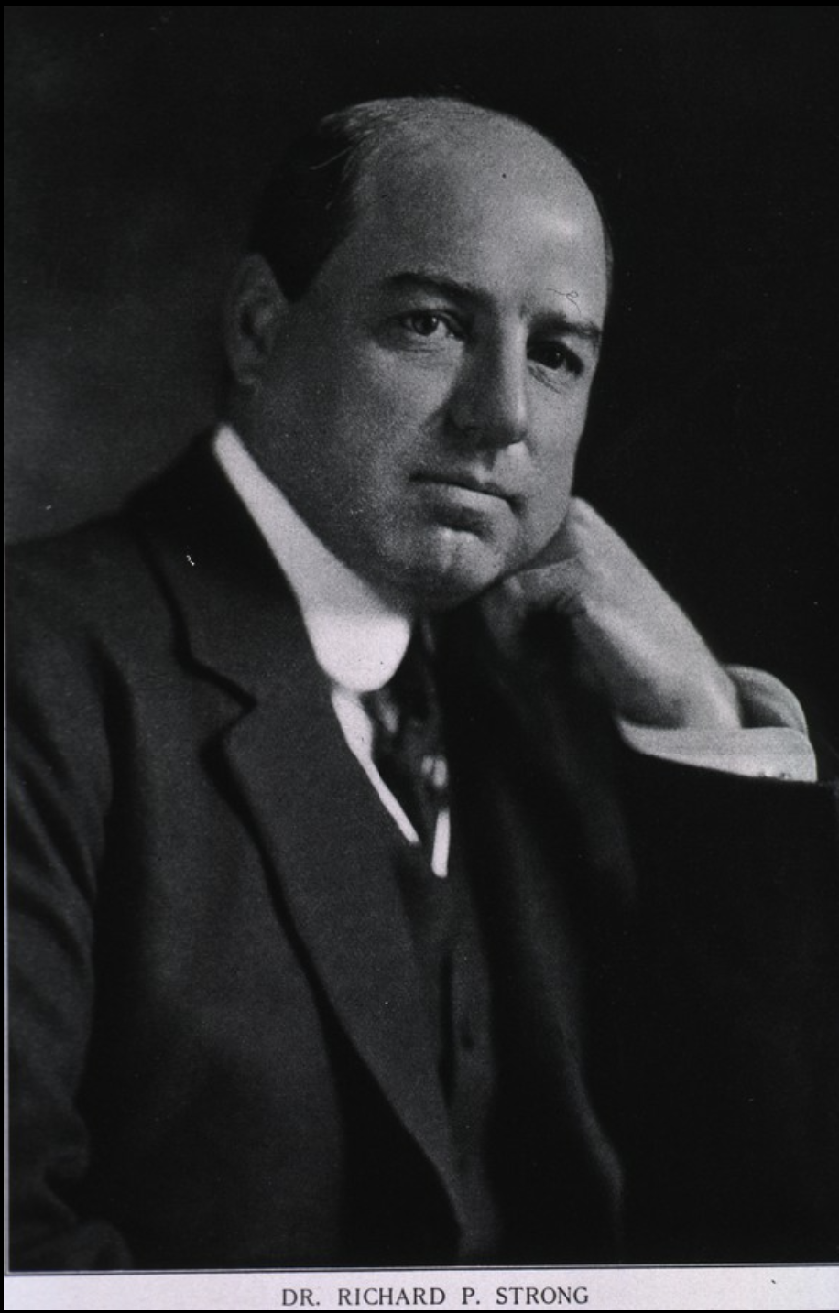
Dr. Richard P. Strong (1912)

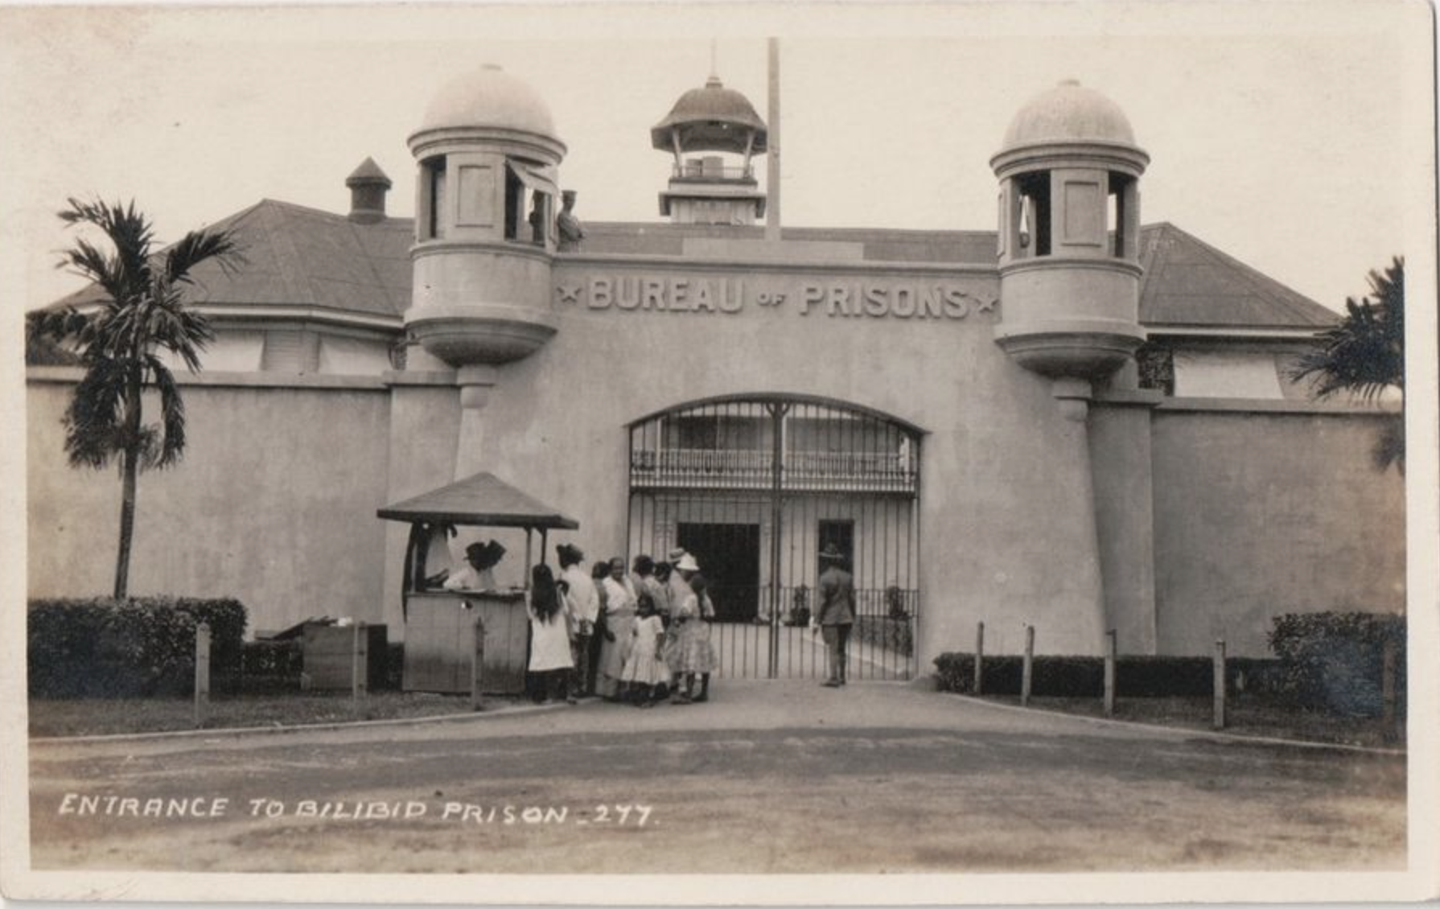
The Old Bilibid Prison, City of Manila, Phillipines (1900)

Episode References:

https://www.jstor.org/stable/44444451?seq=4#metadata_info_tab_contents

https://www.bbc.com/news/world-asia-india-55050012

https://daily.jstor.org/the-deadly-bilibid-prison-vaccine-trials/

“Trends in health research ethics in the Philippines during the American Colonial Period (1898-1946)”
DOI: 10.1111/dewb.12227
file:///Users/lilleeizadi/Downloads/BilibidVaxxTrials.pdf

“Richard Pearson Strong and the Iatrogenic Plague Disaster in Bilibid Prison, Manila, 1906”
https://www.jstor.org/stable/4455385
or
https://shibbolethsp.jstor.org/start?entityID=https%3A%2F%2Fidp.flsouthern.edu%2Fopenathens&dest=https://www.jstor.org/stable/4455385&site=jstor

Disease of the Week:

https://www.bbc.com/news/magazine-34290981

https://www.usrf.org/news/010308-guevedoces.html

Asian American & Pacific Islander Heritage Month:

Donation Drive for this Month: Asian American Justice & Innovation Lab:
https://www.aajil.org/

*For more organizations to donate to, visit our “AAPI Heritage Month” under “Support The Cause” page on our website menu!*

https://asianpacificheritage.gov/

https://www.psychiatry.org/psychiatrists/cultural-competency/education/best-practice-highlights/working-with-asian-american-patients

