EP 30: The Unhygienic Dentist

Description

This week we discuss a grossly unhygienic international case starring Dr. Alan Hutchinson, a practicing dentist who was accused in 2007 of using dental tools to clean his ears and nailbeds, not washing his hands before examining patients, and opting out of glove-wearing while inspecting patient's teeth. But the real question we are left wondering is: what in the world was that smell? chemical cleaner? or pee in the dental surgery sink?

Pictures

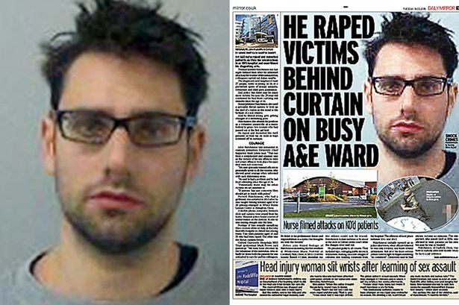

Allan Navarro after the malpractice incident, with his Marilyn. *Picture Credit by Hugh Williams*
his Marilyn. *Picture Credit by Hugh Williams*after the malpractice incident, with his Marilyn. *Picture Credit by Hugh William

Allan Navarro's attorney, Steve Yerrid *Picture Credit by Hugh Williams*

References

The Guardian
https://www.theguardian.com/uk/2007/apr/06/topstories3.mainsection

YorkshireLive
https://www.examinerlive.co.uk/news/west-yorkshire-news/disgraced-dirty-dentist-fails-jail-14289302

BBC News
http://news.bbc.co.uk/2/hi/uk_news/england/bradford/7754804.stm

BBC News
http://news.bbc.co.uk/2/hi/uk_news/england/bradford/6526087.stm

Mirror
https://www.mirror.co.uk/news/uk-news/dad-ae-rapist-andrew-hutchinson-5436889

Daily Mail News
https://www.dailymail.co.uk/news/article-3019399/Unconscious-E-patients-treated-open-areas-hospital-nurse-filmed-raping-anaesthetised-victims.html

pressreader
https://www.pressreader.com/uk/huddersfield-daily-examiner/20150814/281715498347607

Disease of the Week

Mayo Clinic
https://www.mayoclinic.org/diseases-conditions/gingivitis/symptoms-causes/syc-20354453

Healthline
https://www.healthline.com/health/gingivitis

WebMD
https://www.webmd.com/oral-health/guide/gingivitis-periodontal-disease

