EP 42: The Three Strikes Amendment

Description

We take a deep dive this week into the various medical malpractice incidences of Dr. Berto Lopez, a former OB/GYN in West Palm Beach, Florida. From maternal and infant mortality to botched circumcisions, this case will have you wondering how this negligent physician got away with his crimes for so long without getting his license revoked. The answer to that question though may just leave you more disappointed than relieved.

Pictures

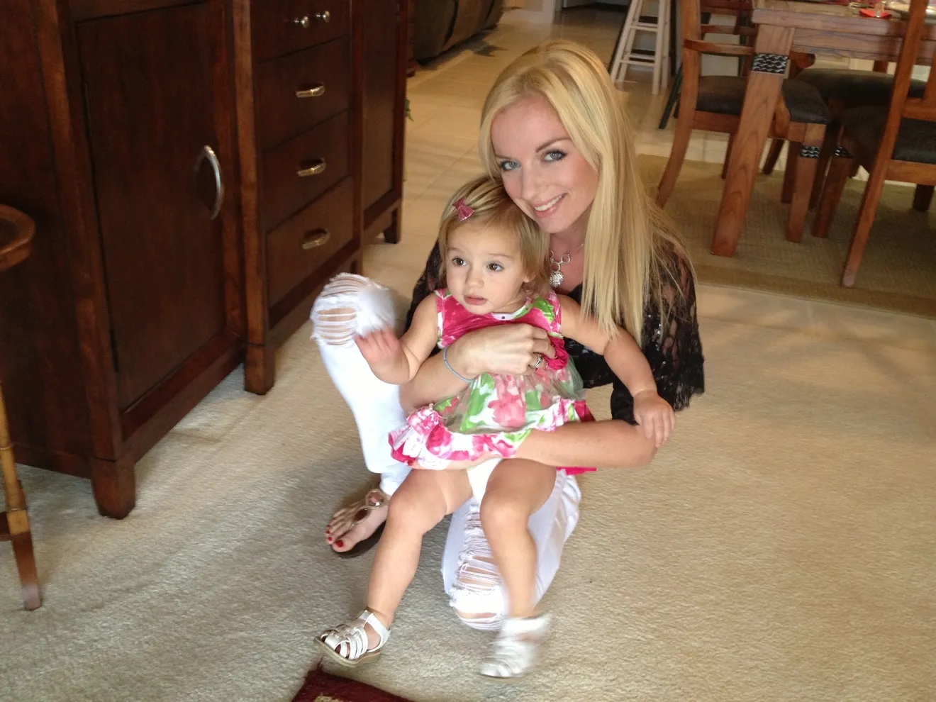
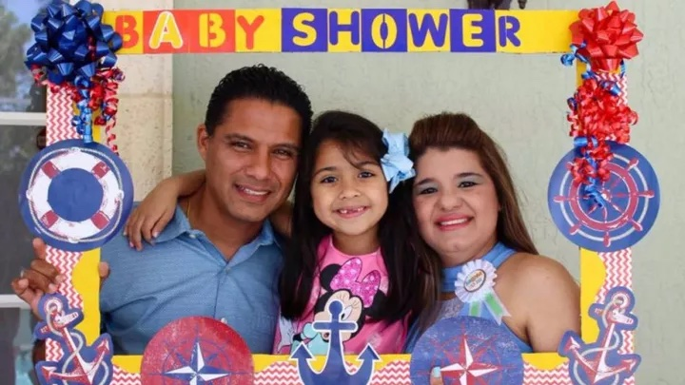

Onystei Lopez (right) is pictured with her daughter Priscilla (middle) and husband Jorge (left) before Onystei's death. Picture credit from Jamie Lopez, who set up a GoFundMe page to assist in funds for widower Jorge.
Ashley Perez, one of the patients who died under Lopez's care, is pictured here with her daughter, Amalia. Picture credit to the Palm Beach Post and the Perez family.

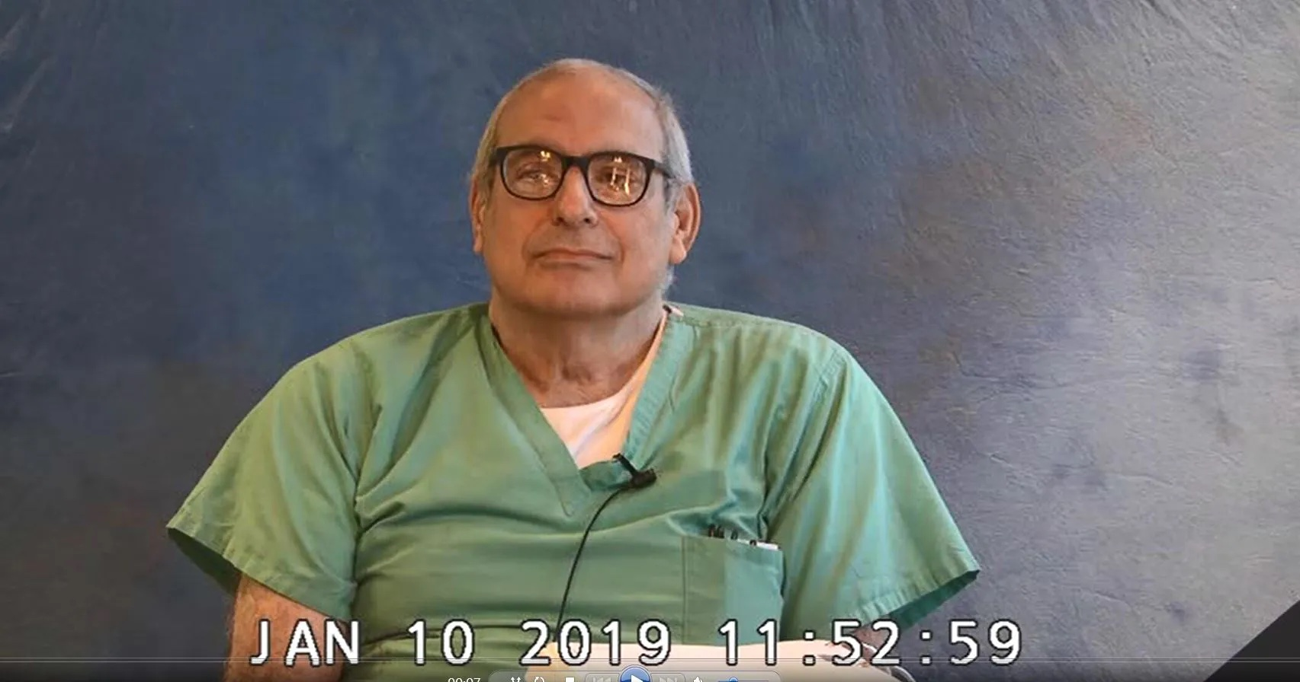

Ashley Perez, one of the patients who died under Lopez's care, is pictured here with her daughter, Amalia. Picture credit to the Palm Beach Post and the Perez family.

References

The Palm Beach Post
https://www.palmbeachpost.com/story/news/2021/02/09/dr-berto-lopez-loses-license-after-mom-bleeds-death-after-childbirth/4409299001/

https://www.palmbeachpost.com/story/news/2021/09/23/florida-doctor-medical-malpractice-lawsuits-women-babies-died/8336090002/

https://www.palmbeachpost.com/story/news/local/2021/09/23/west-palm-ob-gyn-timeline-accusations-and-malpractice-lawsuits/8384544002/

CBS 12 News
https://cbs12.com/news/local/west-palm-beach-doctor-loses-medical-license-after-mother-dies-hours-after-giving-birth

https://cbs12.com/news/cbs12-news-i-team/i-team-how-dangerous-doctors-can-continue-to-practice

FLrules
http://flrules.elaws.us/Gateway/CourtOrders/2009/09-006958N/09006958.pdf

WebMD
https://www.webmd.com/a-to-z-guides/features/ob-gyns-on-trial

FSC: Gale
https://bi.gale.com/essentials/article/GALE|A676762962/47ce0db3e759bbbdd6bcba8590f34d60?u=lake33936

GYRC Trial Lawyers
https://www.grossmanroth.com/blog/2021/september/gary-cohen-takes-on-repeat-medical-malpractice-o/

Daily Mail
https://www.dailymail.co.uk/news/article-9487605/Florida-doctor-loses-license-letting-new-mother-40-bleed-death.html

Disease of the Month

Center for Disease Control and Prevention
https://www.cdc.gov/ncbddd/birthdefects/downsyndrome.html

Medline Plus
https://medlineplus.gov/genetics/condition/down-syndrome/

Mayo Clinic
https://www.mayoclinic.org/diseases-conditions/down-syndrome/symptoms-causes/syc-20355977

Episode Transcript

Episode 42 Transcript

Lillee Izadi 0:19
Hello, everyone and welcome back to another episode of ethical side effects. I'm your hostess for the most Yes, Lillee Izadi joined by the one, the only Mr. TJ McKay here.

TJ Mckay 0:34
Hi, guys, thank you for stopping by for another crazy case of malpractice.

Lillee Izadi 0:40
And today, let me just start off by saying that this case will be just insane guys, and I can't wait to share it with you. But if you're one of our loyal listeners, you know the usual ebb and flow of our episode, and that before we get into our case, we like to share some general announcements. One, I am so sorry for not being able to put together an episode last week as my computer completely broken, I finally got it fixed. And our Wi Fi modem was not working. So we had to get that fixed as well. But we are looking forward to sharing our content that we had planned last week with you this week, too. We are still accepting screenshots for our little merch giveaway until Sunday, March 27. So this Sunday, if you're still wanting to get some awesome free ethical side effects merch, just take a screenshot of the little subscribe button and a screenshot of your five star rating and review on the Apple podcast app, the overcast app, the castbox app, or the pod chaser app and send it to the ethical side effects podcast@gmail.com email in our link tree below, we will be picking two of you amazing listeners to send merch to. And thank you so much to those of you who have gotten your screenshots, and we really appreciate your support. Also, please, if you haven't done so already, check out our little link tree link below and stay up to date with all the things Ethical Side Effects by following us on our Twitter, our Facebook page and our new Instagram. Thank you so much TJ. And make sure to subscribe to our newsletter and share your favorite medical crimes Podcast with your equally amazing friends and family.

TJ Mckay 2:27
Yeah, guys, let me just tell you that you're not going to want to miss out on this amazing opportunity to win some free ethical side effects merge. Not only is it dripping sweat, but you will be able to let the entire world know who has the best medical malpractice podcasts on the entire internet.

Lillee Izadi 2:44
Yes, and if you haven't done so already, make sure to follow us on our new Instagram as TJ has posted some awesome pictures of our new merch. So get on that. And, TJ, to be honest with you, I think we've done enough announcing and not enough storytelling, especially because we were gone last week. So are you all ready to get into our crazy malpractice case for this week?

TJ Mckay 3:08
Absolutely. So without any further ado, let's just get this show rolling.

Lillee Izadi 3:14
Okay, let's get into it.

So, this week I present the case of OB/GYN Dr. Berto Lopez, or honestly, I should say, cases, plural, because this guy has quite the track record. But I'll start off this case first and 2017 with one of his patients. Onystei Castillo-Lopez, who was a medical assistant in Palm Beach County at the time, right here in Florida, TJ, more specifically, on March 25 2017, only say went to the Good Samaritan Medical Center in order to go forward with a scheduled labor induction to deliver her second child. Luckily, the baby who would eventually be named Jorge, was born shortly after ATM, and he was healthy, happy and ready to be welcomed by his older sister Priscilla. Father Jorge and of course his wonderful mother. Oh, nice day. However, during the delivery process, oh nice day cervix received some tears and this is not uncommon during childbirth. So of course, these things though need to be repaired or else incontinence and possible excess bleeding can result and we don't want that right guys. So that's where Dr. Berto Lopez comes into the story. And Dr. Lopez has been an OBGYN For over three decades at that point. And a little background about Dr. Lopez is that he emigrated to the United States. with his family from Cuba. He then later went on to graduate from the University of Georgia with a bachelor's degree in chemistry, then attended the Medical College of Georgia and Augusta to receive his medical degree. And he then went on to complete his residency at Emory University in Atlanta, and then eventually became a board certified OB/GYN in about the 1990s. So this guy is just really centered in "Hotlanta". Am I right, TJ?

TJ Mckay 5:29
Absolutely, Lillee.

Lillee Izadi 5:31
But eventually, Berto Lopez comes down to Florida at some point in his career, and started to primarily work in health care districts of Palm Beach County, Florida, that serves low income residents and worked a lot with people under federal and state health care programs like Medicaid, for example. Now refocusing back to our story, and Onystei, it was kind of my understanding and my inference that Dr. Lopez was not only stays personal OB/GYN. And what I mean by that is that he was not likely the doctor that she was under the care of throughout the duration of her pregnancy. And the only reason I'm getting that vibe is because in none of the news articles or reports I was reading, do they mention a nice day being under his care before this incident that I'm about to say occurs? And I feel like if she had been seeing him throughout this pregnancy, as well as possibly even the family OB/GYN in which he helped deliver her first child, they likely would have mentioned it considering the events that follow in this story. Hmm,

TJ Mckay 6:39
Interesting. So, would you say that Dr. Lopez was the OB/GYN that was at the time on call at this medical facility?

Lillee Izadi 6:49
Yeah, that's exactly what I was thinking actually, TJ. But truthfully, take that with a grain of salt because I cannot confirm nor deny this statement in its entirety. But anyway, he is now in the picture somehow, in order to repair any say cervical tears. But, TJ, some complications start to arise and Onystei takes a turn for the worst.

TJ Mckay 7:17
Wait, what happens?

Lillee Izadi 7:19
So the timeline between the birth of Jorge and the start of Onystei's, complications are a little bit blurred and not entirely coherent. But it looks like Dr. Lopez eventually transfers on the state to an operating room from the delivery suite she was initially in to properly repair these tears. But whatever he's doing to fix these hairs eventually ends up making the bleeding worse, honestly. In fact, her cervical bleeding was so bad, apparently, that the bottom of his scrubs, his socks, and his shoes, got soaked with only stays blood as she continued to bleed out while he was operating on her. Which, by the way, does not sound like it's supposed to happen. I don't know about you guys. But amidst all of this, do you know what Dr. Lopez does? TJ?

TJ Mckay 8:15
I will hope that he will request like some help to get this excessive bleeding under control.

Lillee Izadi 8:21
Right. Like that's, that's a fair assumption. Okay. But Dr. Lopez does not do this. In fact, instead, Dr. Lopez says, I'm covered in blood. Let me go home and change my scrubs. And just gets up and leaves right in the middle of trying to repair only say Starbucks.

TJ Mckay 8:45
Pardon me. Are you serious?

Lillee Izadi 8:48
Oh, I'm dead serious. TJ. He tells the staff in the operating room that he is going back to his house, but that he will be back soon. Okay. But guess what, TJ?

TJ Mckay 9:01
Please tell me he comes back. I know you're not bad to say he doesn't come back. There. See at least come back Lillee.

Lillee Izadi 9:09
No, he doesn't come back. TJ, you are your your assumption was right. He does not come back. He leaves on the state bleeding out under the supervision of nurses and anesthesiologist and an ICU doctor apparently, while he goes home at 11:49pm. And he never comes back. In fact, in some news articles I read it is reported that he fell asleep once he got home, which is like, go off I guess but I physically don't understand what happened between the time he left and when he got home that made him decide to just not want to come back. And honestly, I'm really confused by this part of the case. And what's even worse is that a nice day actually starts to hemorrhage amidst the whole thing, and she ends up dying at 3am The following morning, due to The blood loss from the hemorrhage. And what I was kind of left thinking is not only why he didn't come back, but why the operating room team didn't do anything about this, if that makes sense.

TJ Mckay 10:13
What I can't wrap my head around is understanding why Dr. Lopez made the decision to leave when honestly was still in such a serious condition. And Lillee, did you ever consider whether Dr. Lopez could have like just showered and changed at the hospital? But was it necessary for him to travel all the way back to his residence?

Lillee Izadi 10:38
TJ, that is a great question. And a question that I myself wanted an answer to. So while I was doing research, I actually found that in some of the court reports, or when this case eventually does go to trial, he claims that they were not scrubs for him, I guess, nearer in the operating room, which kind of is a little bit vague, like, does he mean there's no scrubs in his size? Are there no scrubs at all? What was happening during this time that there wasn't any scrubs is my question. But does he mean that he just doesn't like any of the scrubs? Like? I don't know, I just I don't get it. I don't understand how there's no scrubs there for you. And why you couldn't use a pair of Scrubs in there, because I'm sure that there was scrubs to use. But maybe I'm just not very well versed in how medical supplies work in operating rooms. So I'm not even going to question that I guess. But that was the answer that I received. And I was not very content with it to be quite frank. And just to continue with my point of view, because we all know, I always have a lot to say, let's just say best case scenario, in this case, that it's the end of the guy's call shift. And he says lol peace out. Okay. That is not how to handle the end of your shift as a medical professional, in my humble opinion. First of all, I think you should finish this operation regardless. But let's say you're just physically too exhausted to continue. Fine. I get it girl, be an adult, though and communicate that with another physician, or the next OB/GYN on call and page them to finish the job. It was my understanding that before you leave your call shift, you need to keep a running list and do kind of like a check in with the new healthcare team taking over before you leave the hospital. Like come on, guys. This is not amateur hour.

TJ Mckay 12:33
Yeah, I definitely couldn't agree with you more Lillee, if Dr. Lopez was just so mentally drained and thought that it would be in the best interest of honesty, if he just checked out and allowed another OB/GYN to basically take over, I would have completely understood and had respect to his final decision.

Lillee Izadi 12:55
Agreed I can respect that decision if he felt like he couldn't do a very good job unless somebody else took over. Okay. But anyways, after this whole death of Onystei, rightfully so only says husband also again named Jorge was extremely upset, especially because him and his wife had been wanting a second child for so long. And we're so excited when they could finally have that opportunity, despite Onystei at 40 years old, being at the older end of the range that typical females bear children, if that makes sense. But also at 40, you still have so much life left to live and so many memories to make with your family. And Onystei was completely robbed of this due to the negligence of Dr. Lopez honestly, and possibly even other practitioners. So widower Jorge decides to get an attorney on this case by the name of Gary Cohen. And after being put on the case, Cohen's starts to find out details of this case specifically. And it looks like once the cervical tears were noticed, Dr. Lopez did not even immediately transport a nice day to an operating room, and instead just started to fix the issue in the dim light of the delivery room, which, in my humble non professional and just basic inference knowledge, I would guess that this delivery room is kind of underprepared for a major operation such as this, especially if a woman is in this critical condition and was experiencing some blood loss from a tear. I guess the best way to go about this would be putting her an operating room where they have all of the equipment that they need. And the lighting is probably also better, which they kind of talk about later on in certain news articles, but only state was actually in pretty severe condition overall. In fact, she was in such severe condition that some of the experts say that the blood loss that she was experiencing from the terrible So life threatening that in this instance, they would have just performed a whole hysterectomy and taken out the uterus and part of the cervix so that they could save her life basically. However, I don't think that Dr. Lopez realized how serious it was at first glance, and later, I guess in court blame this on the other medical staff not being prepared, and the dim lighting of the delivery room, which, again, like I was saying before, if you brought a nice day into the operating room to be kin with the lighting would probably be more appropriate for this type of thing. And again, you probably would have been more prepared. But anyway, eventually he does realize the severity and decide to transport on the state to an operating room. So good on him finally, right. But something not cool is that he downplayed the severity of Onystei's conditions to the rest of the people in the operating room, which honestly, not only might have been the reason why he was able to leave amidst the operation, and people weren't really worried, but also why the operating team might not have acted as fast to Onystei's hemorrhaging. But after further investigation, it turns out he wasn't even performing the right operation on her. Like we said before, a lot of other OB GYN or other experts said that Onystei's in that case would have likely been given a full hysterectomy in order to save her life. But Dr. Lopez was only giving her a partial one before leaving. And the way he was cutting out the cervix caused even more blood loss, which consequently resulted in only stays hemorrhaging A few hours later. So it's all full circle, guys, okay.

TJ Mckay 16:48
I just couldn't imagine being in the shoes of Dr. Lopez and having such a lack of compassion for a mother who just went through labor or for any patient that was in a similar situation such as, Onystei's, I understand is close to midnight. But I have no remorse for Dr. Lopez after hearing all the details surrounding the data on this day, that Lopez made the final decision to not take the proper steps in passing the case to another specialist that was either Willie in able to operate on a say,

Lillee Izadi 17:23
No, I completely agree with you. It was nothing but negligence showed on Dr. Lopez's part. And boy, do I have more cases for you, TJ as well as our listeners. Because once Cohen started digging even deeper, he started to uncover a very concerning pattern of mother and infant fatalities, starting from the beginning of Dr. Lopez's medical career. Additionally, he found a greater number of malpractice cases facing Dr. Lopez than the average OB/GYN and just to make sure I actually looked up the average amount of medical malpractice cases a typical OB/GYN has throughout their career. And the average is about three Guess how many malpractice suits Dr. Lopez had under his belt? TJ?

TJ Mckay 18:17
I would say he's the type of guy that probably will have about seven malpractice cases again soon.

Lillee Izadi 18:22
Oh, TJ, it was nine. You heard me nine and incriminating evidence for the malpractice case. Cohen actually found that the Palm Beach post, the local newspaper of West Palm Beach and Palm Beach County had been doing their own little investigation on a series of malpractice incidences since the start of his career in the 1980s. And this history, as you can probably imagine, is pretty lengthy. Like, in other words, this case with Onystei is not Dr. Lopez's first rodeo guys. Okay. And it gets so much worse, because I actually found a timeline published by the Palm Beach post with all of his malpractice incidences starting from about the late 80s. Generally, it seems like in recent years, he has been linked to the death of six women and babies to botched circumcisions, and a few other injuries. Now I'm going to talk a little bit more about the specifics of each of these cases. And some of this gets a little bit sad. So if this is a little bit of a touchy topic or a little bit too graphic for you, I encourage our listeners to skip ahead about a minute and a half or so. But according to the Palm Beach post, one of the victims was a 56 year old woman by the name of Joyce rivers, who had her small intestine punctured during an outpatient procedure by Dr. Lopez and she died of complications from it. And this was kind of brought The Palm Beach post by the Palm Beach County Medical Examiner's Office. Additionally, there was Ashley Perez, a 29 year old mother who is a patient of Dr. Lopez that died from internal bleeding following a C section and Tubal ligation after misdiagnosis according to the Florida Health Department, there was also Dominic Shelton, a baby who suffered severe brain damage during premature labor that led development of cerebral palsy after Dr. Lopez not only delayed a C section for too long, but gave Dominic's mother an anti clotting agent during labor that actually gave her an allergic reaction, causing her to go into anaphylaxis and needing the C section in the first place. And there was also Matthew Dixon, a baby born with a broken arm and permanent nerve damage, because a C section wasn't performed according to a lawsuit that was filed against him. Investigative journalist from the Palm Beach post also found another case dealing with a woman by the name of Joanne Catlett, who at age 47, was incapacitated for six months after hysterectomy done by Dr. Lopez during which her ureter which is the duck that carries urine from the kidneys, the bladder was nicked another patient of Dr. Lopez's who chose to remain anonymous and sources suffered from postpartum hemorrhage at the age of 32, after tubal ligation performed by him, and fortunately, this anonymous patient lived, but during that period of hemorrhaging, she lost six liters of blood according to the Department of Health documents. And lastly, there were also two babies one by the alias R.R.R., who lost his penis and a circumcision by Dr. Lopez. And there was also a baby by the alias G.L. whose parents say lost a third of his penis and another botched circumcision done by him.

TJ Mckay 21:58
So my question for you, Lillee is, with Dr. Lopez having such an extensive history with more than the average number of malpractice cases against him. Were there any resources for patients to know about his previous conduct prior to making the decision to make him or have him as their primary OB/GYN?

Lillee Izadi 22:19
That is an actually great question, TJ. I would assume that some states make it a little bit harder to see this information about certain doctors and their medical malpractice cases against them. I think that Florida kind of makes it a little bit harder. And we'll talk about that in just a second. However, again, like I talked about, in the beginning of the episode, I'm sure that he did have patients that were his kind of like long term patients that saw him frequently. But I will say that he might just be on call and that these patients are so kind of incapacitated at the time due to labor or the pain medications that they're on, that they wouldn't even think twice about having a doctor intervene in their situation, because they just need medical assistance. And before we get into all of this, I just wanted to say regarding the cases I just mentioned, that these all happened between 2011 and mostly 2017. Okay. The only incident that was later than 2017 was the baby by the alias G.L. with the botched circumcision, which actually happened in 2021. Okay, so these are all very, very recent.

TJ Mckay 23:31
Yeah, that's absolutely insane to realize that his most recent malpractice case doesn't even deal with own estate because I'm surprised this man was still allowed to be a board certified physician, like after hearing the details from her case. I'm not quite sure that Lopez should be allowed to even practice.

Lillee Izadi 23:51
Oh, I completely agree with you, TJ. And I mean, yeah, this is a lot to unpack. And I want to make a significant point here and that these weren't even the ones earlier in his career, I actually found five other malpractice incidences that he was deemed responsible for between 1988 and 2002. Guys, detailed and a Palm Beach Post article. Are you ready for the TJ? Because I know I wasn't when I started reading about them. But I feel like the stories of these victims need to be shared and it would be doing an injustice if we did it.

TJ Mckay 24:28
I don't know if I can prepare myself to bear what I'm about to hear or to hear how much worse this could actually get. But I do understand that the cases must be heard.

Lillee Izadi 24:40
Yes, so the one dating back to 1988 was about the wrongful death of infant crystal Diane Hicks, who died because Dr. Lopez did not perform a timely C section. In 1992 Another infant Earl Buchanan also died under the care of Dr. Lopez. News articles didn't disclose why, but records indicate that the Buchanan case was brought up and settled way back when over his death. And in 1994. Apparently there were two incidences because one wasn't enough, apparently. So one of them was a teenager by the name of Nokia Gilmore, who died following a procedure during childbirth. I don't think this case was ever brought to court because a cause of death was never officially ruled or claimed. But the other case in 1994, was brought to court and was regarding an infant by the name of Samuel Mercedes, whose neural tube defect was not detected in utero by Dr. Lopez, resulting in the parents finding out that Samuel had spina bifida after he was born. So I guess because he didn't run the proper test or disclose this information, I guess they shoot him. And just hold on tight guys, because this one that I'm about to talk about is a lot. So it seems like a 31 year old woman at the time named Michelle Hirt in 2002 suffered from miscarriage at 17 weeks. And she found this out by Dr. Lopez when she went in for a checkup and he said that there was no heartbeat that he could hear. And in response to this, he went forward with a procedure to remove any dead remains from inside of her. And after this procedure, she of course, under what testing to confirm that the fetus was removed so that no sepsis or any sort of premature birthing of fetal parts was entered. But three weeks later, Michelle started experiencing cramping while visiting a friend and all the sudden, she in fact does give birth to fetal remains right there. Right then in her friend's bathroom. It turns out that Dr. Lopez did not actually remove the fetal parts to their entirety. Nor did he, check the pathology report results that were supposed to confirm the fetus was removed. And the report if he were to read it said that there was still fetal parts in there. So not only did he not remove all the fetal parts, but he also was negligent about not reading the report, which would have confirmed what he didn't want to believe was true.

TJ Mckay 27:28
So would you say there's sort of a trend in some of the malpractice cases against Dr. Lopez, Lillee? Because it seems that Dr. Lopez really took the time to emphasize the importance of attention to the smallest details.

Lillee Izadi 27:44
No, I completely agree with you, TJ, I think that there is a very big trend of negligence and his cases, and no remorse for the fact that he's causing a lot of suffering to the patients that he's supposed to be helping. And if you're like me, you're wondering how in the heck, this guy still has a license? What is going on? And in researching how this has been allowed to happen for so long, I find out something arguably, that is so much worse than I ever thought. Because it turns out TJ, the Florida Medical Board has heard of all of this with him. They knew about his cases, but they still allowed him to practice under certain restrictions. In fact, the hospital he was working at at the time, knew this and still allowed him to practice on a nice day, as long as Dr. Lopez was supervised by another physician. And obviously, we see how that turned out anyway.

TJ Mckay 28:46
Yeah, horribly wrong.

Lillee Izadi 28:49
Yeah, to say the least horribly wrong. And the medical board did not, I repeat, did not take away his license until February 2021. So like, literally a little bit over a year ago, guys, despite this going on for over 30 years, which I just find completely insane. But the big question here is again, why? Why is this the case? Well, let me share some not so fun facts with our listeners. So what I learned from my little investigation into this is that in 2004, Florida voters voted to pass a so called Three Strikes constitutional amendment that would revoke a physician's license after three malpractice findings. And this amendment was fortunately taken seriously and put in place. However, it faced a very strong pushback by the healthcare industry and insurance lobbyist. So state legislators decided to make changes to this amendment. So much so that even though it was put into To effect, it basically undermined what its purpose was. Sound familiar? TJ, felons voter rights.

TJ Mckay 30:10
So wait, Lillee, just for some clarification? What changes did they make to undermine the original amendment?

Lillee Izadi 30:20
I'm so glad you asked. TJ. Great question. So just generally speaking, it looks like the requirements for what is considered a malpractice case, under this three strikes amendment was tampered with, to the point that often cases deemed by the judicial court as a malpractice case, would still not be considered a so called strike by the medical board, if that makes sense. Especially because the changes made include a lot of loopholes for cash settlements, so that no formal entries are made or filed for a strike. And even if a formal case is filed, again, it doesn't mean it's big enough to be considered a strike. And it's kind of confusing, I'm not going to lie. But overall, because hitting every single rigid requirement to be considered a true malpractice case, or a strike, according to the Florida Medical Board, there are many physicians like Dr. Lopez, who often don't even get a strike, let alone three and then being out. And then, of course, doctors and hospital officials tend to be held accountable for putting flags up in the national practitioners database on certain physicians, right. But let's say a physician, like Dr. Lopez, who is working with low income individuals in the middle, a very well populated area where these low income services are very much needed. But there's not enough physicians to do what it takes to provide these people medical care. Do you really think the hospitals are going to report the severity of these incidences all the time? And do you think that a lot of these claims are even going to be taken seriously, because some of these people don't speak English, or some of these people maybe aren't from this country to begin with? Or they don't have enough money to bring this position to court? My guess is a big fat no, especially because his hospital doesn't even care to fire him, let alone report him so that another hospital doesn't hire him.

TJ Mckay 32:32
And it's probably very difficult to find other physicians willing to relocate and work in areas with lower income patients because they rather work in other areas where they can earn a lot more money.

Lillee Izadi 32:44
Yeah, unfortunately, that might be the case for some physicians out there. I won't say all of them, because I know plenty of great physicians that do. But I do think you have a very good point there. But anyway, getting back to the story. Eventually in February 2021, the Florida Medical Board revoked Dr. Lopez's medical license. And in discussing his medical malpractice cases, many people report that he was consistently blaming his circumstances and other staff members instead of himself, nor did he show any empathy towards the suffering of the families or remorse for the suffering he has definitely and undoubtably caused these families.

TJ Mckay 33:27
Truly no shocker there, though, just from me listening to you explaining that the Lopez's reputation of practicing medicine, I could tell he was empathetic for his patients or their family members at all.

Lillee Izadi 33:40
Yeah, exactly. TJ and in terms of Oh, nice days family, as I mentioned before, oh, nice days husband, Sue Dr. Lopez with the help of their attorney, Mr. Cohen. Eventually, they did end up settling with Dr. Lopez. But they had to bring him to court again, when Dr. Lopez stopped making the monthly payments he owed them, which, honestly, just big sigh I just don't even know what else to say, TJ. But you know what, I actually do have something to say and it's just to do better people. It's really that simple. If this is one physician, all future health care professionals listening to this podcast should not be like, it's this guy right here.

TJ Mckay 34:26
Yeah, I'm gonna actually even go further. I'm gonna say he's just trying to not be this guy or doctor death. Please, ladies and gentlemen, strive to be better than these two individuals, who first handily couldn't care less about the outcome in regards to a patient's health. This is that world we definitely live in but these type of professionals do exist in the medical field.

Lillee Izadi 34:49
Exactly. Please you better and honestly just care about people. If you really don't care about the well being of others don't go into medicine. That's all I have to say. Just please don't But anyway, if you all want to take a deeper dive into this case, we will list all of our wonderful episode references and resources, on our case files and pictures page on our website. And if you yourself, have a malpractice case for us, just head on over to our website, which you can find on our link tree and fill out our suggested case forum. And we'd love to get our hands dirty with a crazy case we've never heard before or stumbled upon. But anyway, that is all I have for you guys today. But remember, we didn't have our disease of the month segment last week, when it was a third Friday of the month. So we're going to have it this week, guys. I know. I know. It's gonna be exciting. And I know for a fact that TJ has an amazing disease on the month segment for us next. So stay tuned guys.

TJ Mckay 36:08
And we're back like always to bring you your doses of disease of the month. I'm your disease hosts, TJ accompanied by my wonderful co host Lillee Izadi.

Lillee Izadi 36:19
Hey, guys, thank you so much for joining us.

TJ Mckay 36:23
And unlike Lillee, I really don't have any pre-notes to go through before the disease segment. So without any further ado, how does it sound Lillee? If we just dive right into it,

Lillee Izadi 36:38
I would love to let's get into the disease of the month for March.

TJ Mckay 36:42
Well, for the disease of March, we're taking a closer look into not a disease, but genetic disorder trying to switch up you know,

Lillee Izadi 36:51
Oh, I love it hit me was it TJ?

TJ Mckay 36:54
So today we're talking about the genetic disorder that results from receiving an extra copy of a chromosome and is one of the most common chromosomal disorders. Down syndrome. A person with Down syndrome possesses 47 chromosomes, right, then the regular 46 that would typically be equally donate from both parents. Specifically, individuals with Down Syndrome have an extra copy of chromosome 21. And instead of a possessing two, they have a total of three. Down syndrome can also be referred to as Trisomy 21, because of the presence of three copies of chromosome 21 being present in individuals.

Lillee Izadi 37:34
You know, I've heard about Down syndrome before or Trisomy 21. Why exactly does that occur? I have some idea of like kind of like an aneuploidy issue and nondisjunction. But could you better clarify how this exactly happens in the cell for our listeners, as well as possibly why women who are older in their childbearing years who bear children might have a greater risk of giving their child Down syndrome, if that makes sense?

TJ Mckay 38:04
That's an excellent question, Lillee. And I'm going to touch on all of your questions. As for the last question about why older mothers are more at risk of having newborns that experience Down syndrome, I think physicians and scientists link older mothers having more risk of experiencing nondisjunction during cell division.

Lillee Izadi 38:28
Interesting. So why don't you explain nondisjunction to our listeners a little bit more, for those of us who aren't very well versed in the genetics world, which can be a little bit complicated, so we'll break it down for you.

TJ Mckay 38:41
When it comes to Down syndrome, a process known as nondisjunction accounts for approximately 95% of cases diagnosed during nondisjunction. There's a failure of the chromosomes not split apart during the first or second step of meiosis. And for those of you who are unfamiliar with the term miosis is basically the process of sperm and egg cell development otherwise known as gamete formation. Also, in case if you are wondering, it will be cells that are missing chromosomes due to his matching chromosome not divided properly. When you think about it, every cell has two sets of chromosomes or two big pieces of genetic information, one from your mom and the other from your dad. So if one cell gets more chromosome than the other, now another cell will be left with less chromosome. So generally, trisomy 21 is when an extra copy of chromosome 21 is unevenly distributed to the germline cells being created in miosis. A rare occurrence that can cause damage or is called robertsonian translocation that accounts for approximately four percents, a Trisomy 21 diagnose cases. During robertsonian translocation, a part of a chromosome moves and switches with another part from a second chromosome. So baby The long arm on chromosome 21 translocase overtook chromosome 14, and was those in two hybrids, one with both long arms and one with both short arms. And let the back be known that short arms typically don't carry any important info, it will initially be lost at the end of meiosis. Lastly, about 1% of diagnosed cases are mosaic, which refers to the mixing of the sales, children's diagnosed with mosaic Down syndrome, we have some cells that possess three copies of chromosome 21. Other cells were have been no more two copies.

Lillee Izadi 40:38
Oh, my goodness, that's really cool, I had no idea that you would kind of be a mosaic for that I knew that happened with X inactivation. So fun fact for our listeners, and females and a lot of species of organisms, because there's so much genetic information on the X chromosomes and females have two of them, whereas males only have one, because we're better Come on ladies, the X chromosome in one of our cells kind of cancels out, so that it kind of evens out the amount of genetic information in males and females on the X chromosome. So that's one of the reasons that we actually get female Calicos because one of their access codes, let's say for an orange colored fur because color is on the X chromosome. So one might express orange and the other one might express black in certain cells. So it's kind of like a mosaic, but of different fur colors, which I think is really cool. And I didn't know you could apply that to humans as well.

TJ Mckay 41:37
Yes, and some of the major effects from having an extra chromosome 21 Ashley Lillee includes, but is not limited to, septal defects in the heart chambers between the two atria, duodenal atresia, increased risk of acute lymphoblastic leukemia, intellectual disability, and an increased risk of Alzheimer disease. physical care services can also be observed such as seeming creases across the palms of the hands, a gap between the big toe and the long toe, a flat base or profile epicanthal folds. A major risk factor for children being born with Down syndrome is maternal age, like Lillee touched on beforehand, for a mother that is less than 20 years old has a chance of one out of 1500 births have given birth to a child with Down syndrome. On the other hand, when a mother is 45 years old, we can observe her risk of giving birth to a child with Down syndrome increases to about one out of every 25 births.

Lillee Izadi 42:39
Wow, that's a really big difference. So one in every 1500 for people in like their 20s, I guess. And for women that are 45 and older, it's one in 25. That's just completely insane. I didn't think it was that much of an increase.

TJ Mckay 42:56
Right. There's definitely a huge increase in race when it comes to giving birth to a child with Down syndrome. And I will see as being very important to maybe go see a genetic counselor when you're older and age just in case you could, you know, maybe for see the certain risks when it comes to given birth.

Lillee Izadi 43:17
Agreed, agreed. And I'm glad we could talk about this genetic condition this week as well. Thank you, TJ.

TJ Mckay 43:23
And as always, if you enjoy this week's segment coming downstairs, please head on over to our website where you can always find episode extras that contain all references and resources used in the making of this week's episode. Also, please recommend our podcasts to your family and friends. And we'll see you next month for another disease of the month segment.

Lillee Izadi 43:43
Yes, we'll see you next month for that segment. But we'll see you next week for an amazing case of medical malpractice. Bye guys.

