EP 22: The Fraud Father

Description
This week we discuss the scandals of Virginia OB/GYN Dr. Javaid Perwaiz. After an FBI investigation reveals that Perwaiz committed over 50 counts of healthcare fraud between 2010 and 2019, his patients come to the realization that the countless hysterectomies, tubal ligations, and early labor induction he forced upon them weren't actually medically necessary after all.

Pictures
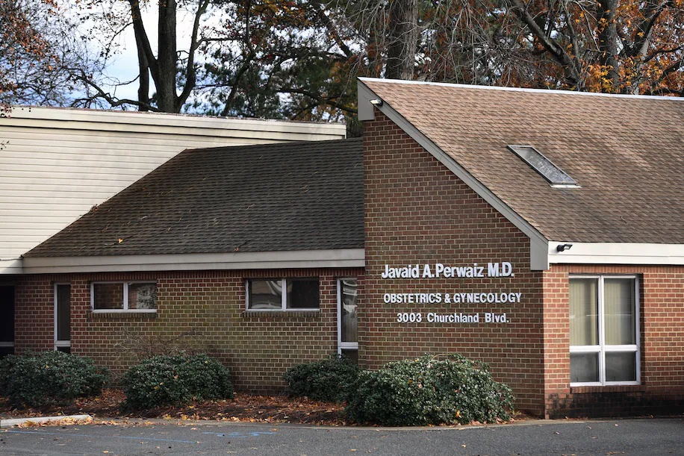
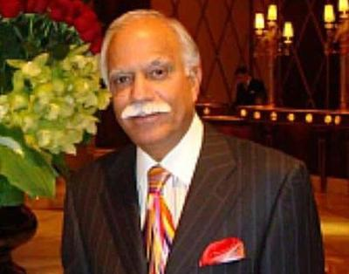

Dr. Perwaiz's OB/GYN private practice clinic.
Dr. Javaid Perwaiz before his arrest in 2019.

Resources
https://www.justice.gov/usao-edva/united-states-v-javaid-perwaiz

https://www.justice.gov/archives/usao-edva/page/file/1291026/download

https://www.washingtonpost.com/local/public-safety/javaid-perwaiz-convicted-virginia/2020/11/09/e7b4f31c-22bc-11eb-952e-0c475972cfc0_story.html

https://www.washingtonpost.com/local/public-safety/perwaiz-virginia-doctor-unnecessary-surgeries/2021/05/18/2e4d7ff4-b7f2-11eb-96b9-e949d5397de9_story.html

https://www.wavy.com/news/local-news/former-chesapeake-ob-gyn-javaid-perwaiz-sentenced-to-59-years-in-prison-for-unnecessary-surgeries-on-women-in-fraud-scheme/

https://www.wavy.com/the-patients-v-perwaiz/

https://www.joshsilvermanlaw.com/practice-areas/medical-malpractice#:~:text=The%20statute%20of%20limitations%20for,%C2%A7%208.01%2D243

Disease of the Week

Mayo Clinic
https://www.mayoclinic.org/diseases-conditions/gonorrhea/symptoms-causes/syc-20351774

Centers for Disease Control and Prevention
https://www.cdc.gov/std/gonorrhea/stdfact-gonorrhea.htm

