EP 25: The Runaway – Dr. E. Coli

Description

On the surface, Dr. Jayant Patel was the busiest general surgeon at his affiliated hospitals with distinguished awards to back up his surgical skills. However, from the start of his medical training, his colleagues are left appalled at his hygiene, surgical sloppiness, and fraudulent medical records. Worst of all, he managed to fool two different countries over multiple years before being stopped.

Pictures
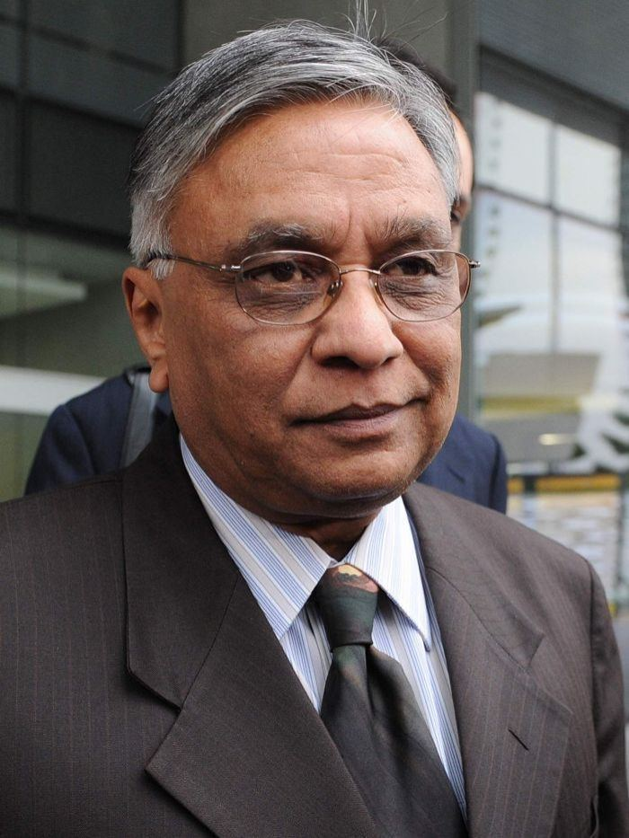

Bundaberg Hospital in Queensland, Australia.
Jayant Patel (aka Dr. Death & Dr. E. Coli), Former General Surgeon.

Episode References
Wikipedia – Jayant Patel
https://en.wikipedia.org/wiki/Jayant_Patel

Kaiser Permanente Thrive Exposed
https://www.kaiserthrive.org/dr-death-jayant-patel/

Independent
https://www.independent.co.uk/news/world/australasia/doctor-death-jayant-patel-escapes-with-fraud-conviction-and-plans-return-to-work-8957992.html

Medical Bag
https://www.medicalbag.com/home/features/despicable-doctors/this-surgeon-spent-his-entire-career-as-a-defendant-in-court/

Facebook - 7NEWS Cairns
https://www.facebook.com/7NEWSCairns/videos/197978904787264/

BBC News
https://www.bbc.com/news/world-australia-32747671

CNN World News
http://www.cnn.com/2010/WORLD/asiapcf/10/28/australia.doctor/index.html

Disease of the Week
Center for Disease Control and Prevention
https://www.cdc.gov/diabetes/basics/diabetes.html

Mayo Clinic
https://www.mayoclinic.org/diseases-conditions/diabetes/symptoms-causes/syc-20371444

