EP53: The Perez v. Chaudhry Case

Description

This week we present the lawsuit Dr. Chaudhry filed against a team of health department investigators after the Silvino malpractice case. Why did one state report lead to Dr. Chaudhry filing a civil suit? Let's just say that this report revealed that Dr. Chaudhry has a lot more drama than just his due process...

Pictures
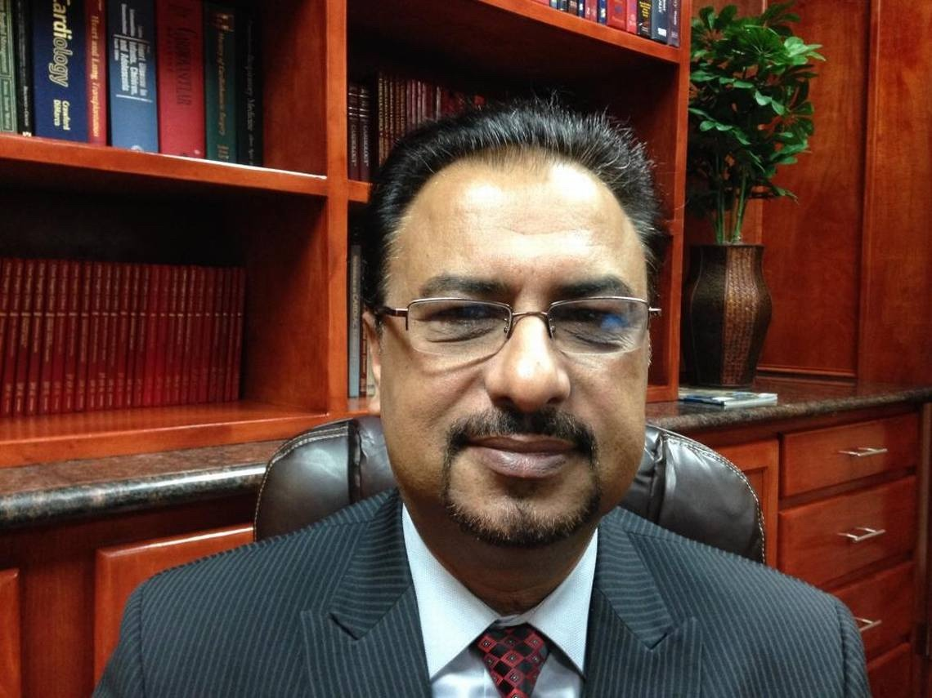

Dr. Pervaiz Chaudhry leaving the court room after a case hearing in 2018. Picture credit given by the Fresno Bee.

References

Gov Info
https://www.govinfo.gov/content/pkg/USCOURTS-caed-1_16-cv-01243/pdf/USCOURTS-caed-1_16-cv-01243-40.pdf

Casetext
https://casetext.com/case/chaudhry-v-smith-2/

Transcript:

Lillee Izadi 0:18
Hello everyone and welcome back to your favorite medical malpractice crime podcast, ethical side effects. If you're new here, I'm your host Lillee joined by my trusty co host, TJ.

TJ McKay 0:31
Yes. So nice to be coming back at you guys with a new episode. And I hope you all had a wonderful Thanksgiving as well.

Lillee Izadi 0:40
Yes, I know our Thanksgiving went well, TJ, and if you guys remember as we discussed in our previous episode, this week, we wanted to talk about the separate case or investigation that came out of the lawsuit between the Perez family and Dr. Chaudhry, so sort of a part two from our previous episode. So that means if you haven't listened to our previous episode, definitely do that. So you have a little bit of a better idea of what we're talking about in this week's episode. But before we get into this new case, remember if you rate and review our podcast, as well as subscribe to us wherever you're listening, it really helps support us and allows us to reach more people. So please spread the love this holiday season to us and the other podcasters you love to listen to on the daily. And lastly, it's already December guys, and you know what that means? Holiday shopping is well underway. So don't forget to get yourself and your loved ones, some ethical side effects merch this holiday season. And you can look at our merch store using our link tree in the episode description below. Or by going to our website.

TJ McKay 1:50
I'm personally excited to give some Ethical Side Effects stickers for our stocking stuffers, Lillee.

Lillee Izadi 1:56
Okay, TJ, I love that idea. Because you know, I'm a sucker for stickers. But anyway, now that our little shameless self promotion is finished, how about we get right into that Chaudhry versus Smith case?

TJ McKay 2:10
Sounds like a plan I can get behind. Let's get right into it.

Lillee Izadi 2:13
So last week, we talked about how a series of horrific mistakes in the operating room led to solino presses vegetative state, and how this eventually led to shot dri paying millions of dollars to the press family as well as him being suspended for that two week period. And we could kind of tell from the last episode that Dr. Chaudhry didn't really think he was in the wrong for all of this, and that overall, he didn't really seem remorseful for what had happened to Silvina in the first place. And this point is really emphasized when on June 17 2016, Dr. Chaudhry and his medical group, Valley Cardiac Surgery Medical Group, filed a civil rights lawsuit against a group of Public Health Department officials. And after naming a few individuals in the civil suit, eventually three defendants were narrowed down for taking this trial to the Fresno Supreme Court. And these three individuals were Dr. Karen Smith, Steven Lopez, and Shirley Campbell. Now, as we know these individuals really not named in the last episode, but amidst so Vinos case, of course, internal investigations usually take place when things like this happen, like malpractice cases, or any sort of major lawsuit is filed so that the hospital of course can get all of its ducks in a row for any sort of legal matters ahead of them, and also to rework any sort of policies that they have to make sure this never happens again. And sometimes if hospitals are overseen by governmental entities, maybe certain government officials like from health departments will investigate the hospital as well. And understandably so because we can't have purposeful malpractice cases happening left and right without being overseen checked up on or stopped in their tracks. But in this case, an investigation did not go underway until an anonymous complaint was made that brought Filipinos terrible circumstances to their attention. Now, there was only one article I read that claims this anonymous complaint was from a nurse. But regardless, the complaint consisted telling the California Department of Health that Dr. Chaudhry had left the operating room before the surgery was actually complete. And one of the reasons given by the anonymous person who submitted this complaint is that at first, Silvino's family did not even know the complete truth as to why Silvino's surgery took longer than the family expected, or why Silvino is now in the ICU after surgery. So this person felt the need to tell the family what really happened to silver, you know, which is apparently how the family even found out in the first place and why the Health Department said If this investigation, and this investigation did not go over well with Dr. Chaudhry at all, because again, he didn't really believe he was in the wrong like we talked about, but to it seemed like he thought that because the investigation was based more on personal judgments of him based on Silvino's case and families lawsuit that there was too much prejudice and not enough facts about how he went about Silvino's case.

TJ McKay 5:26
Wait a minute, I'm a little confused. What do you mean by this?

Lillee Izadi 5:31
So I was a little bit confused by this too. I'm not gonna lie at first. So the way I interpreted this is that, because there was this investigation by the Health Department happening simultaneously to Silvino's malpractice case, where Chaudhry was getting, of course, a lot of bad press, that might or might not be true, because news outlets have a way of turning things over subjectively. It tainted the objectivity of the investigation of his care through the Health Department. And I think this is a very valid point. If I was doing an investigation, and I talked to the family of the victim about their views on what happened, and saw these news articles and new stories in which the physician I was investigating was being shown in a very bad light. I think this might subconsciously make me look a little harder for the things that he did wrong rather than the things he did, right according to the policies in place. So the reason Dr. Chaudhry filed this lawsuit against the people at the health department is because he believes this investigation and a wrongly written report cause the family to filed a lawsuit against him that malpractice lawsuit we talked about in the last episode. So in filing the civil suit against public health department officials, it seems like Dr. Chaudhry basically asks these officials to correct the state report that was filed against him and possibly maybe even compensate him for emotional distress and problems with this practice. And to do this, he wanted to exclude certain testimonies. And to do this, he wanted to exclude certain testimonies, information and evidence and particular areas of the Silvino's case that were not excluded before because now he deemed them you relevant to the investigation of his practice.

TJ McKay 7:29
Okay, so what exactly were these things lowly?

Lillee Izadi 7:33
TJ, I'm glad you asked. And this is actually the biggest reason I wanted to bring up this case to our listeners, because the stuff he deemed irrelevant, could definitely be seen as not pertinent to his investigation, per se. But it's definitely interesting to add as a lens to why Silvino's case might have ended so badly, because overall, this man has really poor character, just based on what I'm about to tell you guys.

TJ McKay 8:05
Oh, my goodness, I'm a little weary right now. I'm gonna say, but give me a second to brace myself and just hit us with it.

Lillee Izadi 8:12
Oh, yeah, this is gonna be a ride everyone. So during Dr. Chaudhry's civil suit, there were 12 motions that he made, which included information or topics that he wanted to exclude from this new lawsuit. One was the mention of any results from the Perez lawsuit, which again, might be weird to some. But that's something I understand because if during members know he was convicted of malpractice, or if anybody for that matter considers that he was convicted for malpractice, they are automatically going to think he wasn't doing what he was supposed to be doing, and will be biased. And he won't get a new fair evaluation of his practice by these investigators as to whether he did do the right things or not, during this case, if any. Also, just a little side note, this piece of information might also be weird to some because, again, at the time this was filed, it was 2016. The results of the Perez case were not decided upon at that point, because remember, that case was finalized in 2018. But it's important to point out that this lawsuit, and where I'm talking about the motions now that he made to exclude this information, was actually in 2020. And the civil rights lawsuit didn't get settled until 2021, which is likely when a lot of this stuff was put forth. So that was the first motion regarding no information about the Perez case. As for motions, two, three and four, they kind of tailored off from this first motion, because he also wanted no testimonies from the Perez family included, no negative print of Dr. Chaudhry regarding that case to be included in the investigation, and that no rebuttals were made by the defendants witnesses about how he handled the Silvino case. Now, the defendants refuted these exclusions for a few reasons. Of course, with the main two being that one of the reasons Dr. Chaudhry claimed to have filed the lawsuit is that their report is causing Dr. Chaudhry emotional distress. And the way that they want to refute that is to show evidence for the breast case being filed for malpractice against him before their case report about the investigation even was published in one out, which would remove them from being at fault for his distress and causing the malpractice suit. And of course, this would all involve relevant information and mention of the Perez case. So it was decided that depending on the testimony presented at trial, the pres lawsuit may be relevant to Dr. Chaudhry's damages in this action. And although some statements from the negative news articles that Dr. Chaudhry was referring to can be quite inflammatory. I think it's important to include some of the facts about him in these news articles within this new lawsuit, because these were based on facts from the health department's state report. For example, one article stated that Dr. Chaudhry was listed as one of seven doctors statewide whose patient death rate was worse than the state average, the state took overall patient health into consideration when calculating these patient death rates. And even with those adjustments, Chaudhry, his death rate was 3.62, whereas the statewide rate was only two. So he can't really make the argument like he did during this case, that he only saw people when their heart health was almost irreparable, and they needed some sort of help. Even when those things were taken into account, he still had a higher death rate.

TJ McKay 11:53
Right? Because that is quite drastically a difference when it comes to the death rates among the running average for the state compared to I think he, I believe he said 3.62, which I will say is on the higher side.

Lillee Izadi 12:09
Yeah. And that's exactly why I find it important to include this when redoing their investigation, or keeping that type of fact, in the state report that the public health department publish, but this isn't even the craziest part because the rest of the motions for exclusion get pretty interesting. And when I heard the rest of these, it really just made me side I this man, because if your life is this much of a mess on the outside, I don't know if I trust you as a person to do my life saving heart operation, you know?

TJ McKay 12:43
Please spill the tea, please, Lillee, go on.

Lillee Izadi 12:46
So apparently his fifth motion is to exclude any mention of his alcohol use, which is like a weird thing to bring up unless there has been something out there in his past, you know, that was like, published, he was convicted of type of thing regarding alcoholism or alcohol abuse. Now, that's just me, I couldn't find anything else surrounding that statement for why he would want to exclude that information. But it was deemed irrelevant unless alcohol use was found to be involved at the hospital or during the surgery that the case report in question was covering type of thing.

TJ McKay 13:21
That is quite suspicious, not online.

Lillee Izadi 13:24
Yeah, I know. And it gets a little more weird, because he also wanted to exclude evidence related to other lawsuits that were filed about other malpractice cases he had, or any lawsuits he was involved in, in general as of recently, so he didn't want anybody to bring up any lawsuits that he was involved in, which again, is just a little weird, you know? And if you have that many all at once, you know, it's kind of a few red flags, in my opinion. And through this, I did find out that he was in a wrongful termination suit with Fresno Heart back in 2011, for some misconduct with nurses and making comments against homosexual team members at the hospital.

TJ McKay 14:09
Yeah, I can see how that can potentially paint him in. Not so great light.

Lillee Izadi 14:15
Yeah, I mean, again, not ideal, and everybody's entitled to their own personal beliefs. But it definitely makes me wonder how he might value and treat the lives of those who might encounter in a medical setting. If he can't even respect the nurses. He's working with him. He can't respect other people on his team that might have different lifestyles or views or whatever it may be to him.

TJ McKay 14:38
Exactly it's just a little unsettling...

Lillee Izadi 14:40
Yeah. So those were the lawsuits that I found that were going on with him at the moment of this little case here. And it looks like the other motions that he presented for information being excluded include claims that Silvino wasn't stable when Dr. Chaudhry left the operating room because he truly believed that he was stable. And I do agree with this information because it seems like he was technically stable before he decided to leave the operating room in the hospital. I mean, despite Silvino not being stable within five minutes of him leaving technically he was stable. Additionally, the last few motions he made for information is revolving around allowing his witnesses to testify during this lawsuit. And also he proposes some motions about the physician assistant, Bella Albakova. The most shocking of the exclusions he put forth is that he requested no evidence be brought up regarding his personal relationship with her, because again, they were dating, which is understandable. But again, he didn't want to specifically include the fact that he was having an extramarital affair with her.

TJ McKay 15:52
Ooh, I don't even know what to say about that, Lillee.

Lillee Izadi 15:57
I know I'm like right there with you, TJ again, it's a little bit awkies.... okay. I'm just a little bit on edge about Dr. Chaudhry is a person and his character. And I now find it even harder to believe that you actually have a good moral code, you know, I can understand why he wanted these things not to be mentioned in this new case. But to be quite frank, I think these all exemplify who he is as a person, which could also impact how he treats patients and how he goes about his practice. I'm not going to say that this is a direct linkage by any means, nor am I going to make the accusation that he's a bad physician, but he surely isn't a righteous person. And for that reason, might not always treat his patients well, because of it.

TJ McKay 16:45
I would have to agree with you there, really, and I'm intrigued to see how this case turns out given all these exclusions.

Lillee Izadi 16:53
Yes, I was too. So looking more into how this case unfolds. It looks like throughout the year following the motions that he proposed certain motions were granted or denied on an individual basis, depending on the evidence that was presented throughout the rest of the trial going into 2021. So the only ones that were flat out granted to Dr. Chaudhry at this point in time and 2020, when he proposes these motions was the request to not bring up his alcohol use his requests to keep the extra marital fair information out of the trial. And one of his requests surrounding the PA in which he wanted to exclude defendants from stating that the closure of Mr. Perez by Bella Albakova was not within the standard and accepted medical care. And I agree with all those statements. I think that the PA knows for sure how to close up and stitch up a patient that is part of their medical training. I've seen it done. I'm sure that that is something that defendants didn't need to bring up anyway. So I have to agree with all this information.

TJ McKay 17:57
I will also have to agree with it. I think those granted turns are not extremely relevant to the investigation of his practices as a whole.

Lillee Izadi 18:06
Yeah, I mean, I don't really care if he's having an affair. I just hope that that's not my spouse, he's having an affair. Anyway, with these terms for exclusions, granted, the trial continues well into 2021, as I stated, and personally, I find it no surprise that the defendants were found not liable for Dr. Chaudhry, emotional distress, nor were they required to amend their state report or compensate him in any way shape or form. And rightfully so, because again, it seems like he isn't willing to accept the fact that he was in the wrong for his actions during the investigation and for the entire Silvino case. And this was even shown with his wrongful termination case because he just continues to poke the bear despite him knowing that he did something wrong, and just wants to create more of a fire to seem like he didn't do anything wrong.

TJ McKay 18:57
And he doesn't deserve to receive a monetary war from his mistake and trying to basically put all his problems on someone else's basically trying to dump all his issues on someone else. Like come on.

Lillee Izadi 19:12
Exactly. I couldn't have said it better myself, TJ that's exactly what he's doing. And with this second part of Dr. Chaudhry revealed, I think that that is it for this episode, as well as all of Dr. Chaudhry shenanigans we've been discussing these past couple of weeks. I hope we don't have to discuss him anymore. But again, thank you guys so much for tuning into this week's episode. And we're so excited to bring you some more content in these next couple of weeks. And as always, make sure you submit a case suggestion to our suggested case form on our website. If you have a case you've been wanting us to cover.

TJ McKay 19:51
Yes, we always really enjoy getting requests from you guys for a case to cover in a future episode.

Lillee Izadi 19:57
Oh, for sure. It literally makes our day! And while you're on our website, make sure to check out our case files and pictures page, or follow us on our listed social media platforms, because we love seeing that you guys enjoy us and our content. And with all that said, we're wishing you guys much love and coziness in the month of December. And we'll see you guys in next couple of weeks for another case of medical malpractice. Bye guys!

