EP 49: The ICU Fentanyl Scandal

Description

When a series of ICU deaths associated with abnormally high levels of fentanyl occur at Mount Carmel West between 2015 and 2018, Ohio State Police and Mount Carmel Health System become weary of ICU physician Dr. William Husel. Four years later he is acquitted of all 14 counts of murder.

Pictures

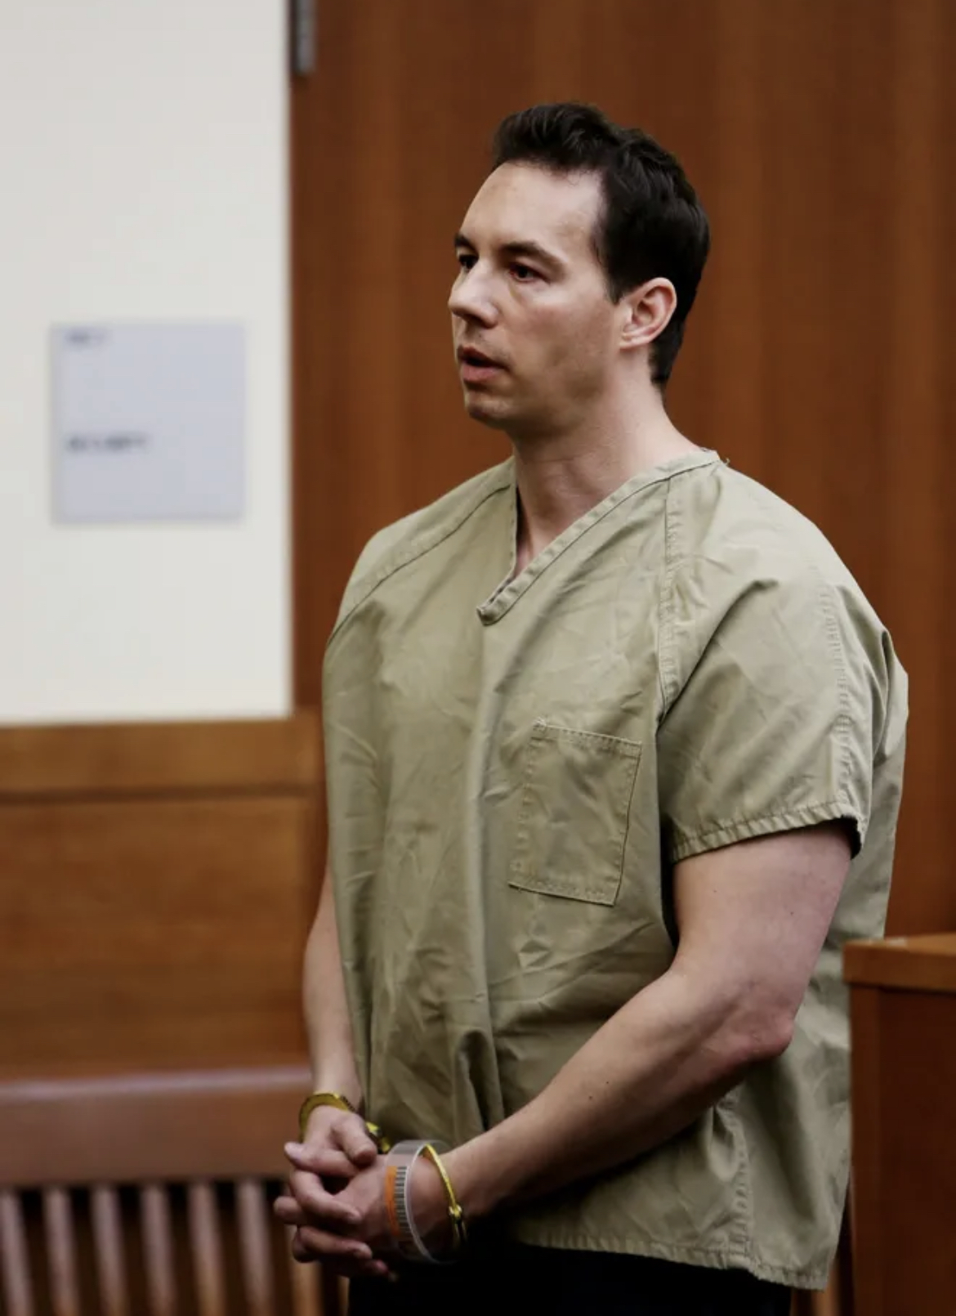

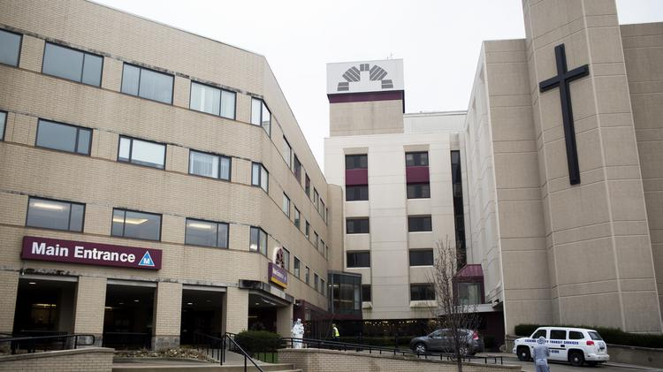

Orthopedic surgeon, Dr. Robert Ricketson. Picture credit from Doximity.
Arturo Iturralde before his surgery on January 29, 2001. Picture credit from Insider Exclusive.

References

The Washington Post
https://www.washingtonpost.com/nation/2022/04/20/william-husel-fentanyl-doctor-acquitted-ohio/

The Columbus Dispatch
https://www.dispatch.com/story/news/crime/2022/04/20/former-mount-carmel-doctor-william-husel-found-not-guilty/7269134001/

Wikipedia
https://en.wikipedia.org/wiki/William_Husel

Society of Critical Care Medicine
https://www.sccm.org/Communications/Critical-Connections/Archives/2019/The-Impact-of-Opioids-on-the-Delivery-of-Critical

The Korean Journal of Internal Medicine
https://www.kjim.org/journal/view.php?number=162442

The New York Times
https://www.nytimes.com/2022/04/20/us/william-husel-ohio-doctor-murder-trial.html

thebmj
https://www.bmj.com/content/377/bmj.o1051#:~:text=Ohio%20doctor%20is%20acquitted%20of%20murdering%2014%20intensive%20care%20patients%20with%20fentanyl%20overdoses,-BMJ%202022%3B%20377&text=An%20intensive%20care%20physician%20in,at%20the%20end%20of%20life.

Episode 47 Transcript

Lillee Izadi 0:18
Hello, everyone, and welcome back to another weekly dose of your favorite medical crisis podcast, ethical side effects. I'm your host, Lillee joined by the best co host around TJ McKay.

TJ Mckay 0:33
What's going on everyone? Thank you, once again for tuning in this week.

Lillee Izadi 0:37
Yes. And this week, I thought I would pick a case that was actually recommended by one of my sisters, Ellee, who is also a loyal listener of our podcast that took place right here in the city of Columbus where I'm currently staying right now. So for our loyal Ohio listeners, you might recognize this case today. But before I get into all of that, I just wanted to wish all of our ethical side effects listeners a happy belated Father's Day and Juneteenth weekend. We sincerely hope it was a great and fantastic one. And if you don't already know we at ethical side effects are continuing our celebration and support of Pride Month by holding a donation drive until July 1. For the organization GLMA, which is again, a national organization made up of healthcare professionals, and community members committed to not only ensuring health equity for lesbian, gay, bisexual, transgender, queer, and all sexual and gender minority individuals, but they also advocate for the equality of LGBTQ+ health care professionals in their work environments, which again, as always, is extremely important. So if you're interested in donating, please go to the support the cost page on our website. And you can find that link in our link tree below. And you can also donate to their organization directly through our website, or you can just donate to our podcast by clicking the donate button on things like our newsletter, website or link tree. And all the proceeds that we receive personally will be going to GLMA this month per our usual donation drive protocol. And if you want to go the extra mile, we also have other LGBTQ+ advocacy organizations listed under that support the cause page that you guys can check out and donate to as well. Lastly, if you haven't already done so, please subscribe to our podcast, follow us on all of our social media platforms, subscribe to our newsletter, and rate and review us on your preferred podcasting platform to show us some very much needed love. We always really appreciate hearing from you guys, and knowing how much you like our content.

TJ Mckay 2:55
Yes, and if you have any questions, please do not hesitate. And feel free to email us at ethicalsideeffectspodcast@gmail.com or reach out to any of our social media platforms. And we'll get back to you as soon as possible.

Lillee Izadi 3:11
Absolutely, I couldn't have said it better myself, TJ and to you know if I happen to miss anything.

TJ Mckay 3:18
Honestly, I believe that you covered everything that was on my mind. And I must say that I'm personally intrigued to see what case you have dug up for us this week, because I don't really know a whole lot about it. So without any further ado, how about we just get right into it?

Lillee Izadi 3:35
Let's get into it.

So this week's case, as I said before, takes place in Columbus, Ohio between 2015 and April 2018 with Intensive Care Unit physician Dr. William Husel. Now Dr. Husel grew up in Cleveland, Ohio, where he eventually attended wheeling just quit college and Ohio State University to finish up his undergraduate degree and then went on to Ohio University School of Osteopathic Medicine. He eventually finished medical school got trained at the Cleveland Clinic for what seemed to be residency training and then started a position at Mount Carmel health systems in 2013. Based on the articles I read, it looks like he mainly worked at Mount Carmel West, but again, since he was part of the Mount Carmel health system as a whole, he might have also worked at other Mount Carmel locations. So one important thing to discuss in regards to this case in what I was learning about it is that we really need to know what an intensive care unit physician does in the first place before we get into what occurred. So intensive care, also known as critical care is a specialty specifically Then involves professionals from many different medical disciplines that help with the management of patients at risk of developing or that have developed some sort of life threatening disease or injury. And much like hospice, the critical care specialty also tends to use high level pain relievers in order to improve the quality of life, while a patient is either battling some sort of life threatening disease or injury, or in some cases succumbing to that illness or injury that they have. The issue that comes up with the use of these pain relievers, though is how much is too much to use in every specific case, you know.

TJ Mckay 5:41
And that question in regards to what amount of opio should be used in both the ICU in the hospital care, say, can honestly be debated for years to come? And it hasn't been ethically argued for years in the past.

Lillee Izadi 5:57
Exactly, TJ and I think that this issue boils down to improper pain management and a variety of areas in medicine. But overall, the entire backbone of this intensive care field is quite honestly, like I was getting at before. And what TJ mentioned is managing pain sedation while also managing opioid overdose, withdrawal and overall trying to prevent dependence should the person not be in the ICU later on. And as you can imagine, this is an extremely hard juggling act, especially since pain can be such a subjective sensation. Right. And that's exactly the trouble that Dr. Husel runs into when starting at Mount Carmel. When on November 21 2018, Dr. heusler was removed from patient care duties on allegations of the murder of 25 of his ICU patients.

TJ Mckay 6:55
Yeah, I just hear you correctly. Did you say 25 patients?

Lillee Izadi 6:59
Oh, yeah. 25 patients, TJ. Now, this was eventually shortened to only 14 patients in this allegation in January 2019, after further investigation was done by the Ohio State Police, and Dr. Husel surrendered himself and his medical license to the appropriate authorities on the medical board.

TJ Mckay 7:20
Okay, so I know I'm getting ahead of myself a little bit here with this question. But I can't contain myself. Where are these deaths all at once? Or do they happen in like 2013 to 2018? Sort of a period? Because if so, why did they all of a sudden get pushed through a criminal investigation by police rather than going through an internal hospital investigation first?

Lillee Izadi 7:47
Great questions, TJ. So from what I was reading, it seems like the first time any concerns with Dr. Husel were actually brought to the attention of the hospital was on October 25 2018. So not even a month before criminal allegation started underway. And this concern was in the form of a formal report regarding Dr. Husel conduct and use of what was said to be a large amount of fentanyl. However, as you've seen with many other cases, this report was not investigated seriously, at first, at least until November 19 2018, when they brought in their investigation, and noticed that a patient by the name of Rebecca Walls had an abnormally high dosage of fentanyl in her system. Now, my first question is what is considered an abnormally high dose of fentanyl? You know, and after doing some research, the recommended dosage differs depending on its usage, of course. However, it did seem like the higher end dosages for things like hospice care and some other things was around one to 2000 micrograms, especially for like I said, extreme cases of terminally ill cancer patients. This is not going to be okay for the average person as we can likely conclude because this is a lot of fentanyl. And it will not always be appropriate for the average ICU patient either. So knowing this, I found it strange that Rebecca was found to have been given this 1000 microgram dose of fentanyl as ordered by Dr. Huseland then died five minutes later.

TJ Mckay 9:29
Yeah, there's absolutely a lot better now. I thought I read somewhere that the estimated lethal doses of fentanyl for humans was about two milligrams and converting 1000 micrograms to milligram reaches that one milligram zone. So that's getting pretty close to the average lethal dosage.

Lillee Izadi 9:51
TJ that literally goes perfectly with what I was just about to say because not only did this Rebecca Walls case, sir quite a bit of attention. But a day later, actually another one of Dr. Husel patients named Melissa Penix died four minutes after receiving a 2000 microgram dose.

TJ Mckay 10:12
Um, yeah, that's literally like the lethal dose of fentanyl. Like, hang on why that's kinda that's kind of wild.

Lillee Izadi 10:22
I know you like read my mind, TJ. And there were many other patients even before these last two cases and 2018. Because remember, he was eventually charged with 14. So to answer the other parts of your question before I went on my little tangent there, the rest of these fentanyl related deaths occurred between February 2015 all the way up until Melissa Penix died in November 2018.

TJ Mckay 10:51
Gotcha. So are there really no other reports? Oh, notice is given about him before 2018?

Lillee Izadi 10:58
No, honestly, not that I saw. And some of the things I did see were like, way back in his past, like in college of him, like making a fake bomb or something which I'm not going to go into, you guys can read it on the resources, I put in our case files and pictures page, because it's a little bit crazy. But honestly, by that point, like the 2018 time point, he had only been practicing there for about five years. So it's not like this case is one of those that goes on for like decades and nobody finds out. However, the trial is a whole other issue, which is just a lot to unpack.

TJ Mckay 11:43
Can we just test bases real quick and say that making a fake bomb isn't normal? So how we're just going to like, surpass that. Like, it wasn't like a big issue here. Like a fake bomb. Come on. Now. What was the purpose behind it?

Lillee Izadi 12:00
I don't even know. And that's one of the reasons like I said he went to the Wheeling Jesuit College in Ohio and then finished at Ohio State because I think he had to transfer from that initial college student that to Ohio State, but I can't confirm that for sure you guys will have to do your own little research on that. But it was a lot to handle honestly and a lot to read and a lot to go through. So.

TJ Mckay 12:22
Okay, anyway, to get back to the story right here with the case what happened and trial Lillee.

Lillee Izadi 12:30
So Dr. Husel trial began on February 22 2022. And the main argument from the prosecution during this trial was that Dr. Husel prescribed dosages of fentanyl that were more than medically necessary to ease pain and that his actions caused the patient's death. To support this they brought in certain witnesses like pharmacists Talon Shroyer, who had previously worked the night shift at Mount Carmel to testify that he thought doctor uses fentanyl orders were unusual, but he did admit in his testimony that he was unsure if Dr. Husel actions could be a result of possible drug diversion. Additionally, the same pharmacist did say that Dr. Husel saved the lives of several of the alleged murder victims by providing life saving interventions such as CPR and medications like that as oppressors too. So that was kind of a mixed testimony. On the prosecuting side, the jurors also heard from Dr. Wesley Ely, who at this point in time, was a pulmonary critical care physician and a Vanderbilt University professor and Dr. Ely testified saying that each of those patients could have died as a direct result of the medication that Dr. Husel ordered for them. And he did not believe personally in his expert opinion that the patients died indirectly from their underlying health conditions that it was basically all of Dr. Husel fault. And in addition to these two witnesses, the prosecution literally brought like 51 Other witnesses to testify against Dr. Husel. So it was a lot on their part. The defense was different in that they only called on an anesthesiologist and intensive care specialists named Dr. Joel Zivot. And Dr. Zivot testified that the drugs administered by Dr. Husel were intended and ordered for comfort care at the end of life. He also testified that he believed all 14 patients Dr. Husel was accused of murdering had actually died from illnesses and underlying medical conditions rather than the fentanyl that Dr. Husel had ordered for them. So Dr. Zivot was basically undermining what Dr. Ely was talking about through this testimony, and it was kind of a back and forth with the defense having a lot less witnesses. So with hearing from all of these many expert witnesses, the jury deliberations began on April 12. And on April 20, they finally came out with their verdict. And that verdict was that Dr. Husel was not found guilty on the charges.

TJ Mckay 15:09
No way! Not guilty? How on earth is Dr. Husel not guilty for the death of his patients?

Lillee Izadi 15:18
I know, I know, I was a little bit skeptical about this case. And honestly, at the end of researching it, I don't know if that is what I was expecting or wanting to hear from this case. But knowing that little part of his past as well as how much fentanyl he was giving his patients, part of me thinks he was kind of guilty. I don't know why exactly. But it just kind of feels weird to me to see that this has happened so many times with his patients, especially with how high of fentanyl doses he was giving them. Like I said before, more specifically, the lowest amount of fentanyl I saw that was linked to someone dying was 500 micrograms, which is still a lot, you know,

TJ Mckay 16:09
Oh, yeah, I completely agree with you, Lillee, because it's a known fact that he was overdosing his patients, which is why I feel like he was guilty. And I just cannot understand how the jury could find him not guilty, not responsible for the death of not only 14 of his patients, but in the beginning. They originally accused him of 25. I think he knew he was overdosing his patients. And he just, I don't even know what to say.

Lillee Izadi 16:43
Yeah, I think that this is a hard one. And like you said, the proper amount of fentanyl and what to do in terms of pain management cases like this is something that can be debated for so long. It's one of those arguments where the quality of life kind of trumps how much medication you have to give the patient in order for them not to suffer. But all of these opioids, whether it be fentanyl, whether it be morphine, all just relieved the pain to the point that you could die if given too much because of respiratory depression. So these patients might be so used to receiving larger than normal dosages of fentanyl for so long, due to their chronic pain, that they just keep upping their dosage to feel any sort of pain relief until the depression of their respiratory tract just seeps in, and they go into a coma and die. So honestly, it could have just been unlucky multiple times for Dr. Husel. And that the patients have reached our threshold that fast. But at the same time, I just find it very strange that in five years, he's had all of these deaths connected to him, at least preliminarily of 25. That's quite a bit for me. I haven't heard many other ICU physician cases like this. So I could be wrong in this being an abnormal one. But I think that going forward, new pain management guidelines need to be established. And every current and future medical professional knows that pain management is a very big issue, especially with the opioid epidemic.

TJ Mckay 18:23
I couldn't have said it any better myself, Lillee, I definitely think that we need to as a whole need to come together and really try to do more about this epidemic that's going on throughout the US because it's definitely sad to observe someone's son or daughter loved one, whether it be suffered silently alone without the assistance of someone like their family members, friends or whatever.

Lillee Izadi 18:58
Exactly. And if you guys are interested in learning more about certain case studies in opioid prescribing and pain management, we will have those cases linked in our episode description as well as our case files that pictures page for our future and current medical professionals to check out. But yeah, overall, he didn't going free, but I believe his medical license, at least as of May 2022 was completely revoked in Ohio. So I don't know if he's eligible to get back his medical license and get back to practicing in Ohio or whether he's going to move to another state in practice. Who knows. But if any developments in this case happen soon, we'll definitely have to release a bonus episode. Right TJ? We will have to. Exactly that is the spirit I love to hear TJ and other than that, this ends our case for the week. However, have no fear because if you do have a case suggestion that you guys would like us to do a little bit of research on On, feel free to go on our website and click on the case suggestion form that we have. And you can fill that out and we'll do some research because we're always looking for a crazy case to cover. But as always, again, please rate and review our podcast follow us on our social medias, get on that newsletter because we'll be releasing one soon. And we will see you next week for another case of medical malpractice. Bye guys.

