EP 47: Screwdriver Shenanigans

Description

73-year-old Arturo Iturralde went in for a routine spinal fusion surgery at Hilo Medical Center on January 29, 2001, only to come out with a screwdriver in a place where a titanium rod should be. The reason why? Only Dr. Robert Ricketson really knows.

Pictures

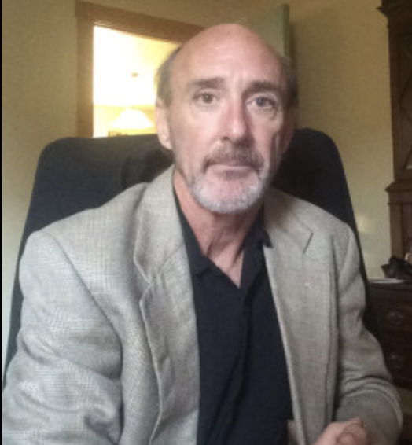
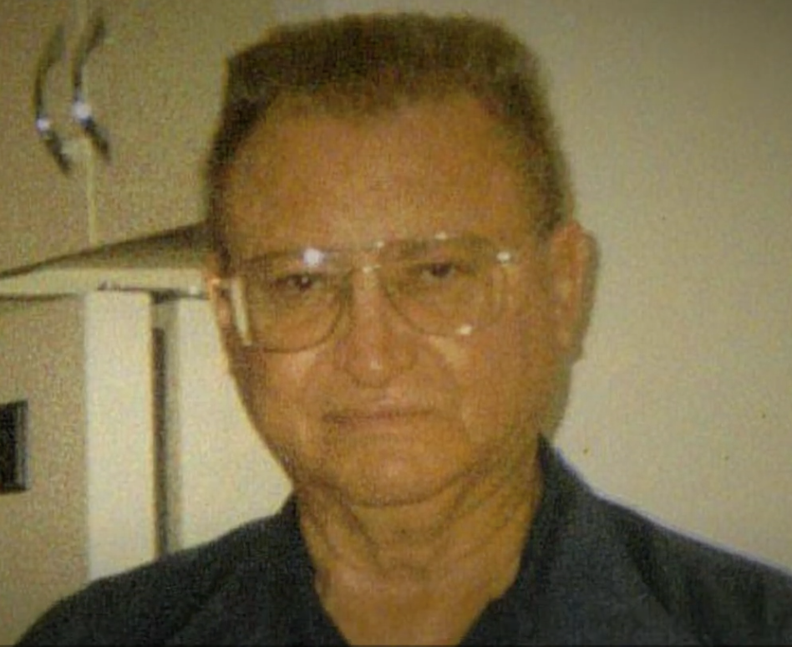

Arturo Iturralde before his surgery on January 29, 2001. Picture credit from Insider Exclusive.
Orthopedic surgeon, Dr. Robert Ricketson. Picture credit from Doximity.

References

Hampton & King Attorneys at Law
https://www.hamptonking.com/blog/7-shocking-medical-malpractice-stories-you-wont-believe-happened/

Insider Exclusive
https://insiderexclusive.com/when-doctors-go-wrong-arturo-iturraldes-story/

abc News
https://abcnews.go.com/GMA/story?id=1630844

Davis Levin Livingston
https://www.davislevin.com/blog/2015/july/-5-6-million-verdict-for-hilo-malpractice/

StoDocu
https://www.studocu.com/en-us/document/southern-new-hampshire-university/ethical-and-legal-considerations-of-healthcare/ihp-420-final-malpractice/10906557

Starbulletin.com
http://archives.starbulletin.com/2003/07/27/news/story2.html

The Health Law Firm
https://www.thehealthlawfirm.com/uploads/FlaHospital_Lawsuits3.pdf (Slide 19)

Episode 47 Transcript

Lillee Izadi 0:19
Hello, everyone, and welcome back to another weekly episode of ethical side effects. As always, I'm your host, Lillee, joined by my wonderful co host, Mr. TJ McKay here.

TJ Mckay 0:33
What's going on guy? Like always, thank you so much for tuning in to another episode this week from medical crime podcast.

Lillee Izadi 0:42
Yes, thank you. And personally, I'm really excited to get into our case for this week, because it is really crazy. And I cannot say that I've ever heard of it before. Like literally now when I'm telling you guys, it's quite the jaw dropper and kind of gives me the vibes of the Christopher Duntsch case we covered a little while back. So...

TJ Mckay 1:05
The last thing we need on this earth is the imitation of Christopher Duntsch. I think this entirely planet has gone through enough after all the chaos that does cause

Lillee Izadi 1:16
Oh, I agree. And I think you'll see why I kind of saw this in this case once we get into it a little bit more. But before we get into the case, of course, I have a couple of announcements like always. So one as you all likely know what we had ethical side effects are continuing our celebration and support of Pride Month by holding a donation drive until July 1. For the organization GLMA, which is a national organization made up of health care professionals and community members, committed to not only ensuring health equity for lesbian, gay, bisexual, transgender, queer, and all sexual and gender minority individuals, but they also advocate for the quality of LGBTQ plus health care professionals in their work environment, which as we all know, is very important. So if you are interested in donating, please go to the support the cause page on our website in our link tree below. And you can donate to their organization directly through them on that website page. Additionally, you can decide to donate to our podcast by clicking the donate button on our newsletter, website or link tree. And all the proceeds from that will be going to GLMA this month per usual donation drive. So again, you can donate directly to them, or you can donate to our podcast and all proceeds will be going there as well. And if you want to go the extra mile, we will also have other LGBTQ plus advocacy organizations listed under that same support the cost page that you can check out and donate to as well.

TJ Mckay 2:49
Thank you, Lillee for hitting all those key notes in the beginning of our episode. And if you have any questions, please feel free to email us at ethicalsideeffectspodcast@gmail.com or you can reach out to us also on any of our social media platforms. And we'll get back to you as soon as possible.

Lillee Izadi 3:09
Yes, and also if you haven't already done so please subscribe to our podcast. Follow us on our social media platforms. subscribe to our newsletter and of course rate and review us on your preferred podcasting platform to show us some love. We always really appreciate hearing from all of you guys and knowing how much you love our content and the only way we know that is if you give us a rating and review comment on any of our social media posts stuff like that.

TJ Mckay 3:36
Exactly. And with Lillee taking the words basically right out my mouth. I'm thinking we're about ready to get into this episode. Lillee What do you think?

Lillee Izadi 3:45
Yes, I'm glad I covered everything then. Fortunately, you did not take the words out of my mouth. Oh, TJ so we can still get into this case today and I can talk about it. And with that, I'm guessing you're ready. TJ

TJ Mckay 3:57
Why do I feel like that was shots fired?

Lillee Izadi 4:00
It wasn't it wasn't I was just trying to play off your words and get into this episode today. So are you ready teaching?

TJ Mckay 4:07
Yes, I am definitely ready. So let's get right into it

Lillee Izadi 4:17
So the case we have for you all this week takes place on the island of Hilo Hawaii, which is very new for us because we have like never covered a case like this before!

TJ Mckay 4:28
And not to get off sidetrack but I can't wait until we take a trip to Hawaii. I just wanted to throw it out there.

Lillee Izadi 4:34
Um, maybe maybe I don't know about that withour salaries. But anyway, back to the case and not our sad financial situation. So the main focus of our case is Arturo Itturalde de who is a 73 year old Reverend for one of the churches on this big island of Hilo. Now Arturo was having some chronic back pain for a while and what appeared to be some increasing leg weakness. So on January 29 2001, he decided to be admitted to Hilo Medical Center to assess this increasing leg weakness as well as his back pain, which would cause him to fall a lot. So he's trying to get a workup and see what's going on with him. And while there are Turo is seen by Dr. Robert Ricketson, who is an orthopedic surgeon. And a little bit of background about Dr. Ricketson is that from what I could see, he went to medical school in Oklahoma and received his medical degree there in around 1988. He then started practicing in Oklahoma and then went on to practice in Texas in 1992. Finally, in 2000, Dr. Ricketson moves again to Hawaii, eventually leading him to start work at Hilo Medical Center where he is called to assess Arturo in January 2001. Bringing us full circle to the craziness of our case today.

TJ Mckay 6:05
Alright, so before we get too far into this case, why did Dr. Richardson move so much in the first place? Like? Did they mention that in any of the research as to why he decided to make the leap all the way to Hawaii from places like Oklahoma and Texas? Because I would think that you will want to have a more stable career.

Lillee Izadi 6:27
Yeah, that was weird to me, too. I eventually did find out why. And don't you worry your little head because we'll get into that in just a second. But after Arturo was being examined by Dr. Ricketson, he was diagnosed with degenerative spondyolithesis, L4-L5 with stenosis. And basically what that means is that a couple of disc or bone structures in the spine at the lumbar area, which is like your lower back, have slipped out of position, which could cause degeneration of the tissue around that spinal disc. And basically, this happens because they're rubbing together because they're placed improperly. Now, additionally, he has to Gnosis in that area, which is causing a lot of pain for him because the disc is basically putting a lot of pressure on the spinal cord, narrowing it. So Dr. Ricketson diagnoses Arturo with this and then recommends that he undergoes a spinal fusion.

TJ Mckay 7:27
So, before we again get too far into the case, do you want to just take a moment to explain what a spinal fusion is to our listeners that might not know what that is and how that would actually help our turtle in this specific case?

Lillee Izadi 7:43
Yes, of course, I honestly didn't know what a spinal fusion was for a while. So what this procedure accomplishes is that it helps permanently fix two spinal bones together to avoid them grinding against each other, which was causing the degeneration that Arturo was experiencing. It can also help straighten the spine out to ensure that there's no stenosis occurring again, which can be the source of a lot of pain. I think we briefly discussed this procedure in our Christopher Duntsch episode, but overall, it's supposed to be a fairly routine spinal procedure. And sometimes they can even do it in a minimally invasive way. So it's not supposed to be some procedure that's way out there, new or basically out of the ordinary in most cases, okay.

TJ Mckay 8:31
So Dr. Ricketson recommends this surgery for our Arturo. So did Arturo decide to go along with the recommendation to have the procedure done?

Lillee Izadi 8:40
Oh, yes. And I guess Dr. Ricketson, was able to fit him in for that same day, actually at the medical center. So Arturo goes into surgery in which he is expecting these little titanium rods to be placed in a spine to like I said before, help with spinal stability and fusing those vertebrae together and relieve pressure on the spinal cord, which is all very reasonable and what Arturo consented to do all goes fine. And well, eventually, and Arturo makes it out of the surgery alive and in good shape. However...

TJ Mckay 9:14
Oh, no, here we go. There's the contradiction. I was waiting for it.

Lillee Izadi 9:18
Oh, yes...However, what came as a big shock to people is that days after the surgery on January 29, the rod that Dr. Ricketson implanted, snapped in half, leaving Arturo to suffer through three more corrective surgeries before becoming incontinent as well as a bedridden paraplegic who had to depend on his sister for care.

TJ Mckay 9:43
I find it hard to believe that titanium rocking just snap a half like like did the company have a medical supply manufacturing error or something like that?

Lillee Izadi 9:54
Oh, no, TJ honestly, I wish it was something like that because I feel like What I'm about to tell you, it's just horrific. So just bear with me here.

TJ Mckay 10:04
Well then just go ahead and hit us with it.

Lillee Izadi 10:07
So it turns out that the surgery went well on the surface, but it was done completely inappropriately. More specifically, Dr. Ricketson acted below the standard of care, because he actually implanted the shaft of a stainless steel screwdriver into Arturo spine after the two titanium rods that he intended to use, were discovered to be missing from the operating room.

TJ Mckay 10:34
Hold up! So you're trying to tell me that this man uses a screwdriver as a rod in someone's bed. Like he puts a whole screwdriver in this patient's bed?

Lillee Izadi 10:49
Yes, not exactly. But basically, he apparently claimed in court reports that he sawed off the handle of the screwdriver, and then use the metal heart as a rod. Which like point for ingenuity king, but this is not the time to try something new. This guy who is a living breathing person is in a lot of pain. Let's fix him and not try to find a novel way to perform a spinal fusion, you know?

TJ Mckay 11:17
I'm so confused still like this. This really is hard for me to wrap my mind around, okay, where were these materials? Like did no one prep the or like, what causes man to be like, oh, you know, let me engineer something. Let me take this screwdriver, you know, soft the handle and boom, you know, I just came up with a new way to allow his spinal fusion.

Lillee Izadi 11:42
TJ Dr. Work gets in said that he had no choice but to implant the screwdriver into our Charles back because again, he did not have the titanium rods needed to complete the operation properly. My question though, was like just stop the surgery and go get more. Those weren't the last titanium rods on Earth. And I'm sure those weren't the last ones they had at the hospital. And in doing some deeper digging, I found that staff did order the M8 titanium CD Horizon kit for surgery. However, Medtronic, the company, which fulfill this order and fulfills many medical electronic orders, did not have the instrument portion of the kit in stock at the time of the order. So the whole kit ended up being shipped out from two separate facilities. However, it was reported that by January 27, both shipments arrived at the clinic. So they were there at the time of the operation. Apparently on January 29. Yet no staff member conducted an inventory of the kits. And Dr. Ricketson knew that in order to use equipment in an operating room, proper inventory had to be done according to the hospital policy set in place. And this was further reiterated to him by a fellow nurse and thinking he could still go forward with the operation, the operating team went through the inventory to prepare, but unfortunately, again could not find any rods despite the shipment saying that it was completed. So they called Medtronic who then offered to have a rep hand deliver rods. But it would take according to Dr. Ricketson like an hour and a half to two hours. Now I don't know at what stage the operation was at when this new information of not having the rods was presented. But obviously Dr. Ricketson still went forward with the operation anyway, regardless of the stage that he was told this information, which I don't understand why like just stop the operation or hold off on it.

TJ Mckay 13:43
Yeah, right. Like he's the one, at least from our knowledge that recommended he gets a surgery that specific day. Our terms current condition, at least from what we're hearing was not a emergency situation, to the point where the hospital policy needed to be challenged or override in any manner.

Lillee Izadi 14:04
Exactly and Dr. Ricketson and claimed in court. But again, the supplies would have taken two hours to get into the operating room, which I understand is annoying, but regardless, I don't see why we couldn't have postponed it. Additionally, even if he didn't want to postpone the operation other day, or didn't realize that he didn't have the right materials at first, and they just thought they needed to do inventory. He could have just had our total weight even in pre op to make sure for sure that they had the materials that they needed. And people challenged him on this point to which he claimed that he didn't feel he could risk keeping Arturo under anaesthetic with an unstable spine for two more hours, I guess considering his age. And again, I understand that but it was your fault that you didn't check to see that the operating room was fully prepped before commencing this process and putting them under anesthesia. You also were extremely impatient to the point that you put the patient in the situation Have you knew going in whether it may be because the inventory counsel needs to be done or that the materials hadn't arrived yet, that you might not have all the materials in time for the surgery when you want it to happen? Why even take that chance? If I were a judge, or a jury member listening to this story, I would have said, Don't tell me you put this guy under, opened him up, and then saw that you have no rods, because that is completely on you and your team, you either came grossly unprepared, grossly impatient, or both, and someone suffered for it?

TJ Mckay 15:32
Exactly. I think regardless, doing nothing to his spine would have been better than just shoving power of a screwdriver in there and hoping for the best. Like it's not even the same material, nor has it been tested for endurance. Dr. Ricketson there had no idea what would happen if he installed that part of the screwdriver into his spine. However, he just took a chance on it.

Lillee Izadi 15:57
Yeah, and what's so bad TJ is that Dr. Ricketson did not show enough respect or care for our two roads even alert anyone that he put the screwdriver in before it snapped in half. Nor did he come forward when it did snap in half. And I was wondering how nobody caught on to the fact that he was using a screwdriver while he was operating. And it turns out that in the original operation, where he placed the screwdriver in Dr. Ricketson did the operation to my knowledge alone with no one else in the room for part of it, because he claimed that he needed to focus, which is super suspicious because now no one can account for his actions. And personally, I've never heard of surgeon doing that before.

TJ Mckay 16:43
Yeah, me neither that is so strange Lillee, I really do anything that would be a thing.

Lillee Izadi 16:49
I'm in the exact same boat TJ and as for the operations he did after it snapped in half. Dr. Ricketson was actually the one doing the revision surgery on our turbo with a real rod. But he didn't tell anybody about there being a screwdriver in there in the first place, like I said before, so it was actually one of the nurses in the or during the revision surgery that disclosed the horrific discovery to Arturo's family and the malpractice lawyers that Dr. Ricketson pulled out a broken screwdriver when operating on a turtle's back, which was held at home malpractice case got started in the first place.

TJ Mckay 17:27
Yeah, folks, that will definitely do it. I'm telling you, Jesus, that is a whole lot to take in.

Lillee Izadi 17:34
Yeah, it definitely is. And we haven't even scratched the surface. Because in doing more research, I was completely and utterly shocked when I came across the past of Dr. Ricketson. And not only was this a serious medical malpractice case for him, but he also had many others even before the Arturo case, which is the reason he kept moving around to different hospitals and states, much like Dr. Duntsch did in one of our previous episodes.

TJ Mckay 18:00
So it's making sense now, I'm guessing this guy straight up, probably got his license revoked and all the state he's moved from being here.

Lillee Izadi 18:09
Yes, I found out that after 10 years of practicing, he already had seven malpractice cases between Oklahoma and Texas, leading him to be on probation for five years while having his medical license suspended in Oklahoma. His Texas one was completely revoked, though, and this is exactly why he ended up in Hawaii. Now I also saw that he was very addicted to narcotic drugs to the point that he was writing fake prescriptions for them and even had to go into inpatient rehabilitation. Knowing how addiction can really take over someone, I could see this being the main reason for his lack of reaching the appropriate standard of care as well as basically neglecting his patients.

TJ Mckay 18:50
Wow. Yeah, that makes a lot of sense lately. I just still don't know how he ended up getting positions at all of these places where people noticing his previous track record of many different malpractice.

Lillee Izadi 19:05
Honestly, TJ, it all comes back to how bad the National Practitioner's Data Bank is. Not only our patients not allowed to access it, but it is virtually useless and holding doctors accountable even for hospitals, because doctors are really only able to be identified in this data bank. And sometimes the physicians aren't even put in much like Dr. Duntsch, was it because of arrangements with the hospital or just the inconvenience of having to go through the red tape of getting them put in?

TJ Mckay 19:35
Yeah, this is almost exactly like the Christopher Duntsch case, which is really disappointing because as I said, we do not need an imitation of him on this earth. I can't believe this case isn't more well now without the similarities here.

Lillee Izadi 19:50
Exactly. And what's even more disappointing though, is that Arturo eventually started to have some severe complications from surgery, leading to Euro sepsis and all ultimately his passing in July 2003. So on his behalf, his family sued for malpractice. And the trial took a total of five weeks. And the jury eventually found Ricketson 65% liable. And the Hilo Medical Center 35% liable for credentialing. Dr. Ricketson despite the questionable history, the award also totaled $2.2 million in compensatory damage and $3.4 million in punitive damages.

TJ Mckay 20:30
I'm actually very pleased with the outcome of the jury deciding that pillow Medical Center was actually liable to a certain point in this case, because I feel like they should have been left on the hook. Obviously, they knew Dr. Ricketson track record when it came to his previous malpractice cases. So I feel like they should have been more selective about hiring him on that.

Lillee Izadi 20:57
Oh, you hit the nail on the head with that that's exactly how I felt about it. And the initial malpractice case also included Medtronic, because technically they didn't have the supplies ready. But I will say they would have delivered them if Dr. Ricketson was just patient enough. So they did eventually get Medtronic out of the malpractice case, because they said that they were not liable. I also don't know what the cap was for the state of Hawaii in terms of malpractice settlements. But I didn't see anything about Arturo's family not receiving the full compensation or award. So I'm guessing they received all of it, which is well deserved, considering again, how bad not only Dr. Ricketson did them, but overall, how systemic failures allowed this to occur in the first place. And as for Dr. Ricketson, again, things are not overwhelmed with him in Hawaii, much like in other states, he had practiced them before. So he actually moved to Kansas and nobody has really heard from him since then, at least in terms of malpractice cases. I did see that some currently published research articles have his name on them. And this doctor Ricketson is also a physician who went to medical school in Oklahoma, but his articles are more infectious disease based and don't seem to have anything to do with orthopedics. So this might not be the same guy after all, but fun fact his ResearchGate profile which is where his research a lot of it has been published and you can connect with him has the same profile photo as the news articles about his malpractice case from insider exclusive So either they have the wrong guy or Dr. Richardson did a complete 360 After this whole thing went down and if he did I don't blame him Y

TJ Mckay 22:35
Yeah, I'mma definitely keep my ears to the streets because now I think you say he's in somewhere in Kansas. I'm be looking at his name to see what next hospital we might see him pop up out because next time I see him working as a medical physician, you know, I'm a community No, I'm gonna do my job.

Lillee Izadi 22:54
Yes, you do your job, TJ. But other than that, that is all I have for you all this week. Please. If you have absolutely any case suggestions, please feel free to fill out our case suggestion form on our website.

TJ Mckay 23:06
Yes, we'd love to be inspired by our loyal listeners case suggested. So don't be shy and send some over.

Lillee Izadi 23:12
Exactly. Stay ethical guys, and we will see you for another crazy case of medical malpractice next week. Bye guys.

