EP 46: Fertility & Fentanyl

Description

This week, our case covers the malpractice case of Yale's Reproductive Endocrinology and Infertility clinic brought forth in 2021 by seven different women on the grounds of failing to follow mandated pharmacy protocols and civil allegations of medical assault and battery and medical malpractice. As the story unfolds, we try to piece together the puzzle of just how one nurse had been getting high off Yale's own fentanyl supply without anyone knowing for months.

Pictures
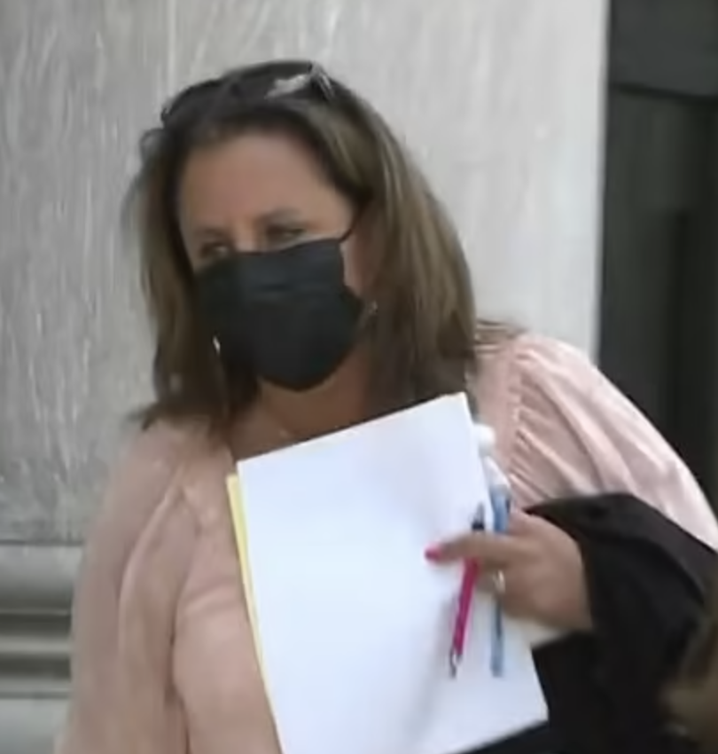
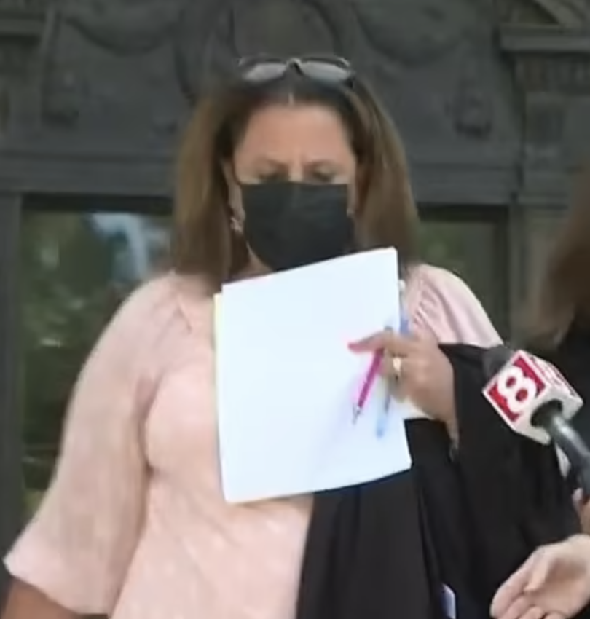

Former Yale Reproductive Endocrinology and Infertility clinic nurse, Donna Maticone, November 2021. Picture credit to Adam Manno's article at the DailyMail.

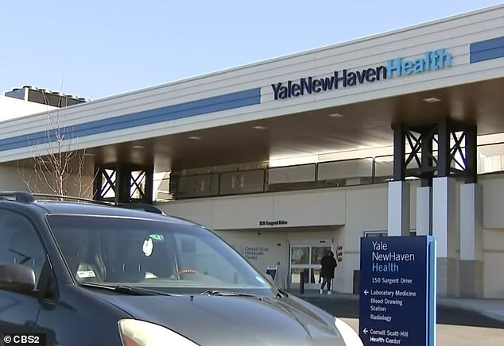

Former Yale Reproductive Endocrinology and Infertility clinic nurse, Donna Maticone, November 2021. Picture credit to Adam Manno's article at the DailyMail.

References

United States Department of Justice
https://www.justice.gov/usao-ct/pr/former-nurse-sentenced-tampering-fentanyl-vials-intended-patients-fertility-clinic

abcNews
https://abcnews.go.com/Health/wireStory/women-sue-yale-fentanyl-switch-fertility-clinic-81237511

Fox61
https://www.fox61.com/article/news/health/dozens-women-join-yale-fertility-clinic-lawsuit/520-0d044f0f-00b8-4ce9-b815-fcdbb0fa9e0d

New Haven Register
https://www.nhregister.com/news/article/Lawsuit-alleges-Yale-fertility-clinic-s-17177426.php

MedicalMalpracticeLawyers.com
https://medicalmalpracticelawyers.com/fertility-patients-sue-yale-university-after-nurse-stole-fentanyl-and-replaced-it-with-saline/

New Haven Independent
https://www.newhavenindependent.org/index.php/article/sentencing1/

NBC Connecticut
https://www.nbcconnecticut.com/news/local/nurse-tampered-with-used-fentanyl-intended-for-fertility-clinic-patients-federal-officials/2435058/

Yale Medicine
https://www.yalemedicine.org/departments/reproductive-endocrinology-and-infertility

SAMHSA
https://www.samhsa.gov/find-help/national-helpline

211.org
https://www.211.org/get-help/substance-use

Episode Transcript

Episode 40 Transcript

Lillee Izadi 0:19
Hello, everyone and welcome back to your favorite medical malpractice crime podcast, ethical side effects. As always, I'm your host Lillee, joined by my co host, Mr. TJ McKay here.

TJ Mckay 0:33
Hey guys, so glad you could join us for another crazy case of medical malpractice.

Lillee Izadi 0:39
Yes. It's always fun to have you guys here. But before we get into it, let's do a little bit of a weekly check in, shall we? How is your week been? TJ? I am doing pretty good.

TJ Mckay 0:50
You know, I can't complain. How are you doing? Lillee,

Lillee Izadi 0:53
you know, I've been doing well to just doing what we've talked about working to save up some money for our move, and overall trying to get my life together before July when we have to start up in Baltimore. But I'm glad we survived another week, and that we can bring some great new content, all of our wonderful listeners to foreshadow a little bit. This week's case is kind of crazy and deals with the nurse actually, instead of a physician. It is also another fertility clinic scandal. But it's definitely different than the IVF mix up we discussed in a previous episode. And let me just say I've never heard of this happening before I research this case. So I'm very excited to share it with you all this week.

TJ Mckay 1:38
I'm also excited to hear what you have in store for us this week Lillee.

Lillee Izadi 1:42
But before we get into the case, I have a couple of announcements. So one, as you all likely know, it is pride month and we at ethical side effects of course really wanted to support the cause of providing greater health care equality to those who are part of the LGBTQ+ community. And with that, if you received our newsletter, you know that we are holding a donation drive from June 1st until June 30th. For the organization, GLMA, or the Gay and Lesbian Medical Association, which is a national organization made up of healthcare professionals and community members committed to not only ensuring health equity for lesbian, gay, bisexual, transgender, queer, and all sexual and gender minority individuals. But they also advocate for the equality of LGBTQ + health care professionals and their work environments, which is very important. So if you're interested in donating, please go to the support the cause page on our website, and our link tree below. And you can donate to their organization directly through them on our website and our link tree. Additionally, if you decide to donate to our podcast through our PayPal by clicking the donate button on, again, our newsletter website or link tree, all these proceeds from this PayPal will be going to GLMA this month, per usual donation drive. And if you want to go the extra mile, we also have other LGBTQ+ advocacy organizations, a lot of them relating to health advocacy, listed under that same support the cause page that you can check out and donate to as well.

TJ Mckay 3:27
Yes, and if you have any questions, please feel free to email us at ethicalsideeffectspodcast@gmail.com Or just reach out to any of us on any of our social media platforms. And we'll get back to you as soon as possible.

Lillee Izadi 3:42
Yes, and of course, if you haven't already done so, please subscribe to our podcast. Follow us on our social media platforms. subscribe to our newsletter to be the first to hear about these extra little content and donation drives and rate and review us on your preferred podcasting platform to show us some extra love because it is always great to hear from you guys.

TJ Mckay 4:04
Yes, it always makes our day to hear from our amazing listeners. But Lillee, I think where our listeners want the most right now is to hear another crazy malpractice case. So are you ready to share this fertility clinic case? Because I'm intrigued.

Lillee Izadi 4:20
Absolutely. TJ, I was wondering when you would ask and you read my mind. So let's get into it.

So our case takes place in orange, Connecticut at the Yale University reproductive endocrinology and infertility clinic, also called REI. Now, on the surface, this is a state of the art Fertility Center that aims to provide comprehensive care and treatment options for a variety of different couples and achieving their wish to have a child or be pregnant. So well What the nation never expected from this facility was a big lawsuit in May 2021. So just last year against them from seven different women on the grounds of failing to follow mandated pharmacy protocols, and civil allegations of medical assault and battery and medical malpractice.

TJ Mckay 5:21
Whoa, I wouldn't expect that either. And I'm assuming you're about to get into it. But what happened to the seven women that they had to make this into a lawsuit against the whole fertility clinic?

Lillee Izadi 5:34
That is a great question, TJ. So it seems like the women were all making allegations that they underwent IVF procedures, which we've talked about in previous episodes. And if we didn't discuss this part of it in our other episode, it is overall a very painful and invasive procedure. And during these procedures, of course, women were supposed to receive fentanyl. Now, again, I believe we talked about fentanyl in the cold case debate episode. But for those of you who are still unfamiliar with what fentanyl is, it is basically a very powerful opioid or pain reliever used as an anesthetic for many surgical procedures, and sometimes hospice care. Now getting back to our key. So again, these women, the seven women were supposed to receive fentanyl at the university reproductive endocrinology and infertility clinic when they went to have these IVF procedures. But a pattern of complaints came forth from patients, when they would go through these procedures and they could literally feel everything. So to give you a better picture of what that would look like, if you were these women, a really big needle is going through your ovaries to extract eggs for IVF. And you can feel it, and they are implanting this embryo in you, and they can feel it when they weren't supposed to. So in other words, this doesn't sound pleasant at all. In fact, I can safely say that based on what these women were testifying, they were like, yeah, it was excruciatingly painful. And they said they were using fentanyl. And I kind of find that hard to believe if they could feel it.

TJ Mckay 7:16
Yeah, obviously, I'm not a woman, but there definitely will be my worst nightmare, honestly.

Lillee Izadi 7:24
Yeah, not a woman. And what's worse is that despite these women saying to the staff, and providers in the room, like, oh, wow, this really hurts, and like not being able to stay still, like they want these women to during the procedures, and like the providers just dismiss their complaint and are like, "Oh, no, the fentanyl works. It's fine. Just hold still." and basically, "Stop yapping." Which, you know, I'm, I'm not going to talk about women being taken seriously, as patients in the medical field. That's a topic for a bonus episode, maybe. But overall, if there have been multiple women saying this in a certain timeframe, and you know, women usually don't say these things. I would be having my own suspicions about you, TJ.

TJ Mckay 8:14
Almost definitely, I mean, better now is like when the strongest opioids out there. And there's a reason that is often so fatal when used inappropriately. So unless these women are like extreme opioids addicts, or are dead, I would think that there's something going on that I'm not understanding here.

Lillee Izadi 8:36
Right. And the fact of the matter is, there was something indeed going on with the fentanyl the clinic was giving them because unbeknownst to these poor patients and these dismissive providers, the patients were receiving saline, not fentanyl.

TJ Mckay 8:54
So, wait a second, they gave them an IV or injection of just regular saline, like the stuff that they use to hydrate you. How does that even happen that many times though, was someone like new and kept mixing up like the raw stuff or out, I just don't understand, like, I'm gonna need you to elaborate a little more Lillee.

Lillee Izadi 9:20
So funny enough, it was actually not as innocent as say, an amateur mistake, like one would think on the surface and kind of like what you were describing. And that's one of the theories I came up with in my brain when I first heard about the lawsuit. But the reason behind the saline substitute is so much worse. I don't know if you're already TJ because it's bad especially for a University Institute like Yale, for example.

TJ Mckay 9:51
On our folks, there she goes with that voice change. You know, when that comes, it's never a good sign.

Lillee Izadi 9:57
Yes, that's for dramatic effect. But yes, It turns out that a 49 year old nurse, by the name of Donna Maticone was actually feeding her opioid addiction with the fentanyl and purposely switching it out with saline.

TJ Mckay 10:16
Are you serious? Now? You got to be kidding me?

Lillee Izadi 10:19
Oh, no, I'm 100%. Serious.

TJ Mckay 10:23
So you're telling me she was stealing opioids from her workplace pharmacy? Like, does she not think this threw out and like rationalized like the potential consequences of her actions?

Lillee Izadi 10:37
Obviously not. And I it's really disappointing. But you know, when you're feeding an addiction, it's all you really think about. And my question was like, How did you even do this? Like, are you telling me nobody is watching this woman? And how long did this go on? And how did she switch out the fentanyl and get access to this whenever she wanted, because usually, there are protocols in place to prevent drug abuse by healthcare professionals or pharmaceuticals, through safeguards in the hospital, like inventory, counting, accountability, security footage, and all that fun stuff. But basically, from what I read, it went down in that part of Donna's responsibilities at the Yale REI involved ordering and the inventory of a variety of narcotics used by the fertility facility, which, of course, included fentanyl. Now, before I go forward with this case, and how it unfolds, I wanted to say that, based on what I read, it seems like pieces of this case and what happened weren't exactly put into place to see this bigger picture until later on down the road. So I'm going to try to explain it as cohesively as possible. But something to keep in mind is that a lot of the strings weren't really connected into how one event led to another. So I'm just giving it my best guess so to speak.

TJ Mckay 12:09
Well, we appreciate your effort, Lillee, because this case seems like a whole mess. So let's just try to get the picture and hope for the best.

Lillee Izadi 12:19
Exactly. So it looks like at some point, one physician colleague went into the inventory area for medications and notice that the cap on one of the fentanyl vials was loose, okay. And then the articles I read, one of them mentioned that Yale made a comment that this was when they first became aware of the issue. Now, I don't know how this one incident of this physician looking at one of the loose fentanyl vial caps made it up the chain to start this big investigation. Nor do I know how all of a sudden they connected it to Donna. But at some point between November 2020. And the trial Donna had in 2021, this all went down to give my two cents of what happened. And please feel free to chime in TJ and take my words as a grain of salt. I'm guessing the calling who noticed the loose fentanyl cap. Maybe mentioned it to a friend or a director of some sort. And it eventually started a spiraling investigation to what was actually going on. From there. They could have targeted Donna as one of the first people to question because again, she plays a big role in the inventory and ordering of the substances. And then she confessed during this questioning. Another possibility I had in mind is that maybe Donna didn't come clean at first. And so investigators decided to check maybe some security footage or something that eventually enlightened them of the things that she was doing. Like I don't know that maybe Donna brought approximately 175 vials of fentanyl that she had taken f rom the Yale REI clinic and then discarded them in waste containers at that same clinic. Kind of suspicious, right?

TJ Mckay 14:11
Yeah, that's definitely suspect and will be a huge red flag for me too. But maybe that's just us. I don't know. I also don't think it helped on the innocence that now they can pair that physicians observations that the loose fed and now cat with the fact that the patients were complaining about the procedure has been so painful. So but while I'm wondering Lillee is if they actually tested the bed and all that was open and realize that it was actually sailing then where they decided to approach all the amatory workers because I will understand that the loose cap will be suspicious enough because you probably can't use that now because of contamination. So they probably will want to know why nobody ensuring the quality of the mess is they get shipped? But do they find out the sailine part from testing it or from Donna herself?

Lillee Izadi 15:08
Honestly, TJ, I had the exact same question myself. And I wish I had the ans wers to that, because that's a really good point and the report I read are not clear on the timeline of events that took place and how the investigation went down. I'm guessing at some point, they did test them because you can't really prove that Donna used the fentanyl and then injected saline into the fentanyl vials unless you tested those vials. But I don't know how soon in the investigation they did that. But regardless, they did find out that something was up with Donna, like I said before, and she doesn't confessing. And what they find out from this is that starting in June 2020, Donna began stealing fentanyl for her own use by accessing secure storage areas and taking vials of fentanyl. And she would take it by using a syringe to withdraw the drug from the vials, followed by injecting saline into the vials so that it would appear as if none of the fentanyl was missing. Because they're both clear, right? So who would ever know?

TJ Mckay 16:10
That's actually so insane. Like that's crazy, that she went to those lengths to feed her addiction. I mean, I know addiction is something that is extremely hard to understand. But to know that you are harming this many people by doing that our professional facility is just too much for me to just handle right now.

Lillee Izadi 16:35
Oh, I agree. And I'm right there with you. It's a hard topic to wrap anybody's brain around. And if you guys haven't watched it, this part of the case where they talk about her injecting saline into vials, reminded me of this Netflix documentary that I watched with my best friends called, "How to Fix a Drug Scandal". And basically, this drug tester and one of the labs starts taking the pure control sample of math that people used in crime labs to test the quality of street drugs found on people they want to prosecute. And she starts using it to feed her addiction by putting drops of the control in her diet pepsi every day, and then replacing it with water so that nobody notices which that's just so crazy to me. But that type of stuff happens like every day. And that's a whole nother story for another podcast, I guess.

TJ Mckay 17:33
Yeah, it's truly say how far some people will go to feed their opioid addiction. Sometimes I wonder for people such as the drug test in the documentary you just mentioned, was that her first time ever experiencing the drug recreationally while on the job? Or does she have like a previous encounter outside of the workplace?

Lillee Izadi 17:54
Well, fun fact, in the drug testers case, that was actually her first time using math recreationally. It was just wild to hear. And it's funny because I think she mentioned that she's never really tried any other drugs before. But she just went right to map, which there's so many things wrong with that, but I'm not going to get into it.

TJ Mckay 18:16
She literally just dived headfirst into the pool and didn't even know how to swim.

Lillee Izadi 18:22
Exactly, that's exactly what she did. She said I'm going to be an overachiever when it comes to this. So highly recommended documentary not to promote anything. But anyway, getting back to the case. The investigation revealed that approximately 75% of the fentanyl given to patients at the Yale Rei clinic between again that time period of June 2020 and October 2020 was tampered with saline. And just like we would imagine most of them were inconsistently tampered with. So some of the vials contain diluted fentanyl, while others contained basically no drug at all and just contain saline. So who knows what these patients were actually getting. But obviously they were rightful in their initial concerns and complaints. So once this was leaked, the patients realize that this is what was going on, and they decided to sue for compensation. So like I said before they filed this lawsuit, and they basically filed it against Gail on the grounds of failing to follow mandated pharmacy protocols, and civil allegations of medical assault and battery and medical malpractice. And they ended up bringing this case all the way to trial, where Donna was represented by a public defender, and they decided to plead guilty. In the court reports. She did admit that she knew that the adulterated vials of fentanyl she replaced at the Yale REI clinic would be used in surgical procedures and that the absence of said anesthetic during an outpatient procedure may cause serious bodily injury to the patients who was serving so She knew what she did was wrong. I guess she apologized for it during the trial. But of course that doesn't make it any better. Donna also confessed during the trial that she initially injected herself with these fentanyl vials using a syringe while working at REI, and then eventually began just taking the vials home. So knowing all of this, the judge in this trial, the Honorable Judge Hall, scheduled sentencing for May 25 of 2021. So again, literally years ago, and at that point, she was initially facing a maximum term of 10 years in prison for tampering with a consumer product. And in this time, Donna also, of course, surrendered her nursing license, and awaited what the turnout of the trial would be, which was a lot less than predicted. It turns out that Donna was actually sentenced to only four weekends in prison, three months of home confinement, and three years of supervised release.

TJ Mckay 20:58
Weekend. Excuse me. Wait, me, Lillee, fed check your research at that you need to take a double check. Are they that has to be inaccurate?

Lillee Izadi 21:08
Oh, no, I was shocked. And I've never heard of something like that before, but again, basically a month in prison. One reason for this more lenient decision is that Donna said in her testimony, that she started using fentanyl because of the stress caused by her broken marriage. And an ex husband who she claimed she was afraid to leave her three children with, I guess he was abusive.

TJ Mckay 21:32
Okay, but how does that excuse her causing other patients to endure agony during their procedure at the infertility clinic? Like, I feel for her Don't get me wrong. She was afraid to leave her children with her former partner that was potentially abusive. However, she could have seeked other methods of like getting help in this situation?

Lillee Izadi 21:56
No, I completely agree with what you're saying. I don't know how this is a valid excuse to cause other people pain. But as far as I know, she was never able to work as a nurse again, of course with this on her record. And in terms of yield changes. Yale did tell the patients at the beginning of all of this that there is no reason to believe that the nurses actions caused harm to their health or the outcome of their treatment, and that the fertility center routinely uses a combination of pain medications during procedures and modifies the medications if there are any signs of discomfort, which, obviously, according to these women is absolutely not the case. And I feel that their statement is avoiding the problem at hand and disregarding the care safety and feelings of the female patients involved. Now they did claim to make changes to protocol. And I think that's really important because in doing my research, I will say that their way of handling narcotics was one of the main reasons why Donna was able to access these files in the first place. It turns out that Yael had bulk ordered fentanyl vials used for pain management during these retrieval, surgeries and other procedures to do IVF. And in doing this, they kind of sidestepped mandated pharmacy supervision that left vials vulnerable to tampering violating state and federal laws by keeping more than those 175 vials of fentanyl at a time in an unsupervised and unlocked area.

TJ Mckay 23:27
Yeah, I mean, that would do it, you know?

Lillee Izadi 23:31
Yes. And the crazy thing is, I don't know the award that these women got because the lawsuit never disclose the amount that these women are seeking in damages, nor do I really know the result of their case for them. But in a year's time, after Donna pleaded guilty, dozens more women started coming forward to the point that 59 In total, are now part of this lawsuit. And some officials suspect that with this huge number, that this was actually going on longer than just between June and October 2020. But at this point, there is no way to prove that. So might be another bonus episode coming up guys

TJ Mckay 24:11
It's mind blowing to comprehend that this one individual who was feeding her opioid addiction had caused harm to so many patients is really a short amount of time if you really think about it.

Lillee Izadi 24:24
Yes, exactly. And I feel like with the topic we're dealing with in this episode, I need to say that if you or someone you love is struggling with addiction, we are including healthcare resources at your disposal to get the help that you or your loved one deserves. And you can find that in our episode case files and pictures page because we keep all of our references there, as well as in the episode description below. You can also find all of our episode references for our cases week in our case files and pictures page if you want to learn more about this case, as always.

TJ Mckay 24:58
If you see something, say something don't let your loved ones suffer alone. You heard it hear from your favorite two geeks at Ethical Side Effects. We love ya'll.

Lillee Izadi 25:10
Yes good old saying, "See Something, Say Something" and adding to that as always, stay ethical guys, and we will see you next week for another crazy case of medical malpractice. Bye guys!

