Episode 18: Nursing Home Neglect

Description:
This week we share the story of Lydia and Earl Scherrer starting in 1996. When Earl wakes up from a coma after a car accident-induced traumatic brain injury, Lydia takes on the role of being his full-time caregiver until the strain of her career forces Lydia to put him in an assisted living facility. However, when Earl dies in her arms after vomiting up black substances, Lydia comes to the realization that nursing home neglect is just skimming the surface of a far bigger problem.

Photos:
Lydia Scherrer's attorney, Craig Knapp, a partner in Knapp & Roberts in Scottsdale, Arizona.

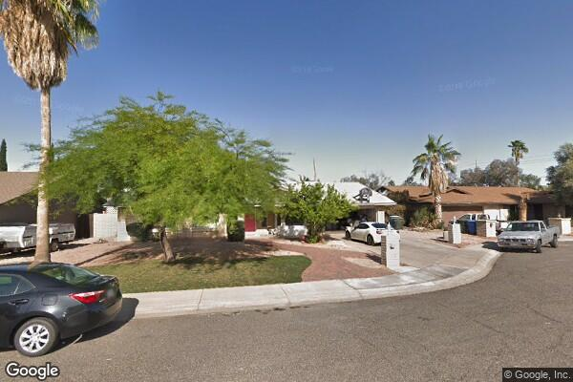
Part of Liberty Manor Residency in Phoenix, Arizona, the assisted living facility Earl Scherrer was residing at.
References:

https://www.bermanlawyers.com/jury-awards-11-million-verdict-in-assisted-living-case/

https://www.barneslawfirm.com/4-most-astonishing-medical-malpractice-cases-in-recent-history/

https://www.knappandroberts.com/articles/knapp-roberts-wins-landmark-11-million-verdict-in-assisted-living-case/

https://nursing-home-neglect.com/jury-awards-landmark-11-million-verdict-after-man-chokes-on-foreign-matter-at-assisted-living-home/

http://www.poppelawfirm.com/Blog/4/Nursing-Home-Neglect/109/Widow-Awarded-11-Million-After-Death-of-Husband-Due-to-Assisted-Living-Facility-Negligence

Disease of the Week:

National Ovarian Cancer Coalition
https://ovarian.org

Mayo Clinic
https://www.mayoclinic.org/diseases-conditions/ovarian-cancer/symptoms-causes/syc-20375941

American Cancer Society
https://www.cancer.org/cancer/ovarian-cancer/detection-diagnosis-staging/signs-and-symptoms.html

