Episode 8: The Cole Case Debate

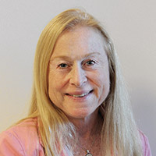
Dr. Judith E. Brill, MD

Cole Hartman with his mother Liz Hartman

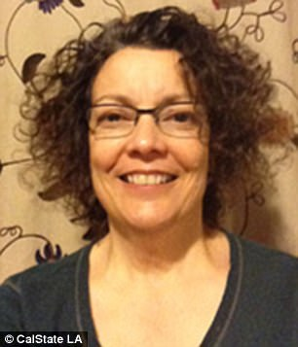
Denise Bertone
Episode Resource Links:

https://www.latimes.com/local/lanow/la-me-adv-organ-donation-20170612-story.html

https://laist.com/news/8-year-old-boy-drowns-in-washing-ma

https://www.dailymail.co.uk/ushome/index.html

https://www.theatlantic.com/health/archive/2017/06/organ-donation-death/530511/

https://www.dispatch.com/news/20170612/use-of-drug-probed-in-los-angeles-organ-donors-death

https://qz.com/1827177/some-drugs-used-to-keep-people-on-ventilators-are-in-short-supply/

https://www.uclahealth.org/judith-brill

https://www.hopkinsmedicine.org/som/faculty/appointments/_documents/_ppc_documents/portfolios/Hutton/Hutton-Portfolio-Samples/the-hospice-and-palliative-medicine-approach-to-caring-for-pediatrics-patients.pdf

https://www.cbsnews.com/news/child-organ-donor-death-ucla-fentanyl-investigated-by-low-angeles-police/

JUNETEENTH:

https://juneteenth.com/

https://www.nytimes.com/article/juneteenth-day-celebration.html

Disease of the Week:

Sickle Cell Disease Association of America, Inc.
https://www.sicklecelldisease.org

Centers for Disease Control and Prevention
https://www.cdc.gov/ncbddd/sicklecell/facts.html

St. Jude Children’s Research Hospital
https://www.stjude.org/content/dam/en_US/shared/www/patient-support/hematology-literature/red-blood-cell-transfusions-for-sickle-cell-disease.pdf

