EP 34: King of Pop, Prince of Propofol (Part 1)

Description

Kicking off 2022 after our brief New Year's holiday hiatus, we bring you the infamous malpractice case of Michael Jackson. In part 1, we discuss the events leading up to the King of Pop's death, the backstory of his personal physician at the time, Dr. Conrad Murray, and the series of missteps that led up to Jackson's death being labeled a homicide, rather than just the average malpractice crime.

Pictures

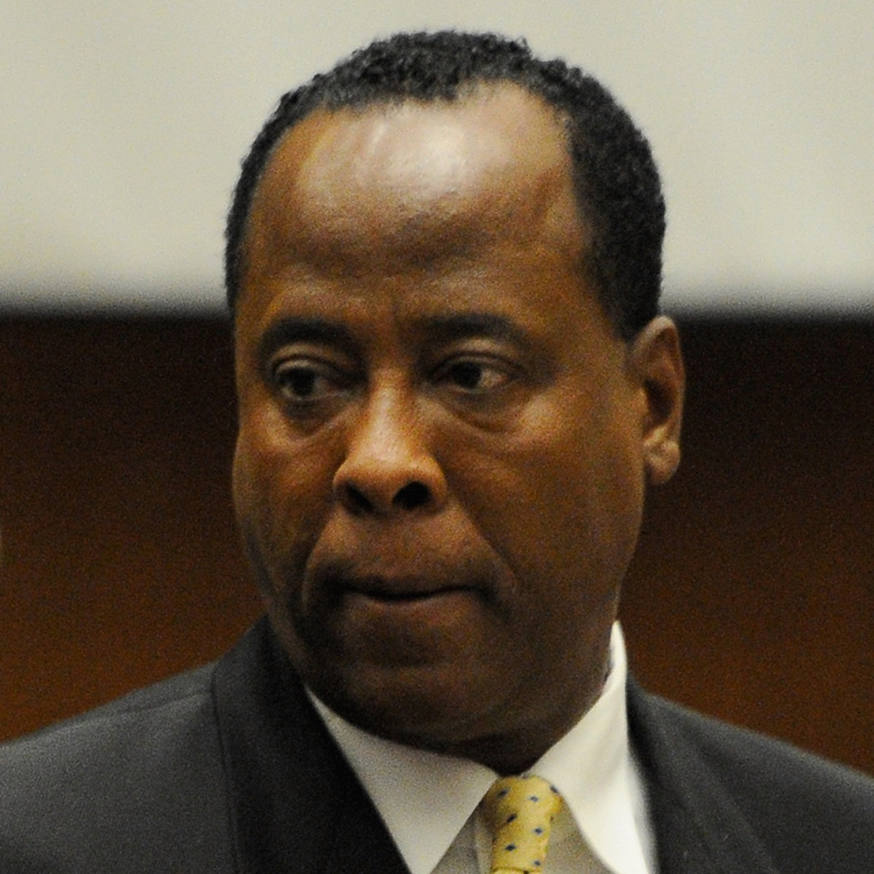
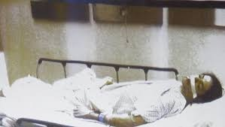

Former cardiologist, Conrad Murray, who was the personal physician of Michael Jackson at the time of his death.
Michael Jackson arriving at UCLA Ronald Reagan Medical Center on June 25, 2009.

References

The New York Times
https://www.nytimes.com/2011/11/08/us/doctor-found-guilty-in-michael-jacksons-death.html

Showbiz CheatSheet
https://www.cheatsheet.com/entertainment/inside-michael-jacksons-former-plans-to-open-slavic-world-of-childhood-theme-park-poland-before-death.html/

Music in Minnsota.com
https://www.musicinminnesota.com/the-death-of-a-superstar-how-exactly-did-michael-jackson-die/

abc17 News
https://abc17news.com/news/national-world/2021/02/11/conrad-murray-fast-facts/

Wikipedia
https://en.wikipedia.org/wiki/Conrad_Murray

CNN Entertainment
https://www.cnn.com/2013/05/07/showbiz/jackson-death-trial/index.html

https://www.cnn.com/2013/04/30/showbiz/jackson-death-trial/index.html

Disease of the Week

Mayo Clinic
https://www.mayoclinic.org/diseases-conditions/genital-herpes/symptoms-causes/syc-20356161

John Hopkins Medicine
https://www.hopkinsmedicine.org/health/conditions-and-diseases/herpes-hsv1-and-hsv2

WebMD
https://www.webmd.com/genital-herpes/pain-management-herpes#1

https://www.webmd.com/genital-herpes/default.htm

Center for Disease Control and Prevention
https://www.cdc.gov/std/herpes/stdfact-herpes.htm

