EP 39: Dr. Blatti: The Long Island “Serial Killer”

Description

Dr. George Blatti shocked Long Island, New York in 2019 when he was arrested for selling various prescription opioids out of parking lots for extra cash. In 2021, his prescription pad was found to be even more of a lethal weapon when five of his patients end up dead from overdoses. Now, this serial killer physician faces the possibility of a life sentence for over 50 charges ranging from the illegal sale of prescription drugs to second-degree murder.

Pictures
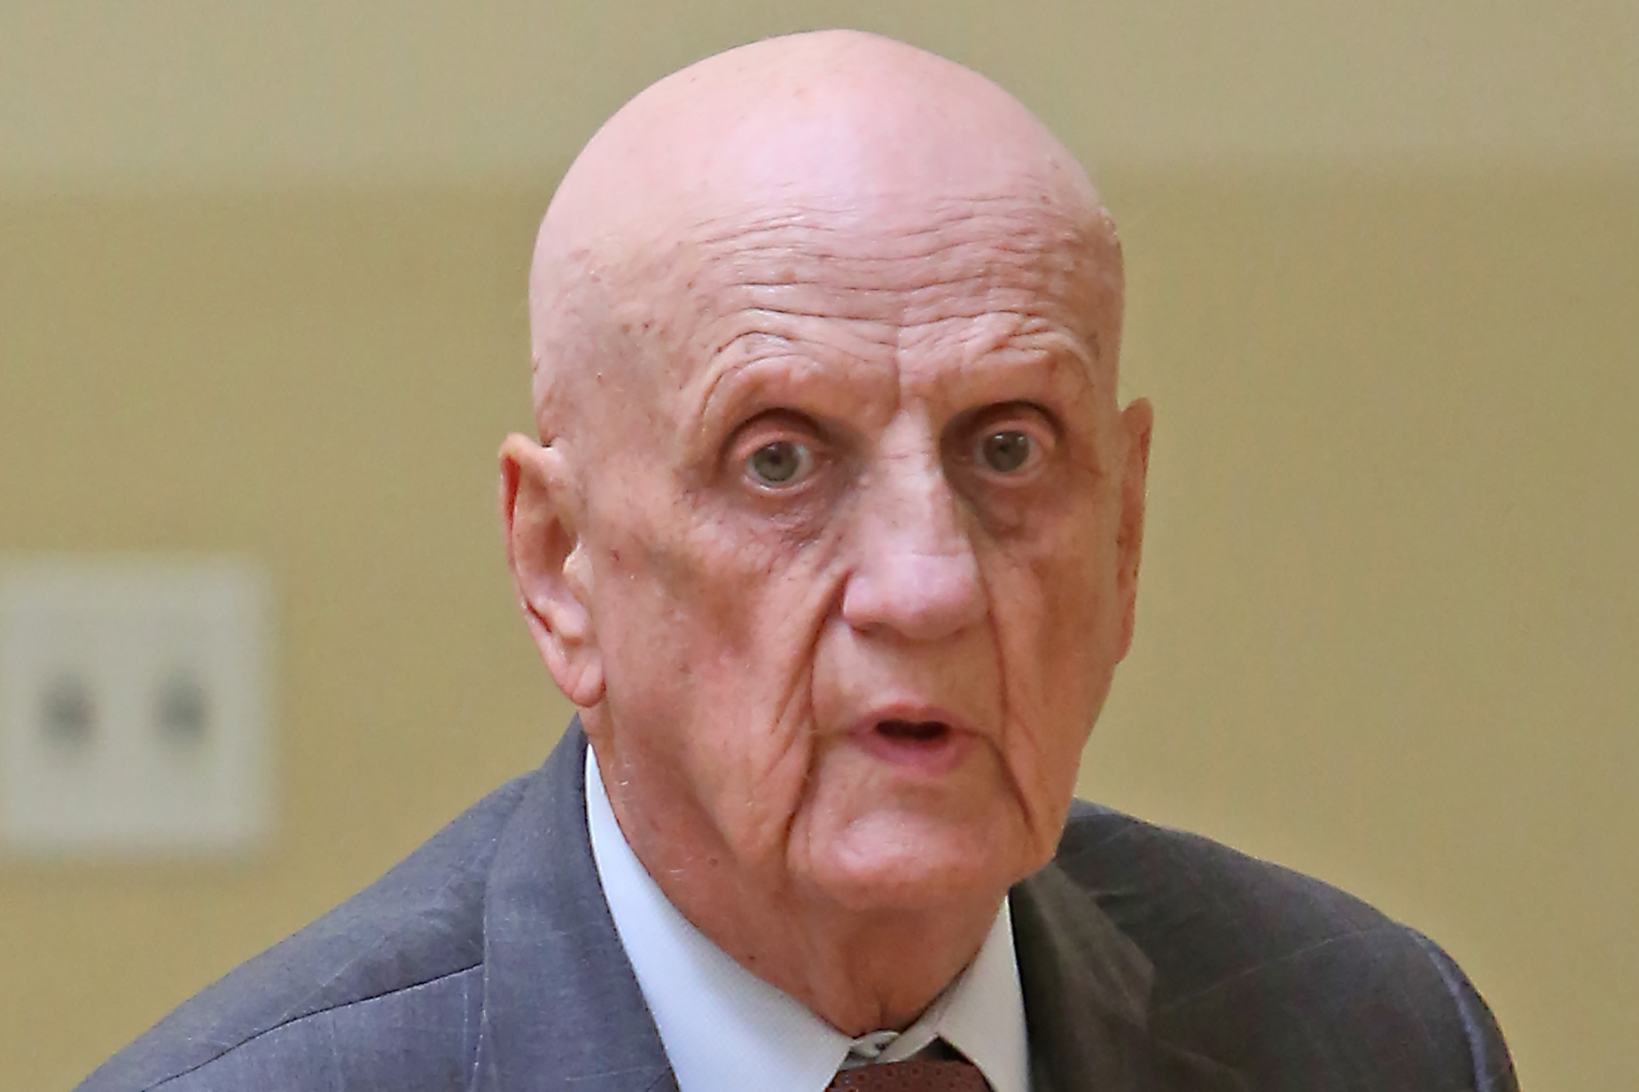
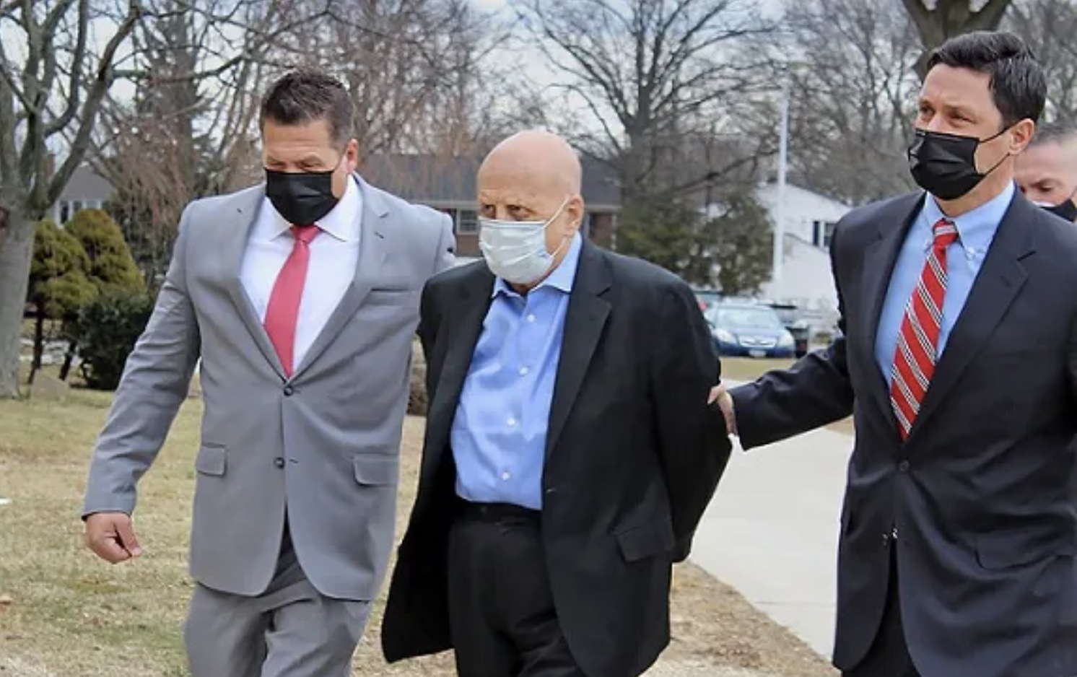

George Blatti being escorted to the Nassau County courthouse on March 4, 2021. Picture credit to Melissa Koenig/LIHerald.com via The New York Times.
Former physician George Blatti in 2021. Picture credit to Victor Alcorn via the New York Post.

References

NBC New York
https://www.nbcnewyork.com/news/local/crime-and-courts/long-island-doctor-faces-murder-charges-over-patient-prescription-deaths-da/2923988/

https://www.nbcnews.com/news/us-news/new-york-doctor-charged-five-murders-alleged-depraved-prescription-abuse-n1259648

LiHerald.com
https://www.liherald.com/franklinsquare/stories/physician-charged-with-murder-denied-bail-by-nassau-judge,133140

Meaww
https://meaww.com/dr-george-blatti-long-island-new-york-murder-5-patients-prescribing-opioids-addicts-examining-drugs

ABC7 New York
https://abc7ny.com/george-blatti-doctor-murder-overdose-deaths-opioids/10388251/

CBS New York
https://newyork.cbslocal.com/2019/10/30/doctor-sell-opioid-prescriptions/

ABC News
https://abcnews.go.com/US/doctor-prescribed-massive-quantities-opioids-charged-murder/story?id=76253323

Episode Transcript

Episode 39 Transcript

Lillee Izadi 0:19
Why hello, everyone and welcome back to another weekly dose of Ethical Side Effects. For our new listeners out there, my name is Lillee, and I'm joined here by my wonderful co host, Mr. TJ here,

TJ Mckay 0:32
What's going on everyone, please give yourself a round of applause for making it to the end of the week. And I'm so glad to see all of our loyal listeners return for this crazy case that Lillee has in store for us today.

Lillee Izadi 0:45
Yes, and before we get into our episode for today, which by the way, is quite the jaw dropper, as TJ was alluding to, I just wanted to take a moment and remind everyone that our donation drive to the organization black health ends on March 1st. So if you haven't already done so, please make sure to tap or click on that support the show link in our episode description below to make sure your donation goes to our PayPal, and we will send it over to the black health organization at the end of the month. If you want to learn more about the impact and mission of black health, or if you want to donate directly to them yourself, you can go onto our website at ethicalsideeffects.com. Under our support the cause page, we really tried to make it super easy for you guys to make an impact for Black History Month by putting all of these awesome links to our platform on our link tree below in our episode description. So you can check out all of that if you have the time as well. We also have links to our merchandise and all of our wonderful social media platforms. So you can keep up to date on all things medical crimes and ethical side effects. So, TJ, am I missing anything? Before we get into our case?

TJ Mckay 1:58
I don't think so. I'm glad you brought up the donation drive because the organization blackhill is a worthy cause whose mission is to bring in too many diseases that are prevalent in the community of people of color. So to reiterate what Lillee said please head on over to the ethical side effects and go to support the cause. Or you could go directly to Black Health Organization website.

Lillee Izadi 2:20
Yes, please do so. And you can even donate to Black Health all year round, as well as a variety of other organizations on our support the cause page if you feel inclined to do so. But without further ado, I think it's officially time that I get into our crazy case for today, TJ and it's a lot to unpack. So let's get into it.

So this case is just very different. Let me just say that. And honestly, it kind of makes me ashamed to want to be a physician. And the reason I say this is because this case is kind of like another pill mill case. Shocker, I know. But I think it goes a little bit deeper and is a smidge crazier than the other pillow cases we've discussed so far. So just buckle up. That's all I have to say people. Getting into the nitty gritty of this case. I'm going to start our episode off by discussing the main star of our case, Dr. George Blatti. Now bladdy is this family medicine physician who received his medical degree from the University of Minnesota Medical School in 1976. And at the start of this case, in late 2019, he was in his mid 70s, still working in Franklin Square, and had been practicing for over 20 years. And in this time of being a physician in this area of Long Island, New York, you can see that there are patients that really adored him. They thought he treated them well and that he was a really good doctor by all accounts. So in November of 2019. You can imagine the absolute shock that came to these patients. When all of a sudden blatty is charged with 22 counts of criminal sale of a prescription for a controlled substance 22 counts of criminal diversion of prescription medications and prescriptions in the fourth degree, six counts of forgery in the second degree, two counts of reckless endangerment in the first degree and two counts of reckless endangerment in the second degree.

TJ Mckay 4:21
Hold up. Because there is a whole lot to process. So this man was really running up these charges to the point he probably broke so many laws that he shocked himself when he heard his entire list of charges in court.

Lillee Izadi 4:37
Oh, sister. I was shocked. And honestly, I'm not even at the receiving end of these charges. So I would not want to be him. It's a lot for me to process myself. But when I was reading up on the news articles about this case, I was getting whiplash man and there was so much to go through. And if you think I'm exaggerating, like the first article I stumbled upon when I looked up his name was titled, "Long Island Doctor, 75, Who Worked From Car Accused of Murdering Five Patients". And first off if you're sitting here like "Lillee, wait, you didn't say anything about him murdering people?" Oh, trust me, I was right there with you. But before we get into that part of this case, I'll enlighten you with the fact that these drug related charges were made against him in 2019. And they were based on investigations done by the Drug Enforcement Agency. And it looks like in this investigation, the DEA found that bladdy was selling pain medications off the record, without any medical exams being done beforehand, or any consideration for the patient's medical or addiction history. So again, it's kind of like a mini pill mill, that he's doing himself to the point that he didn't even have a medical office.

TJ Mckay 5:51
What do you mean exactly that he didn't have a medical office? Where did he practice then? or meet with patients to have consultations?

Lillee Izadi 6:00
Well, funny, you should ask that TJ, because this man literally worked in the most random places. And like I said, he really didn't examine people. So to be honest with you, it's kind of smart to not have an office because you're just knocking down funds at that point. But he would basically work from his car, like I said, and meet up with people who wanted to get prescriptions in his car at the parking lots of places like the rockville center Hotel, which I guess was where he was living at the time, and places like a nearby Dunkin Donuts, and I'm a Dunkin girl myself, okay. And I vehemently disagree with the fact that he's disgracing and disrespecting a good Dunkin Donuts location with these types of criminal acts, you know.

TJ Mckay 6:40
So from my understanding, Dr. Blatti, sounds like a full fledged drug dealer. But the only difference in this case was at the time he was providing opioids and other prescription drugs to his patients. He was a boy certified physician, or I hope that he was a board certified physician.

Lillee Izadi 6:56
Yes, he shockingly was a board certified physician. However, the big issue in this case, turns out that he actually wasn't a pain management certified or specialized physician, which we'll get into slightly in just a bit. But overall, that was the big issue with him prescribing these medications, because although he had a DEA number and was able to, he's really not supposed to nor has the I guess, full knowledge of what he's doing and prescribing these medications all the time, supposedly. And personally, I don't know if this upcoming fact is at the same level of bad or even worse, but even before working out of his car, he was practicing and an old radio shack building, which I guess isn't a big deal. But he didn't even take the Radio Shack sign down. Nor did he get rid of the last bit of merchandise in the place where he was practicing. So this man is basically practicing in an abandoned Radio Shack by himself and writing out prescription opioid scripts, which I guess go off, I can appreciate the hustle. But I can't be the only one that finds that just a little bit weird. And I know if I scheduled an appointment with a doctor and the doctor or the receptionist straight up on the phone was like, "Just turn left. And on 32nd Street, you'll see the old radio shack and we'll be right in there." I would straight up be like this is definitely not for me. And to I'm pretty sure I'm going to get kidnapped if I go in there. I'm too paranoid for this. So I wouldn't be going to that doctor's office personally.

TJ Mckay 8:33
Yeah, there's absolutely no chance I would be seen by a physician that basically practice inside of a band and Radio Shack store. But my question for you Lillee is, and you may not know the answer to this. But why did he transition into working from his car though?

Lillee Izadi 8:48
That's a great question, TJ, I actually had the exact same question while doing research on this case. And unfortunately, the articles don't go too much into it beyond saying that he was kind of forced to relocate into his car. And I don't know why that was I'm assuming he wasn't really paying rent on the Radio Shack place. He was just kind of freeloading on a free abandon store, maybe. So I'm assuming that another group of people came in and actually did the right thing and rented out the Radio Shack. So he kind of was forced to get kicked out if that makes sense, even though he wasn't like a formal tenant of the Radio Shack and he was kind of freeloading off of it. But that is just my assumptions. Take that with a grain of salt. I have no idea. But that's a great question. And while we're getting into some weird stuff, just a side note for our listeners, TJ this kind of reminds me of the time that our friend Mya asked me to go with her to see this new doctor she got and this fool was literally practicing out of a la quinta hotel conference room. And like, please understand me when I say that a hotel conference room is one thing okay? But the LaQuinta or the lucky into however you pronounce it is like a Super 8-style motel looking place, at least here in Lakeland guys. So this is not a Hyatt Regency people. This is a dusty, crusty and straight up busted looking room. And what really sealed the deal for me was when I went to use the bathroom, and they did not. I repeat TJ did not have soap or paper towels. Call me high maintenance. Okay, but I'm pretty sure one not having soap in a bathroom is basically illegal in the time of COVID-19. And to where was the doctor washing his hands? There was no soap in the lobby bathroom. Riddle me that listeners? That's disgusting. Does the doctor not wash his hands? What's going on here? There's so much going through my head.

TJ Mckay 10:50
Wait, I've never heard this story before. When exactly was is when you and Mya went to this so called Doctor at this LaQuinta?

Lillee Izadi 10:58
I honestly think it was like a month and a half ago. It was this past semester.

TJ Mckay 11:02
That is so insane. And I didn't even realize that doctors run out spaces such as conference rooms that they'll look into. And I mean, I guess it's cheaper than having to round your own office space and having to pay rent. But I just don't think you were earning the respect or even the trust of your patient with that sort of look, you know,

Lillee Izadi 11:22
Oh, I agree. And don't get me wrong, I get it because I have worked for doctors that tend to relocate frequently. And I understand that, especially in the time of COVID. There's a lot of traveling health professionals. But I think that this level of kind of laziness is a little bit too much for me to handle. And I truthfully didn't know that people rented out these places that frequently until I met that doctor with Maya or when I rent this case. So this came as a pretty big shock to me. And I guess my biggest piece of advice in the story is, please don't go to a doctor who's practicing out of an old radio shack, or their car or their motel. And I'm on Medicaid guys. I get it. I really do. But getting cheap medical care where sleazy old men cheat on their wives with a drunk hooker, "Woof", okay, just "Woof". Like at that point, just give me a staph infection and call it a day. No need for all of the antics of being in a medical office. Okay. Maybe he'll be on one of our episodes one day, so he's giving us good content.

TJ Mckay 12:28
First off, that just sounds like a HIPAA violation waiting to happen. And secondly, if there's a lesson here to be learned from today's case, it would have to be to say no to contract to have staph infection, and always avoiding a doctor that can't go the extra mile to conduct business somewhere more sophisticated than the locanto or even his car.

Lillee Izadi 12:49
No, I vehemently agree. But I will say that we all have like electronic medical records now for the most part. And at the same time, like he wasn't even doing medical exams. So I guess he didn't really care about HIPAA violations. He just wanted straight up cash. And usually like these medical notes go by the insurance company in order to cover these types of visits. But I don't think he was really visiting with them, nor do I think he really needed the insurance money because people were willing to pay for these prescriptions in cash. So I think his situation is sleazy and a little bit different, like I said, so I don't think there's really a need for all of this medical office stuff in some way. He was just kind of saving funds. But anyway, let me get back to the case. So Dr. Blatti, gets indicted in 2019 for these many drug charges. And it's important to know that his prescriptions called for a total of 1.8 million dosages of opioid pills over a five year period. And one of the articles I read even said that bladdy prescribe a certain patient, nine times a daily maximum recommended dosage of opioids. So this was some heavy duty stuff for being a single guy working in like a makeshift office. And honestly, this wasn't even the end nor the worst of it. Because even a year ago in March 2021, he received five additional counts of second degree murder as the Nassau County Police Department found that five of his patients overdose with the prescriptions he prescribed them. Not all patients were discussed in the report I read, but a few of them included a 31 year old volunteer firefighter who struggled with opioid use for nine years, and a 50 year old woman who suffered from acute neck pain as well as a 44 year old electrician with back pain, asthma and COPD. So it seems like unfortunately, he took advantage of the vulnerabilities of a lot of people who are in severe pain or severe condition and just wanted a way out of it.

TJ Mckay 14:47
Yeah, it's definitely sad to hear that Dr. Blatti added fuel to the fire. That is the opiate epidemic that we're experiencing here in the US and for the five individuals that lost their lives due to overdose. I feel for their families because they were the most affected by the loss of their loved ones. Typically, when trying to help someone overcome a drug addiction, and just being there for them emotionally isn't enough, because, right when you observe improvement in a person's addiction, it always seems that they are put back into the dark place that they are continuously trying to escape.

Lillee Izadi 15:22
Yeah, especially when the drug addiction goes way far back, like some of these cases are when people are in extreme pain. So again, fueling the fire of an opioid epidemic, I couldn't have said it better myself. And it's extremely disappointing that this continues to be an issue even in our day and age when everything is so regulated. But just to say, fun fact, after these charges, he became the first doctor in New York to be charged with murder in the second degree under the theory of depraved indifference to human life. So needless to say, it's really bad and definitely not looking good for him in terms of trial outcomes. But before we get into the status of his court case, currently, some of our listeners as well as me, myself, and I, when I first started reading this case, might have been wondering how in the world he was able to fly under the radar for prescribing such high doses of pain medications, especially because, like I said, we're pretty highly regulated in terms of DEA, and he was not accredited as a pain management specialist. Again, he was a family medicine physician. And although any doctor with a medical license can receive a DEA number to prescribe these types of controlled substances, I feel like patients without this pain management accreditation, would be under higher scrutiny when prescribing these opioids, especially when this huge again, opioid epidemic is going on. Additionally, he is a single physician, you know, I think this is a little bit different than our pill mill episode with Dr. Rodenberg, because he was part of an entire clinic. And if I recall correctly, all of them more, I believe, involved in some specialty to do with pain relief, such as anesthesiology. So when I first read this article, I was again, just really shocked about how one person without the help of any staff really was able to circumvent all of these red flags from the DEA, at least for a little while. But it turns out that he did this in a couple of ways. One, he mainly took cash, but build insurance occasionally. So I guess nothing looked out of the ordinary. And too. Usually we use electronic health record systems like I alluded to before in our previous conversations, but we use them to keep track of all this stuff. And especially any controlled prescriptions given to patients absolutely need to be inputted into this sad Health Record system, much like any other piece of medical records, but apparently, I found out something new in that you can fill out a waiver that exempts you from needing to use electronic health record systems for no more than one year at a time under extenuating circumstances. And some of the circumstances specifically in Florida include economic hardship, and technical limitations, which I guess fits him considering he's 75 years old and practicing in a Dunkin Donuts parking lot. But yeah, I guess nobody really questioned beyond this. And he got away with using paper prescription pads without all the electronic health records interfering. And because this went on for a few years, I guess he might have just continuously filled out a waiver every year. And sometimes if certain states don't require it, some physicians just choose to have these prescription pads supplementally. And I personally understand why this cultural lag is occurring. Because technology, especially in medicine, is happening so fast. And I have met physicians who don't run a pill mill by any means, but still use their prescription pad and just enter it electronically later, or scan a picture of their written prescription into their electronic health records portal, because I guess that's an option as well. So I don't see a lot of problems with using paper prescriptions unless it becomes abused like in this situation, especially because it allowed patients to shop around for the best rates at different pharmacies for their prescription rather than needing to call their doctor and be like, Hey, can I have their prescription transferred to this pharmacy instead? You know, because it's too expensive type of thing. So overall, it's instances like Dr. Blatti's that kind of ruins it for the rest of the bunch, so to speak

TJ Mckay 19:44
Dr. Blatti's pill mill on wheels seems to have been operating really strategically to minimize the traceability efforts of the DEA is astonishing that he was able to lay low and voice suspicions for so many years before he was ever suspected of committing any sort of crimes.

Lillee Izadi 20:01
Yeah, exactly, especially being a single physician like we've covered before. But with all this chaos going on what exactly is the status of his case now, right, because the murders he was charged for just happened back in March of 2021. And he really wasn't acquitted from nor found guilty quite yet, for his first round of charges back in 2019. So giving a brief little timeline, it looks like when he was charged back in 2019, he was facing up to 59 years in prison, and he voluntarily gave up his medical license, so not to nitpick, but they didn't even take it away from him technically, which I just found kind of crazy. But besides that, he also got out on bail at that point in 2019, which was set at $50,000, according to local news outlets in Long Island. However, once he received his second round of charges in 2021, he was facing anywhere between 25 years to a whopping life in prison. And despite his attorney Natalie Bartling, fighting for him to receive bail on the grounds that he no longer has a medical license, and therefore cannot continue to be a threat by prescribing these opioids. Judge Fran Ricigliano denied their request for his bail as of June 2021. So again, this case is still very new and fresh. So there might not be an outcome for a while. And unfortunately, I personally have not seen anywhere if a court date has been set for this trial. But if and when the trial does happen, we'll have to do a bonus episode for sure. Right, TJ?

TJ Mckay 21:40
Are you hinting at possibly our part two of Pill Mills on Wheels?

Lillee Izadi 21:44
I love that I absolutely adore that. That is a one content material, we'll have to put that as the bonus episode title.

TJ Mckay 21:53
But in all seriousness, is truly devastating to know that people such as Dr. Blatti exists in the world, who aspire to work in certain career fields and strive to hold positions of great power, and uses their abilities and resources to line their own pockets without any ounce of compassion or remorse, knowing that he was harming his patients by feeding into their unhealthy addiction of opioids.

Lillee Izadi 22:19
Exactly. And that's why many news outlets and I think the district attorney of Long Island literally called him a serial killer. And his prescription pad was a lethal weapon, so to speak, which in all fairness is kind of true, he had no remorse for people dying, nor did he care that he was feeding a problem that could likely lead to somebody's death. And I think that as a doctor, your aim should be to help and prolong life and never to kill, and maybe his intent wasn't to kill. But obviously he didn't care enough that his patients were suffering with this addiction to stop doing it. So that's where I draw the line in terms of moral acceptance. And I can't even say that the news outlets and the DEA is wrong because no offense that man looks like a serial killer. Have you seen a picture of him TJ?

TJ Mckay 23:11
Lillee, I'm looking right now. And I swear I've seen this man on Forensic Files before.

Lillee Izadi 23:16
Not Forensic Files. No, he literally looks like Voldemort with a nose.

TJ Mckay 23:21
If I saw this man walking down a crosswalk at night, I would literally turn around cross the street J walk just I didn't have to walk right by him.

Lillee Izadi 23:30
I'm right there with you. He looks like the man that you see, in your nightmares. I'm not even exaggerating. If you guys think I'm joking, please go to our case files and pictures page, or honestly to the homepage of our website, and you'll be able to see that face and I guarantee you, you can't unsee it once you see it. It's haunting, no offense, I don't mean to be mean to him. But you can't have that case and these charges and that face, it's just not gonna work. But anyway, before we sign off, I just wanted to say thank you all so much for tuning in to our episode for this week. Again, if you love our content, make sure to subscribe to our newsletter as we will be releasing one next week and subscribe to our podcast so you never have to miss an episode wherever you're listening. And make sure to share with your friends and family after you give us a rating and a review if you haven't done so already. And with all that said, we will see you next week for another crazy case of medical malpractice. Bye guys.

